Arguments for Protection

Vital Sites
The contribution of protected areas to human health

A research report by WWF and Equilibrium

Written by Sue Stolton and Nigel Dudley

Published 2009, WWF – World Wide Fund for Nature and ???

ISBN: ###

Cover design: HMD, UK

Cover photographs: Top:
Bottom:
Acknowledgements

We would like to thank WWF, and in particular Liza Higgins-Zogib and Duncan Pollard for asking us to prepare this report and through them for the funding.

For their vital contributions to the case study sections we would like to thank John Senior and Stacy Giannini, Parks Victoria, Australia; Dr William Bird, Moira Halstead and Lynda Foster, Natural England, UK; Joan Pinch, Tiptree Parish Council, England; Siti Zuraidah Abidin and Surin Suksuwan, WWF-Malaysia; Kathy Sheehan, University of Colorado-Boulder, US; Tom Oliff, Yellowstone National Park, US; Lindsay Mclelland and Jonathan Putnam, US National Park Service. For other contributions to the text we would like to thank Vinod Mathur, Wildlife Institute of India; add China, USA and Colombia

To be completed

Foreword

Hopefully written by WHO
Contents
To be completed

Acknowledgements

Foreword

Contents

Summary

Chapter 1: Healthy people and healthy environments

Chapter 2: The links between protected areas and human health

Chapter 3: Case studies: ###

Chapter 4: What role can protected areas play in reducing the risks to human health?

Chapter 5: Guidance

References

Summary

This is the sixth volume in the WWF series of reports developed as part of the Arguments for Protection project which is assembling evidence on the social and economic benefits of protected areas to widen and strengthen support for park creation and management.

In this volume we explore ### to be completed once report finalised
Preface

Like all the Arguments for Protection series, this report is primarily an attempt to assemble evidence about the positive benefits that can be provided by protected areas, in this case focusing on health and ranging from various ways of accessing genetic material to use as local or global medicines, to options for wild spaces to supply space for physical exercise and emotional healing. We also give practical advice for both protected area managers and health professionals about how these benefits can best be realised and what this means in terms of day-to-day management.

It would be disingenuous to pretend that only positive benefits are possible. Badly planned or managed protected areas can also increase some health problems. This is true both for the spread of some specific diseases but can also occur more generally if creation of a protected area results in loss of homes or resources for dispossessed local communities, who can suffer badly as a result. Alongside the examples of positive health benefits there are unfortunately some equally well documented cases of particular peoples’ health declining because of poor protected area creation or management. We also document these problems and outline strategies explaining how protected areas can help to maximise the health gains and minimise the risks.

In this particular case, another important caveat is necessary. We make no comment on the efficacy of particular treatments. We recognise that the field of medical treatments is one where there is often enormous controversy and that the fact something is used as a medicine does not necessarily mean that it is effective. Analysis of the thousands of traditional, mainstream, alternative and complementary health products derived from nature is beyond the scope of the report and also beyond our own expertise.

This report in the sixth in the Arguments for Protection series; earlier volumes have looked at drinking water, agrobiodiversity, faiths and religions, poverty reduction strategies and disaster mitigation. Further volumes are planned, the next looking at links between protected areas and efforts to combat climate change. A book summarising these and other issues relating to benefits from protected areas is planned for publication in 2010.

Chapter 1
Healthy people and healthy environments

Does nature help us keep healthy; and could protecting nature also help us to protect our health and well-being? From the moment we left ‘the wild’ and particularly since many of us took to an urban existence it seems that we have been aware of missing something in our lives, and have developed strategies to replace our loss. From the Persian walled gardens of Mesopotamia to the big business surrounding individual and municipal gardens today, we are prepared to go to great lengths to maintain some contact with nature. Protected areas provide one of our most global, and arguably most ambitious, strategies for ensuring that we protect and maintain this contact. Perhaps one reason for the protection of over 100,000 protected areas around the world is a feeling that they might be good for us – as well as for the species and habitats they are set up to protect.

In fact protected areas have much more to offer human health than just contact with nature and, as we shall show in this report, wild species are the source of many of our medicines, both so-called traditional medicines and compounds for the ever growing pharmaceuticals trade. Many protected areas also offer important opportunities to improve our mental and physical health. This report attempts, we think for the first time, to quantify the many links between protected areas and human health, both good and bad.

What is health?
Human health is defined by the World Health Organization (WHO) as “a state of complete physical, mental and social well-being and not merely the absence of disease or infirmity”. This holistic view of health reflects the origin of the word, which is derived from the Greek ‘hal’ or whole. This broader definition of health as well-being is increasingly reflected in national health strategies (see case studies in chapter 3), which are providing an opportunity for environmental and conservation strategies to play a much greater role in ensuring health than has been the case in the past. However, as we shall see in this chapter, if we take the whole to include the social and environmental context in which we live, at present many aspects of our health are continuing to be eroded.

As discussed in our earlier report, Safety Net: Protected areas and poverty reduction, the concept and definition of ‘well-being’ has evolved over the last few years. We interpret well-being as having five fundamental dimensions:
- Subsistence: non-economic benefits that contribute to well-being, i.e. health, nutrition, clean water and shelter
- Economic: benefits which provide the ability to earn an income, to consume and to have assets
- Cultural and spiritual: pride in community, confidence, living culture, spiritual freedom, education
- Environmental services: role in environmental stability and provision of natural resources
- Political: relating to issues of governance and thus influence in decision-making processes

These dimensions were discussed in detail in Safety Net, on the premise that to eradicate poverty – a state in opposition to well-being – all five dimensions of well-being need to be addressed. This perspective challenges the assumption that poverty reduction simply refers to an increase in economic well-being. Issues relating to well-being have also been discussed in other reports in the Arguments for Protection series, particularly in relation to clean drinking water in Running Pure: The importance of forest protected areas to drinking water; spiritual values in Beyond Belief: Linking faiths and protected areas to support biodiversity conservation and environmental stability in Natural Security: Protected areas and hazard mitigation.

In this report we will concentrate less on well-being in general and more on how protected areas can contribute to our health in its narrower aspect, relating to physical and mental disease and infirmity

Environment and health: impacts if degradation
Our environment and our health are inexorably linked. As one instance of this, more species of medicinal plants are harvested than of any other product from the natural world; not such a surprising fact when you consider that over a quarter of all known plants has been used medicinally at some period. This report will concentrate on links between health and the environment in relation to protected areas – but to set the scene we will begin by looking at a few of the health problems that are arising from our neglect of the natural environment.

Environmental degradation is literally killing many of us. Globally, an estimated 24 per cent of the disease burden (i.e. healthy life years lost) and an estimated 23 per cent of all deaths have been attributed to environmental factors. In developing countries the link between health and environment is strongest, with 25 per cent of all deaths being attributable to environmental causes.

This environmental degradation affects our health in many different ways, from the impacts of air pollution to changes caused by alterations to ecosystems; research is rapidly increasing our understanding about the importance of these links. For example, between 1976 and 1996 WHO recorded over 30 emerging infectious diseases, including HIV/AIDS, Ebola, Lyme disease, Legionnaires’ disease, toxic E. coli and a new hantavirus; along with an explosion of rapidly evolving organisms resistant to antibiotics. Research has linked forest change, particularly deforestation and forest fragmentation, specifically with the emergence of HIV and Ebola, through increased contact between humans and primate carriers; two of 17 diseases or disease vectors associated with forest change in a recent review. In 2003 the World Health Assembly described SARS as the first severe infectious disease to emerge in the twenty-first century that posed a serious threat to the stability and growth of economies and the livelihood of human populations. One of the lessons from the SARS outbreak is that the underlying roots of emerging infectious diseases may have unexpected links with the biodiversity extinction crisis. Three animal species which have been implicated as hosts of the disease, the masked palm civets (Paguma larvata), a raccoon dog (Nyctereutes procyonoides) and the Chinese ferret badger (Melogale moschata), all enter China from the surrounding region through an expanding regional network of illegal, international wildlife trade .

Research by WHO suggests that the increase in many infectious diseases, not just those which are newly emerging, can be linked to a range of environmental factors. These include the destruction of, or encroachment into, wildlife habitat (particularly through logging and road building); changes in the distribution and availability of surface waters (e.g. through dam construction, irrigation and stream diversion); agricultural land-use changes, including proliferation of both livestock and crops; uncontrolled urbanization or urban sprawl; resistance to pesticide chemicals used to control certain disease vectors; climate variability and change; migration and international travel; trade (legal and illegal); and the accidental or intentional human introduction of pathogens.

Increases in the impacts of other established diseases including malaria and leishmaniasis have also been linked to deforestation and increased cases of Argentine hemorrhagic fever have been associated with the replacement of natural grasslands with corn monoculture, which favours the rodent host. An overview of factors related specifically to increased disturbance of forests, which can contribute to disease spread, include: expansion of human populations into forest areas, with increased human exposure to wildlife; modified abundance or dispersal of pathogen hosts and vectors as a result of forest alteration; and altered hydrological functions that may favour waterborne pathogens. It is also clearly acknowledged that the prevalence and incidence of diseases linked to aquatic ecologies are influenced by hydrological changes that occur when water resources are developed and managed. A review of human illness linked to stressed estuarine and coastal environments, identified a range of factors including: consumption of contaminated seafood; spread of human pathogens (e.g., cholera) via the release of poorly treated or untreated sewage into coastal waters; exposure to toxins from harmful algae; and effects of weather and climate on the rates and means of transmission and severity of infectious diseases. With respect to the health impacts of global warming, some emerging indicators of links include the northerly spread of tick-borne encephalitis in Sweden associated with warming winters; the recent spread of malaria and dengue fever which may be linked to climate change over the past quarter-century; and increases in cholera in the Bay of Bengal linked with El Niño effects. Changes are likely to be complex and simple modelling exercises are unlikely to give reliable predictions.

Resources under threat
Unfortunately, at the same time that environmental degradation is apparently increasing several important health problems, it is also threatening some of the genetic materials that could help to provide solutions, thus creating a double blow for health.

Humans are very good at cultivating plant species that they value, but have a poor track record at conserving those seen as having little direct use to ourselves. However, new medicinal uses of plants are being discovered all the time. For example, the Pacific yew (Taxus brevifolia) is not commercially valuable as a timber species and was routinely discarded during logging operations in the Pacific Northwest region of the US. However it contains the compound taxol, which clinical trials have recently shown to be one of the most promising new drugs available for the treatment of breast and ovarian cancer.

Just as we have traditionally tended to have scant regard for plants which are perceived to have little value to humans, we are also degrading many environments that remain poorly or incompletely studied, and are likely to be losing potentially valuable species even before they are identified by science. As the authors of the authoritative book on human health and biodiversity, Sustaining Life, observe: “… the current crisis of biodiversity loss represents nothing less than an enormous threat for biomedical research, the full magnitude of which we can now only guess”.

As infectious diseases evolve and develop resistance to existing pharmaceuticals, the marine environment is considered by researchers as an important source of chemicals for new medical drugs. There are several potential medical treatments being derived from marine products now in the late stages of clinical trials and several more which have been selected for preclinical assessment, including some 30 possible treatments for cancer in preclinical and clinical trials. Coral reefs are one of the most endangered habitats on the planet, but have high value both for biodiversity conservation and for their contribution to medicines to protect human health. Since the mid-1980s, more than 2,500 different chemical compounds have been found in marine plants and animals; for example compounds from the venom of cone snails, a genus of predatory snails numbering about 500 species that mainly inhabit tropical coral reefs, is used in its synthetic form for the treatment of chronic pain associated with cancer, AIDS and damage to the peripheral nervous system .

Forests are also important repositories of medicinal compounds from wild organisms. However, it has been estimated that fewer than 5 per cent of tropical plant species have been examined for their medicinal value. A nine-year market study in the eastern Amazon found the degradation of forests may lead to the loss of potential modern medicines and the erosion of the only health care option for many of Brazil’s rural and urban poor. Eight of the twelve top-selling medicinal plants were forest based; and five of the top-selling species are being harvested for timber, decreasing the availability of their barks and oils for medicinal purposes. Many of these medicinal plants have no botanical substitute, and pharmaceuticals do not yet exist for some of the diseases for which they are used. In 2006, the WWF report Biodiscoveries, Borneo’s Botanical Secret reported research in the region that had identified a possible anti-cancer substance in a shrub (Aglaia leptantha) found in Sarawak, a possible treatment against HIV from a compound found in the Bintangor tree (Calophyllum lanigerum var. austrocoriaceum) and a previously unknown anti-malarial agent in the bark of a local tree traditionally used by the Kenyah people of Kalimantan. But the main message of the report is that rapid deforestation in Borneo is putting such discoveries at risk. The report noted that 422 new plant species have been discovered in Borneo in the last 25 years, and many others are ‘waiting to be found and studied’ – judging from previous experience some of these are likely to contain potentially important medical properties that can be exploited if the species are not forced into extinction first. Indeed, concern over the populations the Bintangor species led in June 1993 to the government making an order to ensure that the source of the raw materials of two Bintangor species is conserved, by the prohibition of felling and the restriction of export of trees without the permission of the Director of Forests.

Amphibians (frogs, toads, salamanders and caecilians) are one of the most endangered groups on earth. They are also a group that possesses an enormous variety of biologically active compounds, mainly linked to defence mechanisms against predators and infection, from which several important drugs have already been developed and many more medicinal applications are expected. North, Central and South America and the Caribbean are home to more than half of the world’s 5,743 known species of amphibians, but 39 per cent of these are under threat. Regionally amphibians in the Caribbean are most threatened (84 per cent of the region’s 171 species), followed by Mesoamerica (Mexico through Panama) with 52 per cent of its 685 species at risk according to the IUCN Species Survival Commission. Clearly species are going to be lost – and one of the many repercussions of this is that important medical discoveries are also being threatened. Unfortunately, existing networks of public and private protected areas only cover about 63 per cent of threatened amphibians.

Furthermore, as populations rise and the demand for medicine increases (a demand that is further fuelled by the need to treat emerging infectious diseases), the over exploitation of traditional medicines is of growing concern; particularly as at the same time continued environmental destruction means that available resources are decreasing. Around 200 medicinal plant species have been added to the Convention on International Trade in Endangered Species of Wild Flora and Fauna (CITES) appendices indicating that the international community considers them to be at risk and about 15,000 of the estimated 50,000 – 70,000 plant species used for medicine, cosmetics or dietary supplements are threatened according to research by WWF and TRAFFIC.

Losing the traditions
Sustainable sources of traditional medicines also depend to a large extent on ecosystem integrity, both from the practical perspective of maintaining the species involved and also culturally, in that particular landscapes are associated with human cultural practices including health practices. However this integrity is under threat and traditional healthcare is not always effective in a rapidly changing world; particularly when it is closely related with natural ecosystem conservation. Indigenous people’s health, for example, is consistently poorer than comparable indicators for non-indigenous communities within the same country and is often made worse by social and cultural marginalisation. One of the reasons for this is that indigenous health care is often unable to cope with the consequences of colonisation and migration bringing in new diseases, habitat degradation or loss of resources and homelands. Health for many indigenous peoples is not merely absence of ill health, but also a state of spiritual, communal, and ecosystem equilibrium and wellbeing. When one of these elements is degraded then the whole healthcare system is threatened.

Just as the plants used in traditional medicine are in danger, so is the knowledge system. The history of study and application of plants for medicinal use goes back as long as human history itself. At the end of the nineteenth century a new term, ethnobotany, was suggested by John Harshberger to define ‘the use of plants by aboriginal peoples’ as a specific field of botany and plant uses. Since then there has been something of a race against time to capture ethnobotanical knowledge. The complete extinction of whole groups of indigenous peoples, such as the Tetetes of Ecuador, possibly the Curuaia, Xipaia, and Creniê in Brazil, or the Tonocotés, Lule-Vilela, Sanavirones and Chana-Timbúes in Argentina, has almost certainly resulted in a loss of rich information on local medicinal plants and their ecosystems. In Brazil, for example, studies have shown the process of modernization, particularly increasing access to formal education, is going hand-in-hand with the loss of traditional knowledge of medicinal plants.

Traditional management systems often aim to maintain important medicinal plants, but unfortunately these systems are also often breaking down due to changing social conditions and development pressures. Many sacred natural sites – particularly sacred groves – also have a secular role in supplying herbal remedies; research on sacred groves gives us an indication of how medicinal values are now increasingly at risk. For example, in Manipur valley in northeast India, 166 sacred groves were inventoried. 173 plant species were recorded, 96 per cent of which had some form of medicinal uses and several of which were confined to the groves, yet only 11 per cent of the groves were judged to be in good condition and many were already seriously degraded. Similarly, there are approximately 400 holy hills in Xishuangbanna, China, covering 50,000 ha in total and containing amongst other things about 100 species of medicinal plants. However, it was reported that only 10-15 per cent of the hills were in a pristine state. Surveys in one holy hill forest in 1959 and again in 1991 found that 21 tree and shrub species were lost over this period.

Conclusion
So from the fairly narrow perspective of health addressed in this report – the immediate effects of diseases and infirmity – changes in the natural environment are creating a double-edged sword for those concerned with maintaining human health: they are spreading, and in some cases virtually creating, a range of diseases, while simultaneously eliminating some of the wild genetic resources and the knowledge of their use that help to alleviate these diseases. In the next chapter we look at the role of protected areas, both in addressing these and other problems and also in occasionally creating a few health problems of their own. In total, this analysis should allow us to look at the net costs and benefits of protected areas to human health and make recommendations for planners and managers about how potential benefits might be maximised.

Chapter 2
The links between protected areas and human health

How can protected areas contribute positively to health?
IUCN’s World Commission on Protected Areas (WCPA) states that a protected area is: “A clearly defined geographical space, recognised, dedicated and managed, through legal or other effective means, to achieve the long-term conservation of nature with associated ecosystem services and cultural values” (revised definition). This definition and am associated classification of six management categories (see box) define the approach taken to protect land and water areas for the last century. This remarkable commitment to conservation means that today we have over 100,000 areas around the globe protecting over 10 per cent of our land area (but still less than one per cent of our seas).

Box: IUCN protected area categories
- Category I: strict protection [Ia Strict Nature Reserve and Ib Wilderness Area]
- Category II: ecosystem conservation and protection [National Park]
- Category III: conservation of natural features [Natural Monument or Feature]
- Category IV: conservation through active management [Habitat/Species Management Area]
- Category V: landscape/seascape conservation and recreation [Protected Landscape/ Seascape]
- Category VI: sustainable use of natural resources [Protected Area with Sustainable Use of Natural Resources]

As the definition makes clear, the primary aim of these protected areas is to achieve the long-term conservation of nature; but achievement of this goal brings with it many associated ecosystem services and cultural values. The current report will highlight one such value – the contribution that protected areas play in ensuring our good health. Overall, as this chapter will show, this is a good news story: protected areas have contributed positively to a whole range of health-related issues from providing medicinal resources to being places of immense recreational value. But of course real-life stories are rarely 100 per cent positive. We will thus touch on some more problematic issues relating to ‘biopiracy’ (i.e. the appropriation, generally by means of patents, of legal rights over local and indigenous knowledge) and benefit sharing, or rather the lack of it; the problems related to the over-collection of wild medicinal resources; and various health problems associated with protected areas. This chapter will however concentrate on illustrating the many and various beneficial links between protected areas and health. To do this we draw, wherever possible, on literature from peer-reviewed medical journals. We however make no claims for the particular efficacy of any the medical treatments or preparations discussed here.

The survey which follows considers four key ways in which protected areas contribute positively to human health:
- Environmental benefits: which can be divided into two: the direct benefits that come from the conscious management of ecosystems to reduce the risk of disease and indirect benefits related to management activities within protected area that promote better health.
- Sources of local medicines: drawing primarily on ethnobotanical studies carried out in protected areas, to show the wide range of values that these areas contain.
- Sources of global medicines: looking firstly at plants which are used raw or in only lightly processed form (i.e. the growing use of, and trade in, complementary and alternative medicine); and secondly as sources for materials that are components of pharmaceuticals.
- Provision of direct health benefits: looking at the role of protected areas in providing opportunities for a wide range of physical exercise, issues related to mental health and a range of other well-being benefits linked to therapeutic activities; these three issues also contribute strongly to overall well-being.

1. Environmental benefits
The environmental benefits that protected areas can contribute as strategies for helping to ensure health and well-being are two-fold: the direct benefits that come from conscious management of ecosystems against disease and the indirect benefits related to management activities that contribute to better health (e.g. provision of clean drinking water, soil stabilisation etc) or for the resources they contain. Both of these strategies, and examples of where they have been used, are discussed below.

- Direct – conscious management against disease
We have already seen in chapter 1 that ecosystem degradation can often help to spread disease; conversely protection of ecosystems can have a preventative effect. Malaria is one of the world’s most pernicious diseases; it is also a disease with strong links to the environment. There are an estimated 247 million cases of malaria per year (2006 figures), which cause some 880,000 deaths, mostly among African children. Efforts to find a truly reliable cure have so far been unsuccessful, but avoiding the bite of the mosquito is the best way to avoid the disease. There are many ways this can be achieved and land management can play a role in both the spread and the control of the mosquito and thus the disease. Deforestation has been linked to changes in mosquito populations, usually resulting in their increased abundance. A study in the Peruvian Amazon found that the primary malaria vector, Anopheles darlingi, had a biting rate that was more than 278 times higher in deforested areas than in areas that were heavily forested. Avoiding deforestation or restoring natural vegetation can thus reduce risk of malaria and certain other diseases.

Many of the areas where malaria poses a serious risk have seen major habitat loss and relatively low levels of protection. However, where protection does exist research is beginning to show the benefits. In Indonesia, the 32,000-ha Ruteng Park on the island of Flores provides a range of important forest products. Researchers found that communities living near the protected area had fewer cases of malaria and dysentery, children missed school less because of ill health, and there was less hunger associated with crop failure, than in communities without intact forests nearby. Villages within the vicinity of degraded forest cover also had worse water quality, and higher levels of childhood malaria and diarrhoea.

There is good evidence, going back over a century, that habitat restoration can reduce malaria in some cases. Malaria was, for example, finally removed from Italy in the 1950s, following an extensive eradication programme, which included long-term land use planning going back hundreds of years in some places. In the 1880s the previously dense Mediterranean maquis in Tuscany had become severely degraded by human activities and grazing, creating a marsh exacerbating the spread of malaria. A government-led reforestation process was initiated in the early twentieth century involving the construction of a dam towards the sea, placement of several rows of wattle fences to arrest the movement of the sand, and the planting of Pinus pinaster along the sea line and Pinus pinea on the inner part of the dune. The seedlings were protected by planting herbaceous species (e.g. Arundo arenacea, Ulix europaeus, Medicago marina, Euphorbia parialis and Cakile maritima). The restoration eventually also led to the area being designated as Duna Feniglia State Nature Reserve (474 ha; Category IV) in 1971.

Traditional management of resources has also focused on plants with medicinal value. For example, in West Africa, Irvingia gabonensis and Ricinodendron heudeloti, have long been managed for their bark, which was used to treat diarrhoea and dysentery. In southern India, areas have been set aside since the early 1990s to conserve wild medicinal plants through joint initiatives between the State Forest Departments of Karnataka, Kerala and Tamil Nadu, research institutes and NGOs, coordinated by the Foundation for Revitalisation of Local Health Traditions (FRLHT) in Bangalore. These areas include 55 Medicinal Plants Conservation Areas (MPCAs) established by State Forest Departments. MPCAs cover between 200 and 400 ha and represent all major forest types and bio-geographical zones in the region. Together they protected nearly 45 per cent of the total medicinal plant diversity (around 2,500 species) of peninsular India. They also protect 96 Red Listed species. MPCAs are treated as ‘no harvest zones’ with local communities involved in the conservation activities. The MPCAs serve as study sites for conservation biology related research and also the source of authentic and quality planting material for propagation. These MPCAs are an important part of the Medicinal Plants Conservation Network (MPCN), which is creating a sustainable conservation movement providing benefit to non-commercial and commercial users of medicinal plants. More recently this type of land management has in some countries been encompassed into more official protected area networks with the Sanctuary of Orito Ingi Ande, the 54th protected area in Colombia, being specifically set-up to protect the indigenous knowledge of medicinal plants (see case study?).

- Indirect – management for better health
In order to protect wild biodiversity, protected areas also usually maintain natural or near-natural ecosystems, which in turn perform environmental services that would otherwise in many cases have been lost. Some of these services have direct human health benefits and can be an important contributory factor in encouraging protection area establishment.

Earlier research in the Arguments for Protection project has demonstrated the role of forest protected areas in supplying cheap sources of clean drinking water: a third of the world’s hundred largest cities rely on forest protected areas for a substantial proportion of their drinking water supply. Currently over 2 million deaths a year are due to diseases caught from contaminated water and a billion city dwellers have inadequate supplies of clean water. Natural ecosystems are also increasingly recognised as being able to reduce the impacts of extreme weather events and earth movements that can otherwise lead to natural disasters, such as flooding and mudslides, which if they occur often result in an attendant rapid spread if diseases such as choler and diarrhoea. Protected areas also help to maintain stable food supplies, both by providing secure places for reproduction of valuable species, especially in the case of marine protected areas and by protecting genetic material that can be used to help crop breeders to adapt crops to changing conditions. Finally in many cases protected areas themselves help to provide sustainable sources of wild food for the poorest members of society that can provide important nutrition particularly in the case of crop failure.

Although there has been considerable work carried out on the ecosystem service benefits of protected areas, there have been few attempts as yet to translate these into national or global health benefits, but it is increasingly recognised that such benefits do indeed exist.

2: Sources of local medicines
Traditional herbal medicines have been defined as: “naturally occurring, plant-derived substances with minimal or no industrial processing that have been used to treat illness within local or regional healing practices”. Some of these traditional medicines are now traded globally (see point 3 below), but for many countries particularly in Africa, Asia and Latin America, locally-collected traditional medicines are a major resource for meeting primary health care needs. In developed countries it is often a conscious choice to use traditionally-based or alternative medicines, whilst in developing countries there are often few alternatives to traditional medicines, which are both cheaper and generally more available than ‘western’ medicines. In Africa, for example, up to 80 per cent of the population uses traditional medicine for primary health care. In Uganda, the ratio of traditional practitioners to population is between 1:200 and 1:400, whilst the availability of practitioners of western medicine is typically 1:20,000.

Overall, researchers estimate that roughly 28 per cent of plants on earth have been used medicinally; and over 50,000 higher plant species are used worldwide for medicinal purposes . Nepal, for example, recognizes about 1,624 plant species as having medicinal and aromatic values, Sri Lanka about 1,400, India about 2,500 and China about 5,000.

Globally at least 60 per cent of medicinal plants are gathered from the wild, and countries like India and China reportedly harvest 90 per cent and 80 per cent respectively of their medicinal plants from uncultivated sources. Ethnobotanical studies have been conducted in numerous protected areas, showing not only the wide range of values these places contain, but also that in many parts of the world some species, and sometimes also the knowledge on using these species, is increasingly being confined to protected areas. Without these studies (which still only cover a tiny proportion of the world’s protected areas) information would go unrecorded and perhaps, as the knowledge-base changes, would eventually be lost. Some examples of ethnobotanical studies in protected areas are given below:
- From 1993 to 2000, 180 people were interviewed in Montseny Biosphere Reserve, Spain (30,117 ha) to collect ethnobotanical information on over 35 medicinal plants, with 4023 use-reports. When compared with literature, 501 unreported or uncommon uses that corresponded to 201 plant species were recorded, and 57 had never or very rarely been cited as medicinal or toxic.
- An ethnobotanical survey of Arrábida Nature Park (10,821 ha, Category V) in the Southwest of the Iberian Peninsula, Portugal, worked with 72 local people to gather data on the medicinal uses of 156 taxa, belonging to 56 botanical families. This included 214 previously unreported uses corresponding to 81 taxa.
- Another ethnobotanical study in a Portuguese park, Serra de Sao Mamede Nature Park (29,694 ha, Category V) interviewed 45 people who provided data about 165 useful plants, 150 of which had medicinal and/or aromatic use; 224 popular names were noted, 98 of which had not been documented before.
- An ethnobotanical study carried out in Cilento e Vallo di Diano National Park, Italy (178,172 ha, Category unset) documented the local use of 90 plant species for medicinal, food and domestic purposes. 59 local people were interviewed and 883 use-reports were been recorded. In total, 63 species were documented as medicinal. In general the recorded species are well known in the region, however some uses were unusual.
- A study of the uses of medicinal plants in the Alto Tirreno Cosentino area of Calabria in Southern Italy, a small area lying between the Tyrrhenian coast and the Pollino National Park (171,132 ha, Category V), reports 52 medicinal species belonging to 35 families. The study concludes that folk phytotherapy is greatly reduced and largely abandoned, in the wake of modern pharmaceuticals. What remains relates mainly to minor diseases and ailments such as those concerning the skin (15 species), rheumatic pains (8 species), ailments such as colds, coughs and even bronchitis (11 species) and toothache, decay and gingivitis (10 species).
- A survey of Kopaonik National Park, Serbia (11,800 ha, Category V) found 83 wild species from 41 families and 96 preparations for use in human therapy. The most frequently reported medicinal uses were for treating gastrointestinal ailments (50 per cent), skin injuries and problems (25.6 per cent), followed by respiratory, urinary-genital and cardiovascular problems (20.5 per cent, 20.5 per cent, 19.2 per cent, respectively). Plants with unusual phytotherapeutic uses are Galium verum L. (sedative properties) and Eupatorium cannabinum L. (influenza-like illnesses), while plants with interesting but lesser-known properties include Daphne laureola L. (rheumatism and skin ailments) and Ficaria verna Huds. (tubers for treating haemorrhoids).
- To date 63 plant species used by local people as medicinal, aromatic, alimentary and ceremonial plants, have been identified in Piatra Craiului National Park in Romania.
- ‘Zagori’ is the name given to a group of villages in and around Vikos-Aoos National Park in Greece (12,600 ha (core zone) and 9,200 ha (peripheral zone), Category II). Renowned in previous centuries as a major centre of folk medicine, its practitioners, called ‘vikoyiatri’ or ‘komboyiannites’, were famous beyond the borders of Greece. Research, carried out using literature sources and interviews, reported about 100 plants and their therapeutic uses.
- Ethnobotanical research recorded the local use of medicinal herbs in Margalla Hills National Park (17,386 ha, Category V), a rapidly developing area of Pakistan, to ensure information on the native uses of these herbs was not lost. About 100 informants were interviewed and a total of 50 species belonging to 27 families were recorded as being used by inhabitants of the park, ten species of which are also sold in the local market.
- About 100 local people were interviewed concerning 21 important herbs belonging to 19 families used medicinally in Ayubia National Park, Pakistan (1,684 ha, Category V). Most of the plant species are reported to be quite effective remedies for different diseases such as diarrhoea, diabetes, jaundice, backache, stomach ache, ulcers, cold and even cancer. These plants are also used by the local herbal healers and hakims as traditional medicines.
- Ten plant species (Bistorta affinis, Cremanthodium arnicoides, Heracleum candicans, Koenigia delicatula, Pedicularis longiflora, Pedicularis pectinata, Pleurospermum candollii, Veronica biloba, V. biloba var. minima and Waldheimia stoliczkai) are traditionally used by tribal people in Pin Valley National Park (67,500 ha, Category II), in the Himachal Pradesh region of India for the treatment of dysentery.
- 112 species of medicinal plants have been recorded as used by the local population in the Valley of Flowers National Park, India (8,750 ha, Category II), with five of these species listed in the Red Data Book of Indian Plants.
- In Nagzira Wildlife Sanctuary, India, 28 plant species belonging to 22 families are used in ethnomedicine practice by tribal and local people of the Nagzira wild life sanctuary and nearby area to treat different ailments affecting human health and other cultural practices.
- Betla National Park, India (23,167 ha, Category II) is rich in floristic diversity with more than 600 species. Important medicinal plants include Andrographis paniculata, Asparagus racemosus, Phyllanthus emblica and Hemidesmus indicus.
- In India, nearly 15–20 per cent of the Ayurvedic medicine is based on animal-derived substances. Traditional knowledge of 15 animals and animal products used as medicines by the inhabitants of three villages (Bawaria, Mogya and Meena), surrounding the Ranthambore National Park, India (39,200 ha, Category II) have been studied. Interviews through structured questionnaires with 24 informants (16 men and 8 women), provided the information regarding therapeutic uses of animals, for diseases including tuberculosis, asthma, paralysis, jaundice, earache, constipation, weakness and snake poisoning. The zootherapeutic knowledge was mostly based on domestic animals, but some protected species like the collared dove (Streptopelia sp.), hard shelled turtle (Kachuga tentoria) and sambhar (Cervus unicolor) were also mentioned as important medicinal resources.
- Interviews in two remote settlements within Gunung Leuser National Park, Indonesia (792,675 ha, Category II) with practitioners of traditional medicine (dukuns) documented the parts used, methods of preparation and the medicinal uses of 158 species.
- An ethnobotanical study from Shey-Phoksundo National Park, Nepal (355,500 ha, Category II) notes the very large number of plant species used as traditional medicines in the area. There were 107 and 166 species of ethnomedicinal importance in surveyed areas of Dolpa and Mustang district respectively. Communities living inside the Shey-Phoksundo National Park rely on agriculture, grazing and seasonal trade. Due to low agricultural production, largely related to limitations of production at high altitude, most of the people rely on the collection of wild medicinal plants for subsistence.
- A detailed survey in Langtang National Park, Nepal, over five years (2001-6) interviewing 700 households found 411 medicinal and aromatic plants being used, with about 90 per cent of people in the protected area relying on traditional medicine.
- 52 species are used in traditional medicine by the Orang Hulu community of Kampung Peta in the Endau Valley, Endau-Rompin National Park, Malaysia.
- 20 species of trees, shrubs, epiphytes, climbers and herbs found in Gunung Mulu National Park in Malaysia are used by the Penan and Berawan people for medicinal purposes.
- Between 1986 and 2004, the National Institute for Materia Medica of Vietnam conducted comprehensive surveys of medicinal plants in nine protected areas, chiefly in northern and central Vietnam. Numbers of medicinal species found varied between 326 and 744, with Hoang Lien National Park in Lao Cai province supporting the highest number. Comprehensive surveys of medicinal plant species are reportedly planned for all national parks and special-use forests, but will probably take some years to complete.
- Of the 652 species recorded in an initial survey of Cat Tien National Park, Vietnam in 1991, 120 were recorded as being of medicinal use.
- As in the rest of Ethiopia, people in the Bale Mountains National Park (247,100 ha, Category II) rely on ethnomedicinal plant species to manage human ailments. Observations and semi-structured interviews were used to gather ethnobotanical data detailing how 56 ailments were managed using 101 different ethnomedicinal plant species. Most of the medicinal plant species reported were threatened.
- A study of the Yuracaré-Trinitario people in the Isiboro-Sécure National Park (1,200,000 ha, Category II) in the Bolivian Amazon found up to 38 different medicinal plants are used by traditional healers.
- In Cumbres de Monterrey National Park (177,396 ha; Category II) Mexico data on 240 species (comprising 170 genera and 69 botanical families) and 146 different uses of plants were recorded, based on 95 interviews with local people. Most of the cited uses (98) were found to be medicinal; the most common are the control of colic (21), diabetes (19), stomach aches(9) and headaches (8); in all these cases, plants are boiled and ingested orally.

It is clear that protected areas can provide the people living in or near them with a wealth of medicinal resources. However, resource use by indigenous, traditional and local people in protected areas is not without its own controversy and management challenges. Traditional systems to protect medicinal plants through taboos, seasonal and social restrictions on gathering, the nature of plant gathering equipment, etc, are often disrupted by protected area management and legislation. Some protected area legislation restricts or totally forbids collection of resource from certain categories of protected area – even when there has been a long history of resource use from an area before being designated as a protected area. Also some 70 countries now have national regulations on herbal medicine collection, which can also apply to protected areas. Additionally, as many protected areas conserve often isolated remnants of habitats the pressures on the resources that remain within them are ever greater – and the services they are able to offer can decline without careful management.

Whatever the regulatory or policy environment, where medicinal resources are legally collected from protected areas this collection should clearly be done in a sustainable manner. Sustainable use is defined by the CBD as: the use of components of biological diversity in a way and at a rate that does not lead to the long-term decline of biological diversity, thereby maintaining its potential to meet the needs and aspirations of present and future generations. Putting such fine ideals in practice is not always easy; it has been suggested that the fundamental conditions needed to achieve sustainable harvesting of wild medicinal plants include:
- A defined area, under adequately strong tenure
- Presence of a responsible person or organisation
- A management plan, which is periodically reviewed
- Procedures to monitor harvested species and set management prescriptions for them
- Procedures to ensure that harvesters are involved in the preparation of the management plan and the setting of management prescriptions
- Procedures to ensure good quality produce
- Procedures to ensure acceptable working conditions for harvesters.

Where such systems exist protected areas can provide a safe and sustainable resource for local medicines. In Bwindi Impenetrable National Park (BINP) in southwest Uganda, for example, the park management has been working with the local people to develop sustainable resource use after many years of conflict over access to resources in the protected area. Community consultation meetings were convened by BINP managers and researchers to develop recommendations for monitoring programmes and update of community memorandums of understanding (MoUs) on resource use in the park. The meetings confirmed that demand for forest resources are high and continued monitoring is important; they also agreed zoning options. Monitoring programmes for three plant species (Ocotea usambarensis, Rytigynia kigeziensis and Loeseneriella apocynoides) that are used for medicine and craft materials have been developed and agreements on resource use agreed with members of the local community.

3: Sources of global medicines
Much of the medical wisdom that has been developed over millennia is also now being used as the building blocks of an increasingly global, and profitable, trade in health. Ethnobotanical knowledge is being studied by research institutes to see if it can be adapted for use in ‘western medicine’; the US National Cancer Institute spent nearly US$89 million in 2004 in studying a range of traditional therapies and the pharmaceutical company Novartis invested over US$100 million in 2006 to investigate traditional medicine in Shanghai alone. Such activities can however raise questions about who owns the knowledge being researched – an issue which is discussed in more detail below.

The links between global medicines and protected areas can be divided into two main areas; firstly protected areas can act as the sources of material, primarily plants, which are used raw or only lightly processed form; and secondly they can be sources for materials that are processed as components of pharmaceuticals.

Medical research on Everest
Although the links between protected areas and medical research are primarily related to resources from protected areas, sometimes it is the special qualities of the area itself which attracts researchers. The understanding of human physiology, for example, can be aided by medical research which takes place in conditions which are at the limits of our survival ability. The unique conditions of Sagamartha National Park in Nepal have been used for medical research for nearly half a century. Between 1960 and 1961 six doctors and scientists over-wintered at 5,800m on a glacier a few miles from Everest Base Camp; the vast amount of unique data gathered during this period literally rewrote the textbooks of high altitude physiology. In 1981 the American Medical Research Expedition to Everest (AMREE) went higher still and conducted detailed studies at Everest Base Camp (5,300m) and in the Western Cwm (6,300m). The data gathered provided the closest estimate of the limits of low oxygen tolerance in humans. In 2007 this research area was further developed by Caudwell Xtreme Everest, the largest high attitude research project to date.

The Caudwell Xtreme Everest research aimed to provide clinicians with vital information on oxygen deprivation toleration. The practical application of this information being focussed on the hypothesis that some critically ill patients may have adapted to the low oxygen levels and may not need the aggressive interventions, such as ventilation, that are currently given to get blood oxygen levels closer to normal ranges. All medical interventions carry some risk, so any research which leads to the possibility of less aggressive treatments is clearly of great use. The results of this research should eventually lead to better treatments for patients with conditions such as acute respiratory distress syndrome, cystic fibrosis, emphysema, septic shock and ‘blue baby’ syndrome.

- In raw or only lightly processed form
Chinese traditional medicine is perhaps the best example of a traditional medicine which is now a major global medical business. In China the traditional medicine industry accounted for 26 per cent of the total output of the pharmaceutical industry in 2006 and exports of traditional medicine products account for five per cent of all exported pharmaceuticals made in China (which were worth US$1.1 billion between January to November 2007). Imports of traditional medicine products reached US$318 million in 2007, 17 per cent higher than a year before, and overall it is estimated that the international trade in Chinese traditional medicine is growing at any annual rate of about 10 per cent. Driven by this market demand, many wild plant medicinal resources used in Chinese traditional medicine have been collected beyond their regenerative capacity and between 15 and 20 percent of medicinal plants and animals used in Chinese medicine are now considered endangered. Check against Chinese case study

As well as these international markets in traditional medicines, the use of complementary and alternative medicine is increasing rapidly. The term “complementary and alternative medicine” covers a wide range of therapies, from acupuncture and reflexology, to aromatherapy and herbal medicine. The percentage of the population in developed countries which has used complementary and alternative medicine at least once is high; with WHO estimating that 48 per cent of people in Australia having used complementary and alternative medicine, 70 per cent in Canada, 42 per cent in USA, 38 per cent in Belgium and 75 per cent in France.

The value of medicinal plants in the international marketplace is more than US$50 billion annually. The impact of this growing herbal industry on plant material can be considerable. About 3,000 medicinal and aromatic plants species are traded internationally and most are wild collected. In Europe alone, at least 2,000 medicinal and aromatic plant taxa are used on a commercial basis. Of these two-thirds, 1,200-1,300 species are native to Europe and in the 1990s at least 90 per cent were still wild-collected. More specifically, 30-50 per cent of medicinal and aromatic plant material in trade in Hungary is wild-collected, 50-70 per cent in Germany, 75-80 per cent in Bulgaria, and almost 100 per cent in Albania and Turkey.

This concentration on wild-collected resources is for three reasons:
- There is relatively little known about the growth and reproduction requirements of most medicinal and aromatic plant species, which are derived from many taxonomic groups for which there is little or no experience of cultivation.
- The time, research, and experience leading to domestication and cultivation are costly, and relatively few medicinal and aromatic plant species have the large and reliable markets required to support these inputs.
- In many communities where wild collection of medicinal and aromatic plants is an important source of income, land for cultivation of non-food crops is limited.

As our landscapes are modified through urbanisation and agricultural expansion, the areas suitable for the collection of herbal medicines are restricted and protected areas can become some of most important sources of available plant material. In North Korea, for example, over 500 plant species in the Myohyang Mountains Protected Area in South Pyongan and Chagan Provinces are recorded as having medicinal value and around 100 of these are believed to experience significant harvests, for both subsistence and trade use. Management priorities for the medicinal species in the area have been assessed and 34 of the harvested medicinal species are considered priorities for conservation action. North Korea’s Medicinal Plant Resources Management Unit is developing cultivated sources for some of these species and can obtain others from forests outside the protected area, but at present the protected area remains the only source within the country for at least 11 species used in herbal medicines.

The potential to link effective conservation with medicinal plant collection in protected areas has been considered in detail in Southeast Europe, which has traditionally been one of Europe’s most important source regions for medicinal and aromatic plants. Whilst the trade in these plants is a major economic activity in many countries in the region, nature conservation has traditionally not been regarded as a priority. However as a network of protected areas is gradually developing in the region, the possibility of linking this with sustainable collection of medicinal and aromatic plants is also being considered. If effective, such a link could provide much needed income for local people and contribute to protected area management costs. The German Bundesamt für Naturschutz (BfN) been developing a project to study the current sourcing of and trade in medicinal and aromatic plants and the possibility of using income generated from trade in these plants for nature conservation in protected areas in five selected countries: Albania, Bosnia-Herzegovina, Bulgaria, Croatia, and Romania. In Albania this synergistic relationship has been explored in Prespa National Park and Ohrid Protected Landscape, both of which offer the opportunity for the collection of plant material which can be traded with Germany – Europe’s largest importer of medicinal and aromatic plants and Albania’s most important export destination. More than 70 medicinal plant species are collected in the protected areas, most of which are for sale in Germany. A study of protected areas suggested that control and monitoring of wild collection should be embedded in a comprehensive monitoring system as part of a management plan to ensure that conflicts between sustainable harvesting and conservation aims are detected and avoided. Proposals for a control and monitoring system, a licensing and training system for collectors as well as requirements for labelling of products were all elaborated in the study. Further afield similar work is being carried out; as noted above subsistence collection of traditional medicines is very important to the local populations living around Shey-Phoksundo National Park in Nepal. Commercial collectors also operate in the southern periphery of park, and a project run by the WWF Plants and People programme in the late 1990s aimed to understand the social and ecological strategies of commercial collectors with a view to proposing improved management systems.

The development of effective management for protected areas where commercial resource use is acceptable is the key to sustainable trade and hopefully to equitable benefit sharing. Effective management can also help combat the well documented problems of over-exploitation of medicinal plants – which is often illegal and an all too common feature inside and outside protected areas. The many examples of trade in illegally collected plants for use in complementary and alternative medicine need not be recounted here, but the example from Great Smoky Mountain National Park in the USA, is illustrative. The equivalent of approximately 8,000 ginseng plants (Panax quinquefolius) were confiscated from two different groups of poachers in 1993 leading to the development of detailed protection methods for vulnerable plant species. In Vietnam trade in traditional medicinal plants is poorly researched but in some areas is clearly having a major impact. In Binh Chau Nature Reserve in southern Vietnam, Tinospora crispa was extensively harvested between 1996 and 1998, and is now very rare; similarly in Bach Ma National Park, local herbalists report that several medicinal species have become rare.

Global policies to conserve medicinal plant species
There have been several international initiatives to conserve important plant species including the CBD’s Global Strategy for Plant Conservation, in the current context Target 13 is particularly relevant: The decline of plant resources, and associated indigenous and local knowledge innovations and practices that support sustainable livelihoods, local food security and health care, halted. Other efforts have focused more specifically on medicinal plants: in 1993 WHO, IUCN and WWF published Guidelines on the Conservation of Medicinal Plants and in 2003 WHO published Guidelines on Good Agricultural and Collection Practices for Medicinal Plants. These primarily address the national and international policy level, whilst a new initiative from IUCN’s Medicinal Plants’ Specialist Group has been developing standards aimed at providing the medicinal plant industry and other stakeholders, including collectors, with specific guidance on sustainable sourcing practices. The first version of these International Standard for Sustainable Wild Collection of Medicinal and Aromatic Plants (ISSC-MAP) was published in 2007. The ISSC-MAP were published by the IUCN Species Survival Commission, BfN, WWF Germany and TRAFFIC, following consultations with an international advisory group of more than 150 experts. The standards include a set of principals and criteria (which are reproduced in Appendix 1), as well as ISSC-MAP Proposed Indicators covering six areas: maintaining wild MAP resources; preventing negative environmental impacts; complying with laws, regulations, and agreements; respecting customary rights; applying responsible management practices and applying responsible business practices.

It is not only wild plants that provide medicines in raw or only lightly processed form. The healing of human ailments with medicines obtained from animals or ultimately derived from them is known as zootherapy. Although animal-derived remedies constitute an integral part of traditional medicine in many parts of the world, particularly for people with limited or no access to mainstream medical services, their role in health care has generally been overlooked in discussions about public health, conservation and management of faunal resources, and ecosystem protection. In Pakistan 31 substances from animal parts and products constitute nine per cent of all the medicinal substances in the inventory of traditional medicines and a survey of traditional medicine in use in the markets of Israel recorded 20 substances of animal origin. Research into animal-based medicines from insects, arachnids, amphibians, reptiles, birds, and mammals in Brazil found 46 raw materials that are recommended to treat a wide range of common illnesses and injuries. In Brazil, 96 per cent of medicinal animal species are wild caught and 27 per cent are on one or more lists of endangered species. The challenge of protecting endangered species that are important in Chinese medicines is well known, and has had major impacts on populations of animals such as the greater one-horned rhinoceros (Rhinoceros unicornis); tiger (Panthera tigris), bears, various turtle species etc. In Vietnam, TRAFFIC estimate that between 5-10 tiger skeletons are sold annually to be used in traditional medicine; with each skeleton fetching approximately US$20,000, creating a strong incentive to poach and trade tigers. Protected areas that have successfully protected endangered species are unfortunately often the targets of illegal poachers of animals used in traditional medicines – as they represent a reliable source of the species concerned.

Honey has many uses, including medicinal (see case study) and is a potentially sustainable resource from protected areas; organic standards exist for honey production, which can help to ensure good management and hence sustainable supplies. Honey collection is permitted from many protected areas throughout the world including for instance forest reserves in Malawi and Kenya, the Sundarbans National Park in Bangladesh, Ritalgala Forest in Sri Lanka and Mudumalai Wildlife Sanctuary in India.

- As a component of pharmaceuticals
Developing new drugs is often a long, complex and costly process – but the rewards of finding a reliable cure can be very great. The global pharmaceutical market is worth billions of dollars and is growing all the time (it is forecast to reach US$1,043.4 billion by 2012). However, there is a long time-lag between initial research and a profitable pharmaceutical product; and very few potential pharmaceuticals make it through the rigorous research, testing and development process.

The first challenge in finding a new pharmaceutical product is the quest for new materials. The building blocks for new treatments vary widely, but one major area for research is bioprospecting, i.e. the search for wild species that contain chemicals with potential medicinal or commercial applications. All organisms contain compounds which protect them against disease; and sometimes these compounds can lead to the discovery of new drugs. Because all living things are remarkably similar, particularly at the genetic and molecular level, these ‘natural’ building blocks can provide vital leads to new treatments. Thus for instance by studying the paralysing compounds (i.e. toxic peptides) that provide a defence mechanism for cone snails, snakes, scorpions and spiders, researchers have found new pain relief treatments. Similarly, the alkaloid toxins which amphibians use to defend themselves from attack have been the basis, amongst other things, of antibacterial treatments.

Although over half the synthetic medicines produced today originate from natural precursors; including some well-known pharmaceuticals such as aspirin, digitalis and quinine, the systematic search for new compounds from the plant world is quite new. In the early 1980s no US pharmaceutical companies were involved in researching plants in developing countries; by 2000 there were over 200 corporations and US government agencies studying rainforest plants for their medicinal capacities and plant-based pharmaceuticals were estimated to earn over US$30 billion per year. Today natural products play a dominant role in the development of drugs for the treatment of human diseases.

Protected areas are thus now viewed as vital reservoirs of potentially important chemicals by the pharmaceuticals trade. Bioprospecting within protected areas is regarded as a good option by pharmaceutical companies for three main reasons: 1) the establishment of clear agreements concerning resources is much easier when property rights are clearly established, as is often the case with state-owned properties; 2) relatively simple governance structures, as is again the case with state-owned protected areas simplify negotiations (although resultant lack of wider stakeholder involvement can result in major issues of equity of benefit sharing), and 3) high levels of both biodiversity and knowledge about wild species (e.g. park staff often know where rare species can be found).

Pharmaceutical companies usually only need quite small amounts of material so that collection can be consistent with conservation of species. However links between protected areas and bioprospecting will only be equitable if there is clarity in the sharing of any benefits accrued from the compounds discovered from protected areas. There are already numerous examples not only of the role of biodiversity in providing pharmaceutical compounds, but also unfortunately of the sources of these compounds being taken from protected areas without prior-informed consent: i.e. biopiracy. This can either involve direct removal from a protected area or occur because the traditional knowledge of those living in or around a protected are has provided information that a species may have a medical use. At least 89 plant-derived medicines used in the industrial world were originally discovered by studying indigenous medicine. Indeed many of the examples given in this chapter (e.g. the patent received by Merck for an antibacterial compound collected from Etosha National Park, Namibia) illustrate not only the medicinal benefits from protected areas but the lack of sharing of these benefits with the original sources.

INBio Bioprospecting Agreements
The National Institute of Biodiversity of Costa Rica (INBio), a non-governmental and non-profit making public body, has been a front runner in the development of bioprospecting research agreements. Since its inception in 1989 INBio has signed 19 agreements with industry and 18 with academic institutions agreements. INBio’s strategy has been focused on developing a diversified portfolio of bioprospecting agreements promoting innovation, learning and an increase in national scientific capacity. Its strategy is based on the premise that ‘the best way to conserve biodiversity is to study it, value it, and utilize the opportunities it offers to improve the quality of life of human beings’.

The bioprospecting research agreements developed by INBio include key elements such as:
- Access (limited in time and quantity)
- Equity and compensation (research costs and royalties)
- Technology transfer (infrastructure and equipment)
- Training of national scientists
- Non-destructive uses

Each agreement has a work plan and research budget that includes a 10 per cent donation to the Ministerio del Ambiente y Energía (MINAE) (Ministry of the Environment and Energy), which helps cover direct biodiversity conservation costs. The agreements can also contribute to species identification, sample collection and preparation, collection records, information management, training, management, etc. The agreements stipulate that if benefits are derived from the discovery of a successful product, 50 per cent of the royalties which INBio receives according to the agreement will be donated to the Sistema Nacional de Areas de Conservación (National System of Conservation Areas) and the rest will be invested in continuing the process and other INBio activities.

Many of the protected areas in Costa Rica have been used for bioprospecting activities. For example, INBio has coordinated sample collection projects in Braulio Carrillo National Park, which is located close to the capital San José, with Merck & Co., Indena Spa, Phytera, Ehime Women College of Japan, Harvard University, Utah University and the National Institute of Cancer in the United States of America. Constructive links between the pharmaceutical industry and protected areas which have resulted from INBio projects include royalties paid to the National System of Conservation Areas (SINAC) and to the National Institute of Biodiversity (INBio) by the Costa Rican pharmaceutical company Laboratorios Lisan S.A. for the sale of its Q-assia pill. The pills, which treat digestive problems, are produced from the Hombre Grande tree (Quassia amara).

It is not the purpose of this report to review in detail all the issues related to bioprospecting (or indeed biopiracy), as this has already been done in detail elsewhere. However, with only a small proportion of the Earth’s biodiversity being taxonomically described and biodiversity undergoing a major extinction event, it is clear that we may be losing species of potential importance to our health. As protected areas increasingly become the reservoirs of remaining biodiversity the pressure to open them up for bioprospecting could increase rapidly. If managed effectively the relationship between conservation and pharmaceuticals could be a model for providing important benefits for both.

The key to developing a beneficial relationship is in benefit-sharing. The box below from Costa Rica shows how including consideration of conservation in bioprospecting budgets can provide much needed funding for protected areas. The United Nations University Institute of Advanced Studies, for example, has published an excellent introduction to Biodiversity Access and Benefit-Sharing Policies for Protected Areas. In cases where such benefit sharing has not been so equitable conflicts can be long and complicated (see case study from the USA for just one of many examples) and protected areas and/or the people living locally to them have in the past generally been the losers.

The experiences of the International Cooperative Biodiversity Group’s (ICBG) programme to address the linked issues of drug discovery, biodiversity conservation and sustainable economic growth show how difficult it can be to ensure truly beneficial relationships are developed. The ICBG supports a range of projects designed to guide drug discovery from natural products in such a way that local communities and other source country organizations can derive direct benefits. Several of the projects involve protected areas, for example, the University of Illinois is leading a study on biodiversity and the discovery of pharmacological agents from tropical forest plants of Laos and Vietnam (see box). However, ICBG has also attracted criticism, in particular in relation to indigenous rights, and has in consequence withdrawn from some projects.

ICBG funded bioprospecting for tropical forest plants in Laos and Vietnam
Finding treatments or cures for AIDS, cancer and malaria is rather like the search for the Holy Grail. Tried and tested treatments can be worth billions of dollars and huge prestige for pharmaceutical companies. But research and trials can cost millions.

An ICBG grant is funding the University of Illinois in Chicago to work in Laos and Vietnam, in collaboration with the US National Center for Natural Sciences and Technology, the Cuc-Phuong National Park in Vietnam, the Research Institute for Medicinal Plants in Laos, Purdue University, and Bristol Myers-Squibb Pharmaceutical Research Institute, to find treatments for AIDS, cancer, malaria and tuberculosis from tropical forest plants. As well as aiming for major medical breakthroughs, the project also has conservation objectives, including: (i) biodiversity inventory and conservation at Cuc Phuong National Park (CPNP) in Vietnam, that will include the preparation of a Manual for taxonomic identification of the flowering plants in the park, the establishment of a Threatened Plants Rescue Center, the implementation of a conservation education program, and the transfer of GIS-based biodiversity assessment technology to Vietnam; (ii) developing infrastructure and human resources for the preservation of traditional knowledge in the uses of plants in primary health care of local communities through the establishment and/or upgrading of ethnomedical gardens; and (iii) strengthening the capacity (institutional infrastructure and human resources) of host institutions in Vietnam and Laos, in higher level of expertise, to undertake research in biodiversity study and conservation, ethnobotany, and plant-based drug discovery far into the future, beyond ICBG.

A major step in creating a better policy base for access and benefit sharing to materials from protected areas comes in the form of the CBD’s Bonn Guidelines on Access to Genetic Resources and the Fair and Equitable Sharing of the Benefits Arising from their Utilization. These voluntary guidelines are designed to assist Parties to the CBD, governments and other stakeholders in establishing legislative, administrative or policy measures on access and benefit-sharing and/or when negotiating contractual arrangements for access and benefit-sharing. Over fifty Parties have so far reported efforts to develop national legislation or policies to implement the CBD’s provisions on the use of genetic resources. If truly equitable systems of benefit-sharing were to be agreed and implemented, the rewards for developing countries could be notable. In the early 1990s a report for the United Nations Development Programme estimated that the value of developing-country germplasm to the pharmaceutical industry was at least US$32,000 million per year, however in reality only a fraction of this amount has actually been paid for the raw materials and knowledge that local and indigenous people contribute. It is worth adding here what is meant by benefit-sharing. The CBD currently has a working group working on definitions, which aims to help adoption of an international regime on access and benefit sharing at the 10th meeting of the Conference of Parties in 2010. A definition has been developed and published which sums up the ideal type of relationship between resource providers and resource users: Benefit sharing is the action of giving a portion of advantages/profits derived from the use of human genetic resources to the resource providers to achieve justice in exchange, with a particular emphasis on the clear provision of benefits to those who may lack reasonable access to resulting healthcare products and services without providing unethical inducements. Finally, the CBD Hoc Open Ended Working Group on Access and Benefit Sharing is negotiating an international regime on access and benefit sharing in relation to biological resources and traditional knowledge which are due to conclude in 2010.

The complexities (and probably the costs) involved in ensuring these equitable partnerships with resource providers is now apparently leading major pharmaceutical companies and the ICBG programme to move away from collecting wild plants, with research activities being directed to collecting microbes from the ocean floor, data stored in bioinformatics databases or from other ‘troublefree’ collecting sites. If this is indeed the case it could be that a potentially profitable relationship between protected areas and pharmaceutical companies is being lost. This could be detrimental to both protected area funding and thus long-term security and to the development of treatments from some of the major diseases facing humans.

Whatever the future of bioprospecting in protected areas, there are clearly some examples of profitable (although not necessarily equitable) pharmaceuticals, which have been developed from natural resources, often collected from protected areas.

- Animals: Many forest animals serve as sources of medicines, for example 23 per cent of the compounds in 150 of the most commonly prescribed drugs in the United States in 1993 came from animals. A specific example is Angiotensin I, a drug to treat high blood pressure derived from the Brazilian arrowhead viper (Bothrops jararaca), a tropical forest species, which bought the US company that developed it (but not the people of Brazil) billions of US$ profits annually. A compound which has antimicrobial and fungicidal properties and may be useful for controlling fungal infections in humans was isolated from giraffe dung collected in Namutoni at the entrance of Etosha National Park in Namibia.

- Plants: In China, approximately 7,000 unique compounds have been found in over 8,000 herb plants, for example, the herbal remedy Artemisia annua, used in China for almost 2000 years is effective against resistant malaria. Pharmaceutical products derived from tropical forest species include quinine from Cinchona spp.; cancer-treating drugs from rosy periwinkle (Catharanthus roseus); treatments for enlarged prostate gland from Prunus africana; diabetes treatments from Dioscorea dumetorum and Harungana vismia; and several medicines based on leaves of the succulents of the Mesembryanthemaceae family. In 1987 collections of the forest liana Ancistrocladus korupensis were made in Korup National Park, Cameroon (129,481 ha, Category II) by researchers working for the non–profit Missouri Botanical Garden and the Centre for the Study of Medicinal Plants in Yaoundé, on behalf of the US National Cancer Institute. A possible anti–HIV compound, michellamine B, was identified in the sample. Another possible anti-HIV compound activity was isolated from Chrysobalanus icaco subsp. Atacorensis) originally collected from Manovo-Gounda-St. Floris National Park, Central African Republic (1,890,868 ha, Category II) in 1987. Research carried out in Cotapata National Park (26,934 ha, Category II) a mountainous tropical forest on the east side of the Andean Cordillera in Bolivia, has led to the discovery of plants with antiplasmodial or antileishmanial activities. A traditionally-used malaria treatment from Madagascar has recently been investigated by the Universite Pierre et Marie Curie-Paris A compound isolated from the bark of Strychnopsis thouarsii, collected in Andasibe National Park, completely protected mice from malaria in experiments.

- Microorganisms: One of the most famous examples of microganisms from national parks is the thermophile Thermus aquaticus, which was collected in a hot spring at Yellowstone National Park (899,139 ha, Category II) by researchers in 1966 (see case study). In Europe, the immunosuppressant property of cyclosporine was identified in 1972 from a soil sample collected in the Hardangervidda National Park in Norway (342,200 ha, Category II) by a researcher in 1969. This was eventually used in the production of the drug Sandimmun, which was introduced to the market in 1983 by Novartis. By 2000, it was one of world’s top-selling drugs with total sales of US$1.2 billion. A bacterium found in the soils of Easter Island (much of Easter Island is protected within Rapa Nui National Park) led to the development of the drug rapamycin is an immunosuppressant used to prevent rejection in organ transplant. Studies of the caves in Carlsbad Caverns National Park, New Mexico led to the discovery of previously unknown bacteria on the walls and in the pools of several caves. By releasing enzymes that kill competitors, the bacteria in the pools compete fiercely with each other for the few available nutrients. Testing in the laboratory revealed that some of these enzymes attack leukaemia cells and may someday become instrumental in medical treatments.

- Coral reefs: Protected areas have an important role to play if our coral reefs and the many benefits they provide are to be conserved. The island of Coiba in Panama has been studies by scientists at the Smithsonian Tropical Research Institute (STRI) for over 30 years. Ongoing STRI research has revealed Coiba has a wealth of new species, especially among its soft corals (e.g. seven species new to science were found in 2002). Twelve species of sponge have been analyzed and tested for medicinal value. Two of these were found to contain active components used in cough medicine while the International Co-operative Biodiversity Groups (ICBG) recently discovered a soft coral species (octocoral) that has powerful anti-malarial properties. A reason for the establishment of the Coiba National Park (430,825 ha) and recognition as a World Heritage Site was the demonstration of the economic utility of conserving the park’s biotic resources. Similarly, the discovery of an anti-inflammatory agent from the soft coral Pseudopterogorgia elisabethae found in the reefs off the Bahamas Island initially led to fears of declining populations, however study of the corals reproduction and regrowth led to a management programme for coral reefs near Grand Bahama Island for the cultivations of P. elisabethae. As well as conserving populations of P. elisabethae the management is helping conserve the reef. Previously island residents overfished the reef ecosystems until according to local researchers there was little left. Now island residents can make US$35 for a little less than half a kilo of P. elisabethae harvests, compared to US$10 for harvesting the same weight of local lobsters.

4: Provision of direct health benefits
Direct health benefits can be broadly grouped as: i) those linked to the role of protected areas in providing a wide range of physical exercise; ii) issues related to mental health; and iii) a range of other well-being benefits linked to therapeutic activities. These three issues are also strongly linked with and contribute to overall well-being.

- Physical exercise
It has been calculated that in the US every US$1 invested in physical activity leads a saving in medical cost of US$3.2. As population and population density increases worldwide finding safe places to exercise in however can be a challenge. Protected areas are for many a life-line in these circumstances. It is not surprising perhaps that people with good access to large, attractive public open space are more likely to walk more.

In the UK, around 60 per cent of the population do not undertake sufficient physical activity to maintain good health (recommended as 30 minutes of moderate activity at least 5 days a week). This presents a major preventable health risk and correcting this is a public health priority. Exercise has a major role in the prevention of chronic heart disease, strokes and vascular disease. Many protected areas in the UK are thus actively developing outdoor activity programmes (see case study). For example regular health walks are organised at the Royal Society for the Protection of Birds’ Sandwell Valley nature reserve and Forge Mill local nature reserve, a few miles from the middle of the city of Birmingham in England,. Feedback from the walkers indicates that they feel safer walking as part of an organised and sociable group; and are thus presumably more likely to take part in such activities on a regular basis. Indeed, a key aim of the UK’s Countryside and Rights of Way Act 2000 was to increase public access to mountain, moor, heath, down and common land. In Wales, ‘Let’s Walk Cymru’ is a nation-wide initiative developed in partnership with the Sports Council for Wales, the Welsh Assembly Government and Countryside Council for Wales, which aims to increase the number of people participating in walking as a regular activity. Since 2003, over 22 walking projects have been established across Wales, with over 10,000 led walks, more than 18,000 participants joining these group-led walks and approximately 1,500 volunteer trained as walk leaders.

Taking walks in protected nature is not a new phenomenon. As the Australian city of Sydney in New South Wales developed in the 18th and 19th century, so the value of the mountains to the west of the city grew as a place of recreation. In the area now protected as the Blue Mountains National Park and World Heritage site (264,848 ha, Category II), a number of walking tracks were built in the 1830s and 40s, the popularity of which increased dramatically with the completion of a rail connection in 1860s. The earliest gazetted public recreation reserves in the area were the Fish River Caves (later Jenolan Caves) in 1866 and the Grand Canyon in 1872. Katoomba Falls was gazetted in 1883 following presentation of a public petition arguing their value for the ‘health, morale and intellectual advancement’ of the residents of Sydney. In Japan, shinrin-yoku (taking in the atmosphere of the forest) has also long been a major form of relaxation; and walking trails through national parks are well defined.

The morning walkers of Keoladeo
Keoladeo National Park (KNP) in India was designated as a World Heritage Site in 1985 primarily for protecting a large number of migratory aquatic birds particularly the Siberian Crane (Grus leucogeranus).. KNP covers 28.73 km² and is located close to the town of Bharatpur in Rajasthan State. The town has a population of ca 250,000.

Amidst the urban landscape of Bharatpur town, the forests and wetlands of KNP attract hundreds of people, both men and women, who visit the park every morning to walk inside and enjoy the fresh air, beauty and tranquility. The park has designated ca 2km stretch which ‘morning walkers’ enjoy every day between 5 and. 7 am.
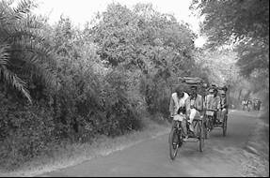
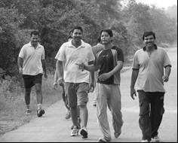
Morning walkers (© Bhumesh Bhadauria) and rickshaw pullers at KNP (© Vinod Mathur)

During summer, when daytime temperature in Bharatpur town can reach over 45⁰ C, the number of ‘morning walkers’ touches nearly 1,000. The park management has ‘waived’ the entry fee for these local people, who enjoy the vital environmental services of fresh, un-polluted air inside the park. No motorized vehicles are permitted inside the park and the only means of transport allowed is the ‘cycle rickshaw-pullers’, who also serve as nature guides.

The walking paths in KNP provide a good example of intangible benefits that local people derive from a protected area which also helps to maintain peace and harmony.
Text box written by Vinod Mathur of Wildlife Institute of India

More direct physical exercise in protected areas can be organised through working on management tasks such as infrastructure development and restoration activities. Many countries have volunteer networks which provide a vital contribution to protected area management. Some of these volunteering networks are now also noting the health benefits that working on protected areas offer. In the UK, for example, the British Trust for Conservation Volunteers (BTCV) runs a ‘Green Gym’ scheme across the country using the natural environment as a health resource. Evaluations of the project have shown improvements in physical and mental health after participating in the scheme. Many of these Green Gyms are active in national nature reserves. The Wallingford Green Gym in the South of England, for example, contributes to management activities on a range of reserves including the Aston Rowant National Nature Reserve, Riverside Meadow, Castle Meadow and Mowbray Fields Nature Reserve. The group meets once a week and has its own website to organise events, typical activities include tree planting and fencing.

- Mental health
What many of us instinctively feel about the value of being in a natural landscape to our health and well-being, has been the subject of research for the past 40 years or more, leading to considerable theoretical development and a newly developing terminology. The ‘biophilia’ hypothesis describes a bond between humans and other living systems; popularised by E O Wilson the term describes “the connections that human beings subconsciously seek with the rest of life”. Then there is ‘stress recovery’ or ‘stress restoration’ theory, which notes the value of natural settings (often through visual if not actual contact) in providing solace and refuge from the pressures of life and environmental stress. Another theory is that of ‘restorative environments’, which describes those settings that foster recovery from mental fatigue; as well as the similar concept of ‘therapeutic landscapes’. The notion of ‘topophilia’ distinguishes between a sense of ‘rootedness’ and ‘sense of place’. The former depends less on knowing what you value about an environment than habitually living within it, whereas the latter involves awareness of a landscape’s special worth and importance.

To complement the theoretical approach to understanding the links between natural places and well-being, there is a considerable body of research that reinforces the importance of these links. Cecily Maller et al, published a summary of the evidence supporting the assertion that contact with nature promotes health and well-being, and contends that the following statements are clearly demonstrated by research:
- There are some known beneficial physiological effects that occur when humans encounter, observe or otherwise positively interact with animals, plants, landscapes or wilderness
- Natural environments foster recovery from mental fatigue and are restorative
- There are established methods of nature-based therapy (including wilderness, horticultural and animal-assisted therapy among others) that have success healing patients who previously had not responded to treatment
- When given a choice people prefer natural environments (particularly those with water features, large old trees, intact vegetation or minimal human influence) to urban ones, regardless of nationality or culture
- The majority of places that people consider favourite or restorative are natural places, and being in these places is recuperative
- People have a more positive outlook on life and higher life satisfaction when in proximity to nature (particularly in urban areas)
- Exposure to natural environments enhances the ability to cope with and recover from stress, cope with subsequent stress and recover from illness and injury
- Observing nature can restore concentration and improve productivity
- Having nature in close proximity, or just knowing it exists, is important to people regardless of whether they are regular ‘users’ of it

A study in six rural communities across Victoria, New Zealand looked at the health, well-being and social capital benefits gained by community members involved in the management of land for conservation. The results indicate that involvement in practical conservation work may contribute to both the health and well-being of members and to the social capital of the local community. A total of 102 people participated in the study (64 men and 38 women) comprising 51 members of a community-based land management group and 51 controls matched by age and gender. The members of the land management groups rated their general health higher, reported visiting the doctor less often, felt safer in the local community, and utilized the skills that they have acquired in their lifetime more frequently than the control participants. A similar study in the Netherlands, using data on the self-reported health of over 10,000 people with land-use data on the amount of green space in their living environment, found that a green environment was positively related to a range of positive health indicators.

The large open expanses of east Africa have proved popular tourist destinations, and for many countries in the region their vast protected areas have proved of major economic benefit. Perhaps as well as being for the experience of seeing the herds of wildebeests and predatory lions, the landscape itself is also a draw. For early humans, a place with an open view would have offered better opportunities to identify food and shelter and to avoid predators; and there is considerable evidence that people’s aesthetic preferences conform to this scenario today. When offered a variety of landscapes, people react most positively to savannah-like settings, with moderate to high depth or openness, relatively smooth grassy vegetation or ground surfaces, scattered trees or small groupings of trees, and water. These findings emerge cross-culturally, in studies of North Americans, Europeans, Asians, and Africans. This effect may extend beyond aesthetics, helping recover health. Research on recreational activities has shown that savannah-like settings are associated with self-reported feelings of “peacefulness,” “tranquility,” or “relaxation” and viewing nature scenes is associated with enhanced mental alertness, attention and cognitive performance. Although much of this research is based on the benefits that occur by viewing nature (often a picture many thousands of miles from the source of the image); being in nature also impacts upon health.

Wilderness experiences, ecopsychology or nature-guided therapy are terms used in health-related literature to define activities which require entering a landscape rather than just viewing it. Such actions are described as therapeutic in many studies. There are several examples of so-called wilderness therapy for psychiatric patients, emotionally disturbed children and adolescents, bereaved people, rape and incest survivors, cancer patients, renal disease, post-traumatic distress syndrome and addiction disorders. A literature review of 187 research papers in 1995 supported the idea that participation in wilderness experience programmes results in positive benefits, such as enhanced self esteem and sense of personal control, and negative results from participation are virtually non-existent. However, much of the research was not peer reviewed, tended to lack of rigor and there were few long-term studies, suggesting that further study of these issues is still required.

Natural therapy in English protected areas
- Rye Meads Nature Reserve, Hertfordshire
The Royal Society for the Protection of Birds (RSPB) runs several nature reserves in the UK. The following example comes from a report they commissioned from Dr William Bird on the links between their conservation work and positive impacts on human health. The Rye Meads nature reserve is a wetland reserve in an urban area near to the River Lee in Hertfordshire, England. The reserve is managed to ensure high levels of accessibility with wheelchair-friendly trails and 10 hides from which a variety of habitats including reedbeds, wet meadows, open water and artificial sandbanks, can be viewed.

The report focussed on one individual, David Crew, who suffers from both epilepsy and Asperger’s syndrome (which is similar to autism) and came to the RSPB to start volunteering following a difficult period in his life. As William Bird stated in the report: “Unemployment and bouts of depression saw David in a pretty low state, and his illness meant he faced mixed reactions in the world of work and volunteering; it took all the efforts of his friends and family to get him back out into the world.

Despite facing these difficulties David situation greatly improved thanks to links with the local reserve. As Dr Bird goes on to relate: “David has been volunteering at RSPB Rye Meads nature reserve for over three years, and carries out a range of physically demanding tasks. He says: ‘I like outdoor work but had spent several months in my house not really mixing with other people. I thought this would be a good opportunity to enjoy some physically demanding outdoor work.’ In fact, David credits volunteering for the RSPB at Rye Meads with building up his strength as well as his mind, saying he has never felt this fit. ‘Tasks like digging holes are a real source of stress relief and act as a therapy – a way of letting off some steam. I can also feel myself getting fitter and stronger and this all adds to my confidence. I enjoy lending my time to worthy causes and find that doing so gets me out and about and back into society following a very dark spell. Volunteering at the RSPB has completely changed my outlook and given me a new focus, making me feeling better both mentally and physically’.” .

- The Phoenix Futures Programme
The Phoenix Futures Conservation Therapy Programme has been helping rehabilitation of people with substance misuse problems through active involvement in conservation projects in National Nature Reserves (NNRs) in England since 2001. Every week, groups from three of Phoenix Futures’ residential care units travel to local NNRs to take part in activities such as habitat management, boundary construction and footpath repairs. The groups are supervised by professionals who can offer both the practical expertise and the social skills necessary. After ten weeks on the programme, and subject to their completing risk assessments, task reports and learning logs, participants are presented with a certificate noting their achievements.

The NNRs involved in the project are: Derbyshire Dales NNR’s in the Peak District National Park,, Castle Eden Dene NNR near Peterlee, County Durham and Lindisfarne NNR and Natural England’s Kingley Vale NNR on the South Downs.

Although the project notes that measuring the success of this type of activity is difficult, an assessment of the effectiveness of the project is made by comparing the percentage of drug users who remain in the treatment programme (with treatment defined as being effective when clients stay in it for 12 weeks or more). From mid-2007 to mid-2008, 73 per cent of Conservation Therapy Programme attendees stayed in treatment for 12 weeks or more, compared to 49 per cent of non-participants.

One of the participants in the scheme summed up the experience of being involved in the project: “My life has been on self destruct for at least ten years, I put all my efforts into harmful things for my body and mind. From a dark place where I thought I was trapped and must admit I became comfortable with and was willing to be that way for the rest of my days. My way of thinking finally changed which led to Phoenix Futures. Ecology has just been a breath of fresh air to rekindle what I once had and can have again, only much improved. Not only does it give me what I need physically but mentally it is very therapeutic and is, and will, help my recovery.” .

- Therapeutic activities
In the 19th Century, before antibiotics were available to treat disease such as tuberculosis, sanatoriums hoped to create the ideal conditions for fighting infections by providing a regime of good food, rest and a healthy environment. The first sanatoriums were opened in Germany in the 1850s with treatments based around exposure to open-air, preferably at high altitude. Today, many protected areas still have sanatoriums within them (need to check all these against WDPA when in works): for example, Sanatorium Energetick in Tunkinsky National Park in Siberia; Sanatorium Amber Shore in Kemeri National Park in Latvia; Rakhmanov’s Springs Sanatorium in Katon-Karagai State National Nature Park in Kazakhstan.

Because heated water can hold more dissolved solids, warm and especially hot springs also often have a very high mineral content, containing everything from simple calcium to lithium, and even radium. Because of both the folklore and the claimed medical value of some springs, they are often popular tourist destinations, and locations for rehabilitation clinics for those with disabilities or ill health. Many protected areas include hot springs. Perhaps two of the most famous are at Pamukkale in Turkey and Hot Springs National Park in the USA. Pamukkale is recognized as a World Heritage Site. The medical properties of the spring water were, according to legend, bestowed by the gods, especially Asklepios (demigod of medicine) and his daughter Hygieia (goddess of health, cleanliness and sanitation), under the protection of Apollo (god of medicine and healing). The thermal springs of Hot Springs National Park (2,330 ha, Category V) in the Ouachita Mountains of central Arkansas have been valued for the recreational and therapeutic benefits of the thermal baths, as a source of drinking water since the history of the area was first recorded. In Latvia, the Kemeri National Park includes many culturally important buildings linked to the Kemeri Spa which became famous for its curing springs. The first water analysis was done in 1801 by an academic from St. Petersburg, T. Lovics, and the first data about using the mud from the springs for medical purposes was published in 1891.

A more controversial activity is swimming with wild mammals such as dolphins. Dolphin swimming is advertised on the visit Kenya web site at Kisiti Marine Park, Kenya,. Although in this case the main purpose is recreation, animal facilitated therapy with dolphins has been used as an alternative therapy for a wide range of physical and mental disabilities and illnesses in humans; and has been suggested as an effective treatment for mild to moderate depression. However, in some locations, dolphins are disturbed by such activities, and dolphins have been recorded as leaving their usual territories in favour of quieter areas.

Many of these therapeutic activities are today linked with tourists activities. For example, Green Line Safaris offers wellness tours in Oulanka National Park, Finland in collaboration with a registered relaxation and physiotherapist, for special groups such as business employees and senior citizens.

Disbenefits
In the sections above we have discussed the strong links between protected areas and our health in a number of ways. But such a discussion would not complete without acknowledging that there can be less positive outcomes from these links as well; some of the main ones are briefly noted below.

- Forest animals and insects can serve as hosts and vectors to a number of important diseases such as yellow fever, leishmaniasis and Chagas disease. Today about three quarters of all emerging infectious diseases are, or have been, transmitted between animals and humans; with the pathogens causing these diseases usually traceable back to wildlife. As protected areas become more isolated in the landscape and animals possibly become overcrowded in these restricted areas, concern has arisen over the evolution of parasite virulence and it has been suggested that conservation policies should be prepared to address this problem, especially given the serious health risks currently posed by the spread of virulent viruses (e.g., avian influenza).

- Diseases can be transmitted between closely related species such as people and primates or cattle and buffalo. Transmission can take place when, for example, domestic animals graze with wild animals in or around protected areas or when tourists, researchers and field staff enter protected areas to view primates. Zoonotic diseases are those caused by infectious agents that can be transmitted between (or are shared by) animals and humans. For example, Ebola was transmitted from a chimpanzee (Pan troglodytes) in Cote d’Ivoire in the 1990s and more recently from western lowland gorillas (Gorilla gorilla gorilla) and chimpanzees.

- Park management can sometimes inadvertently be the cause of health problems. The fact that many protected area rangers and managers need to stay away from home for long periods of time has been identified as a contributory factor in the increased spread of AIDS. In cases where communities are forcibly relocated to make way for protected areas this can also spread disease through exposure to new diseases. For example, when communities were relocated from the high plateau of Nyika National Park in Malawi, many went to the lowlands and succumbed to malaria, against which they had built up little natural resistance

- There is growing number of reported confrontations around the world between humans and wild animals – a phenomenon termed ‘Human Wildlife Conflict’ (HWC). The main drivers behind HWC are that growing population pressure often leads to the poorest in society pushing agricultural frontiers to more marginal areas that have become the sanctuary of many wildlife species and have often thus been designated as protected areas. As wildlife lose more and more of their natural habitat and have reduced access to natural food sources, they eat agricultural crops and livestock, can destroy property and can injure or kill people. And these problems are likely being made worse by increased drought and/or floods, both likely manifestations of climate change. As conservation succeeds and wildlife increases the problems of HWC are becoming worse. In Namibia, a rough estimation of the combined costs of HWC to communal area farmers is US$1 million annually; in Nepal, the average damage by elephants is as much as 27 per cent of the yearly income for each individual household in some regions. The consequences for local people are not only on their livelihoods but at the most extreme can lead to injury or death.

Chapter 3
Case Studies: ###

Need intro here – to be written once all case studies in

Parks Victoria - Healthy Parks Healthy People
Parks Victoria is a unique agency in that as a statutory authority it manages a diverse array of environments extending over 4 million hectares (15,500 sq miles) in the State of Victoria, Australia. These areas include national (terrestrial and marine) and state parks, conservation reserves as well as major metropolitan parks in Melbourne. In addition it has responsibility for the recreational management of Port Phillip and Western Port bays and navigable rivers flowing through Melbourne. Through effective environmental and visitor management, Parks Victoria is dedicated to preserving the natural and heritage values of Victoria’s parks, bays, and waterways, including full protection of sensitive areas.

Parks Victoria’s annual turnover is AUS$160 million. It is a diverse, decentralised agency with more than 1,000 employees located at 120 work centres in five regions throughout Victoria. Parks Victoria employs staff across the State in a wide range of roles, 850 of whom are trained emergency wildfire response personnel. Approximately 70 per cent of the staff are professionals with formal qualifications in park and reserve management, environmental management and recreation. This highly skilled and experienced team includes specialists in business systems, financial management, planning and marketing, and over 400 rangers based in parks, bays, and waterways. Over recent years Parks Victoria has developed a strong reputation nationally and internationally as a leading park management agency.

Like many protected area management agencies around the world, Parks Victoria needs to remain relevant to communities and governments in the midst of many other important considerations. Issues affecting education, health, security, transport, energy, and water, among others, can overshadow parks when legislators are considering environmental priorities. However, there is no need to exclude one priority at the expense of another. Increasingly governments are encouraging more holistic strategies that foster partnerships between sectors and which involve collaborations that realign common interests.

Its unique range and scale of responsibilities enables it to readily communicate with its urban constituencies about the value of biodiversity in relation to human wellbeing and thereby positively influence both their advocacy and visitor impact .

- Research
In 2002 an independent international literature review on the ‘health benefits of contact with nature’ was published by Deakin University’s Faculty of Health and Behavioural Sciences and updated in 2008. The research revealed a large body of empirical evidence supporting the seemingly obvious and reflected original presumptions such as this demonstrated by a 1929 extract from the Metropolitan Town Planning Commission report, Melbourne: “Abundant evidence is available to substantiate the views of city planners, the medical profession, and psychologists that proper outdoor recreation has a most beneficial effect on the health, morals, and business efficiency of communities, and consequently on the national life” which can be likened to many similar US and UK statements in the 19th century.

Continuing research around the world has further reinforced the findings which relate to the value of nature to health and wellbeing at both individual and community levels, and to preventative as well as restorative outcomes.

- Strategic Direction
On the basis of the research Parks Victoria has progressively adopted a “Healthy Parks Healthy People” approach to all aspects of its business. This philosophy seeks to reinforce and encourage the connection between a healthy environment and a healthy society, particularly as more people are now living in urban-dominated environments and have less regular contact with nature.

The organisation recognised that it has a clear role to play enabling people to experience the health benefits associated with the precious natural environment. In line with this more symbiotic approach to service delivery, Parks Victoria is repositioning itself as a provider of services with deep societal benefits rather than a custodian of natural values alone. In essence it is now looking at parks management from the outside in rather than from the inside out. In Victoria it is reshaping the role of parks in the community and their value to society.

To achieve this aim new partnerships are required along with the need to dissolve disciplinary barriers and realign common interests with others, such as those within the health and community sectors. Bridging sectoral boundaries is vital to rethinking the role of parks. We require people from a whole host of sectors to imagine the potential of parks from the outside-in. The worlds of sustainability and health have developed almost independently of one another, despite the best intentions of each to address issues of common concern. It is time to reunite them.

However, this kind of collaboration does not just happen; a shift in deep-seated, fragmented ways of understanding parks is required across a whole range of sectors. Political support, champions, leadership, research and public awareness campaigns are all necessary to shift into a new park management paradigm.

- Promotion
Beginning as an awareness raising campaign to highlight the connections between a healthy environment and a healthy community, Healthy Parks Healthy People has evolved into a new park management paradigm supported by many of Australia’s leading park and health organisations.

The key elements of the promotion have been:
- The first challenge was to develop a genuine and effective positioning in line with Parks Victoria's core values. The positioning needed to trigger a perception in the minds of the public of an organisation that exemplified the qualities and attributes of custodianship, environmental protection, and a contribution to a civil society. The clear and simple slogan "Healthy Parks, Healthy People" was used, implying that the environmental health of parks results in a healthy community and that spending active recreation time in a well cared-for park environment can lead to greater health and fitness of both individuals and society.

- Broad-based awareness was generated through an eight-week radio and print promotion programme, with activities supported by editorials in the national press. A festival showcased state-wide park and recreational opportunities and displays from community and recreational groups celebrating the benefits of outdoor recreation.

- Parks Victoria ‘Healthy Parks Healthy People’ television advertisements aired for two weeks in April 2006 on metropolitan channels and on regional television. The campaign was very well received by the general community, staff and stakeholders. Enquiries to the Parks Victoria Information Centre and website traffic increased during the period of the campaign.

- In line with these broader media and communication strategies, all existing Parks Victoria brochures and promotional programmes are now themed "Healthy Parks, Healthy People," including stands at three major annual exhibitions and major events.

Partnerships and Alliances
Advancing the Healthy Parks Healthy People agenda also involved developing partnerships with health and other bodies and with stakeholder groups. These alliances gave extra credibility to the approach by legitimising the links between a healthy park system and a healthy society. Some of those are outlined below.

- A partnership was established with a national television programme ‘Postcards’, which featured an actual park ranger as one of the presenters to highlight park venues and visitor opportunities. Each segment was tagged with the Healthy Parks, Healthy People message. The series was so successful it was placed in the popular time slot of 7.30 p.m. Saturday, and received even higher ratings. Later, this courtship with television evolved into a partnership with a similarly high rating programme.

- Support was sought and obtained from peak health bodies like the Royal Australian College of General Practitioners, Asthma Victoria, the National Heart Foundation, and Arthritis Victoria. Colourful posters and brochures were distributed to general practitioners' offices state-wide, and more recently (in conjunction with Maternal and Child Health Services and the Australian Breastfeeding Association) a congratulations card is provided to the mother of each new baby. These advise patients and mothers on the benefits of the natural environment and where to get more information about healthy activities in parks.

- Parks Victoria has continued to work with key partners and stakeholders in the planning and construction of ‘bike trails for a liveable city’ initiative which promotes the construction of new trails in developing areas, improving the connection between existing trails, and linking communities to places of work, activity centres and Melbourne’s park network. In 2007, an impressive 3,160 cyclists cycled through Melbourne’s parks and along bike trails as part of our third Bike Path Discovery Day. This free event now annual aims to increase awareness, knowledge and use of Victoria’s off-road trails and parks and their benefits.

- Community programmes which support people from culturally and linguistically diverse backgrounds have been developed - these include:
- development of a multilingual Park Note translated into 33 languages, training for Parks Victoria Information Centre staff to increase their capacity to manage callers from non-English speaking backgrounds (including the use of interpreter services); provision of park information to the Welcome to Victoria Kit (distributed annually to every new migrant child entering the education system); and
- a new Volunteer Bilingual Park Guides programme in partnership with a number of community organisations. The 11 graduating guides conduct tours in a second language including Turkish, Arabic, Spanish, Macedonian, Sudanese and Greek to newly arrived and culturally and linguistically diverse communities to assist them in understanding and appreciating their local open spaces, flora and fauna. It is believed that this course is the first of its kind in Australia and the concept has created interest in other parts of Victoria, as a highly innovative approach to helping settlers gain a sense of belonging in their adopted home.“I thank Parks Victoria very much. Going out makes me feel very happy after all the difficulties I’ve been through. Now I’m in a foreign country I forget about what is going on in my home country. The river reminds me of home because my house was near the river and we used to go there to collect water. People would give birth at the river and swim there too.” Adau (Sudanese participant). “As a teacher and a community project facilitator for the last 27 years, I have not seen another group of people build such a strong and cooperative relationship as with this group” Dimi Bouzalas, Project Leader, Merri Creek Management Committee

- Through partnering with the People & Parks Foundation, and in conjunction with the Variety Club, over 100 disadvantaged young people were supported, to be involved in camps which gave them an experience of nature. Further, over 500 volunteer hours were spent with the Sea Search programme which monitors Victoria’s marine national parks and sanctuaries. Data from this programme across 15 marine and coastal parks and reserves helps Parks Victoria to manage these areas whilst providing benefits to the participants.

- ‘The World’s Greatest Pram Stroll’ – an annual initiative to encourage young mothers to meet and mix in a pleasant environment, and encouraged to establish a great habit and avoid post-natal depression and social isolation. The ‘stroll’ was first held in 2002 and has grown to an annual event which attracts 5,000 mums, dads and their families simultaneously strolling at one of the 28 local or regional parks for the event in 2008. The event is organised in conjunction with health NGOs and family magazine publishers.

- A significant contributor to the success of Healthy Parks Healthy People to date has been its endorsement by staff. Across the organisation, there is a growing appreciation of the relationship between a healthy parks system and a healthy society and programs that demonstrate the broader role parks can play are beginning to grow from the ‘grass-roots’.

- The Road Ahead
Parks Victoria will continue to advance the societal value of parks here in Victoria. We will broaden the role parks play and build awareness in Australia that parks are a vital part of a healthy and sustainable future. Parks Victoria has set in motion a process that will help achieve this aim.
- Whilst recognising that the connection of people to parks and to nature has a long history and is an enduring value we need to ensure we are relevant to today’s societal needs and to be planning for the future.
- Climate change response – we need a plan, action and communication about what it means for parks
- We need to be better engaged with the community – listening, educating, building support and partnerships and meeting people’s needs
- To be excellent park managers we need an evidence base for decision making. We need knowledge, expertise, data and commitment to performance evaluation
- We need to expand people’s understanding of the benefits of parks and to strengthen the connections between people and parks to achieve mutual benefits. (Healthy Parks Healthy People)
- We need to be a sustainable organisation; environmentally, socially and financially. We need to operate in an environmentally sustainable way, to foster social cohesion amongst staff and to secure the resources required to manage parks well.

- Leading the way: International Healthy Parks Healthy People 2010 Congress
To catalyse action and broaden the role of parks, Parks Victoria will host the inaugural International Healthy Parks Healthy People Congress in Melbourne during April 2010. It is expected to attract over 1500 delegates from Australia and around the world. Participants will come from many different sectors and provide a diversity of viewpoints. Already IUCN has endorsed the event and beyondblue (the national depression initiative) and Deakin University have joined Parks Victoria as partners in the Congress. The internationally renowned scientist, Sir Gustav Nossal AC has agreed to be the Patron.

UK: Walking its Way to Health
The UK has a publicly funded National Health Service (NHS) – but the costs of keeping the nation healthy are huge and increasing rapidly. Overall, running the NHS cost some £92 billion in 2008 (the budget has risen considerably in recent years; it was for example £52 billion in 2002). Given that many of the diseases now threatening the UK population are avoidable, the NHS is gradually shifting its emphasis from treatment and cure to prevention. The costs of avoidable physical and mental ill-health are significant, with estimates ranging from £11-50 billion per year in terms of health costs and productive days lost. There is clearly a need urgently to increase the nation’s well-being, just as in the past there was a need to fight infectious disease, ensure water purity and improve sanitation.

- A long but sedentary life
The population of the UK has greatly benefited from the rapid improvements in medicine and availability of medical care during the last half century. But as lifespan has steadily increased, lifestyles have become less healthy. 70 per cent of the UK population leads sedentary lives creating many major avoidable health problems such as obesity, diabetes, heart disease and some cancers.

One move towards preventing ill health has been to link the national health agenda more closely with the government agencies responsible for environmental protection in the different countries that make up the UK (respectively Natural England, Countryside Council for Wales, Scottish Natural Heritage and The Environment and Heritage Service in Northern Ireland). Natural England, for example, has a publicly funded budget of some £2.9 billion to ensure that the country’s natural environment, including its land, flora and fauna, freshwater and marine environments, geology and soils, are protected and improved. It also has a responsibility to help people enjoy, understand and access their natural environment. Natural England’s recent manifesto recognises that its responsibilities in effect add up to a ‘natural health service’, which also has the potential to make a major contribution to the health and wellbeing of the nation.

These links between a publicly funded health service and publicly funded bodies managing the natural environment are slowly being developed through more binding policies and objectives. In 2008, Natural England published a Policy Position Statement on Health and Wellbeing which includes three major ‘wellbeing’ policy positions relating to different stages of life plus one overarching position on the rationale of linking our environment to our health. The policy statements states:
“We believe that:
- Better health and wellbeing are two of the major social and economic benefits we can secure through good management of the natural environment in both rural and urban settings.
- Specifically:
  - children should experience and familiarise themselves with their local environment to benefit their mental and physical health and further their development.
  - Adults should be offered increased contact with the natural environment resulting in reduced stress and more fulfilling lives.
  - Healthy Ageing is enhanced by close and frequent contact with the natural environment leading to greater independence and dignity.
- Connections between people and the natural environment should go beyond the lives of individuals to create a lasting legacy of strong and healthy communities for future generations.

- Activities and programmes
Against a background where public use of the natural environment has been declining over the last decade, some new programmes are demonstrating how contact with the natural environment can make a measurable impact on people’s health and wellbeing. Three leading programme initiatives in England are:

- The Green Gym which offers individuals an outdoor alternative to conventional gyms. Green gyms allow people to increase their physical activity levels through direct involvement in practical conservation activities.

- Active Woods is a national drive by the Forestry Commission to promote the range of health and fitness opportunities offered by Britain’s woodlands. Hundreds of events are being organised across England such as activity days, den-building competitions and dog walks, reflecting the campaign’s three themes of naturally active, naturally stimulating and naturally relaxing.

- Walking the way to Health (WHI) is a joint initiative between Natural England and the British Heart Foundation. WHI aims to encourage people, particularly those who take little exercise, to do regular short walks in their communities. There are currently over 500 local health walk schemes across England.

All these schemes take place in a range of areas throughout England, including National Parks, National Nature Reserves and many local and private reserves, as illustrated by the example below. There are also similar initiatives developing in other parts of the UK.

Tiptree Heath, Essex, England
Tiptree Heath is a 25 ha (61 acre) Site of Special Scientific Interest. It is the largest remaining significant fragment of heathland in Essex which in past centuries covered thousands of acres. The heath is privately owned common land and is managed as a protected area by the Friends of Tiptree Heath and the Essex Wildlife Trust. The heath has a variety of habitats, with pockets of woodland, a stream, two ponds and open areas which are in the process of being restored to heathland in favourable condition. It is home to many locally and nationally important plants and invertebrates.

Public access to the heath is an important management objective following the recent introduction of grazing cattle as an effective management strategy. Gates, allowing pushchair and disabled access, have been placed on the most frequently-used paths, and there is also a full perimeter path outside the grazed area. These networks allow for a well supported WHI initiative. Walks take place weekly and eight walk leaders have been trained to lead activities at the site. Walkers take part for a variety of reasons including health related issues such as heart disease and diabetes, and for mental health issues, general improvement of wellbeing and for social reasons. Buggy (i.e. pushchair) walks are in the process of being trialled and there are also walks of special interest, i.e. history/art trail/bat walks/flora and fauna species walks and a dawn chorus walk. One of the warden/walk co-ordinators also jointly runs with volunteer leaders regular work parties which constitute a Green Gym involving volunteers of ages from 12 to over 70 including a good number of teenagers and younger adults.

Malaysia: Wild Honey and the Tualang Tree
In Malaysia, the Tualang honey is one of the prized possessions of the rainforest. It is named after the Tualang tree (Koompassia excelsa) in which the bees (Apis dorsata) make nests. There is a wealth of tradition associated with the honey collection and nowhere is it more studied and written about as than in the Ulu Muda area in the Malaysia state of Kedah. Research conducted by entomologist Stephen Buchmann showed that the Tualang honey collected in Ulu Muda is among the best in the world as the bees gathered nectar from 180 species of flowers.

Found in north and central Peninsular Malaysia, Borneo and Sumatra, this tree belongs to the Leguminosae family. The Tualang tree has tall buttresses and its bole can reach up to 290cm in diameter. The Tualang tree is the tallest recorded rainforest tree in the world (83.8m) and is the third tallest of all trees after the giant redwood of California at 101.5m (Sequoia sempervirens) and the blue gum of Victoria, Australia at 97.8m (Eucalyptus regnans) .

Being a great forest emergent with tall straight boles and wide-spreading crown, the Tualang tree makes a good honey tree. It has hard and heavy wood that can support the weight of the large bee comb in which a single comb may weight 40kg or more. Being an emergent, the Tualang tree provides a clear area below the comb and in some situation, an even larger space around the comb. This is important to the bees because any close vegetation could provide access to its open nest and food store for any climbing mammals or insects (especially ants). Other trees that are also a nesting place for bees includes the binuang (Octomeles sumatrana), Ficus albipila and mangrove trees such as Avicennia spp. and Ceriops spp., , .

- Ulu Muda
The Ulu Muda Forest Complex (Ulu Muda) consists of eight forest reserves; namely the Ulu Muda Forest Reserve (FR), Pedu FR, Padang Terap FR, proposed Bukit Keramat FR, Chabar Besar FR, proposed Bukit Saiong FR, Chabar Kecil FR and proposed Ulu Muda FR. Despite its size and significance, Ulu Muda remains a hidden realm. It is unknown to most Malaysians and the outside world in general. Listed as one of the ten special places for ecotourism by the National Ecotourism Plan and identified as an Environmentally-Sensitive Area Rank I by the National Physical Plan, Ulu Muda is of outstanding value for its wildlife conservation and nature tourism. Unlike other rainforests in Malaysia such as Endau-Rompin and Taman Negara, Ulu Muda area contains forests with Thai-Burmese characteristics due to its proximity to southern Thailand. Covering an area approximately 160,000ha, Ulu Muda is located within the district of Baling, Padang Terap and Sik in the north-eastern corner of Kedah (a northern state in Peninsular Malaysia).

Ulu Muda boasts a high concentration of saltlicks and hot springs that are important to the health and well-being of wild animals. Studies conducted during a scientific expedition to Ulu Muda provide an indication of the abundance and diversity of the wildlife species as follows (as percentage of the total in Malaysia): 55 per cent of mammals (including six out of 10 primates, 78 per cent of squirrel species and 53 per cent of bat species), 175 of bird species (including seven out of 10 hornbill species) and 42 out of 54 reptile species. Aside from that, Ulu Muda area also functions as a water-catchment forest.

Ulu Muda supports life beyond the flora and fauna that inhabits its forest. It sustains the water needs for agricultural, domestic and industrial uses for the northern region of Peninsular Malaysia. Irrigation schemes supported by the catchment forest supply water to the “rice-bowl” of Malaysia (Kedah is the largest rice-growing state in Malaysia) and to the electronics and heavy industries sector centred at Penang and Kulim (southern Kedah) .

- Honey Gathering Tradition
Beyond these apparent contributions, there is another facet of Ulu Muda’s intricate ties with the locals – the honey gathering tradition. This tradition is one of the cultural highlights in the Ulu Muda area that is unique to the Malay villages, and is quite different from commercialised honey gathering activities and from honey farming. Aside from making livelihood from the wild honey which is bottled and sold, traditional honey gathering is associated with rural culture. Practices and knowledge are passed from one generation to the next and is followed with eager anticipation. The honey collecting season (each season lasts about two or three months) creates an opportunity for the gathers to be away from the city (where they usually work/stay during the rest of the year) and to spend time in the forest. A leader of one of the honey gathering clans remarked that when the bees arrive, he completely forgets about home.

In the Ulu Muda area, there are approximately 70 bands of honey gatherers operating and they must obtain special permission from the Sultan of Kedah as the honey belongs to the ruler. A Tualang tree can harbour more than 80 combs each housing between 30,000 and 70,000 bees. Each band of honey gatherers has specific Tualang trees that they can collect honey from. Honey gatherers start by constructing a makeshift ladder from the ground level up to the combs. Traditional honey collection occurs during moonless nights as any source of light would help the bees to know where to sting. The honey gatherers also use traditional torches to produce glowing embers that distract the bees from attacking them. Collectively, the honey gatherers harvested as much as 150,000 pounds of honey each season. Tualang honey gathering allows each man in the band to make as much as US$150 more per month than he would make as a rubber taper or farm labourer.

The Tualang honey that is collected is also marketed by the Federal Agriculture Marketing Authority (FAMA) that was established under the Ministry of Agriculture and Agro-based Industry. FAMA’s involvement has not only broadened the marketing scope of the honey but it has also put in place a framework for generating income for the locals through agro-tourism activities (such as following the honey gatherers when they are collecting the honey) and in maintaining the credibility as well as the quality of the honey sold. In 2007, FAMA and Hospital Universiti Sains Malaysia signed a memorandum of understanding to further enhance efforts in researching the medicinal properties of honey.

- The medical values of honey
Honey is acknowledged in numerous religions, cultures and civilisations as a natural and healthy food containing many medicinal properties. Honey is mentioned in religious books such as the Torah, the Bible and the Qur’an and it properties have been well known throughout history by, for exmaple, the Malay, Chinese and Indian cultures. The Qur’an, for instance, refer to honey as a healer of disease while in the Bible, honey is referred to as a wholesome food among other things, . Easily digestible and palatable, honey also contains mineral (such as magnesium, potassium, calcium, sodium chlorine, sulphur, iron and phosphate), vitamins (such as B1, B2, C, B6, B5 and B3) and is a rich source of carbohydrates.

However, it is the medicinal properties of honey that is the subject of numerous research and written articles. From folk-medicine to modern professional medicine, honey is regarded to be a natural cure. An international conference on the medicinal uses of honey in 2006 saw numerous papers presented including about the use of honey to treat infectious diseases (infections from both gram-positive and gram-negative bacteria) and autoimmune disorders (such as multiple sclerosis, systemic lupus erythematous, rheumatoid arthritis, etc.).

The applications of honey in treating traumatic and surgical wounds for present and future treatment are also increasing with the advent of antibiotic resistance in bacteria. As such, honey bioactivities that are gaining wide acceptance in modern medicine include:
- Antibacterial action
- Rapid debriding action
- Stimulatory effect on growth of tissues for wound repair
- Anti-oxidant and anti-inflammatory action (minimises scarring)

- The threat to Ulu Muda
Presently, logging activity is the main threat facing the Tualang tree and Ulu Muda. Deep axe incision of about 15cm has been found in one of the century old Tualang tree at Ulu Muda. As a result, the tree became withered, the branches brittle and the number of combs in the tree declined as compared to previous years. Not only that, logging in Ulu Muda is depleting the floral resources in the rainforest and has resulted in the decreasing yield of the Tualang honey. However, the bigger threat is the unprotected status of Ulu Muda (much of which is within production forest reserves). To date, there have been two proposals by the state government to log Ulu Muda to generate revenue. The Federal Cabinet banned the first logging proposal (in 2003) stating that Ulu Muda is an important water catchment area and should remain undisturbed following protests by local NGOs that formed the Friends of Ulu Muda coalition, including WWF-Malaysia. In 2008, the state government again proposed to log Ulu Muda, prompting local NGOs to protest again against the logging proposal, .

There are now strong calls for the protection of the Ulu Muda forest by establishing a state or national park covering the entire forest complex and preparing a management plan for the area. This would be of utmost importance in safeguarding the honey gathering tradition, the Tualang tree and the rich biodiversity of Ulu Muda.

Bioprospecting in Yellowstone National Park
In the United States most of the potential bioprospecting in national parks is related to the study of microorganisms, a research partnership which is almost as old as national parks themselves. Yellowstone was America’s first national park; it was established in 1872 and the first research permit for the collection of microbial specimens from its hot springs was issued in 1898.

Yellowstone National Park is owned by the American public and managed by one of the US Federal Land Management agencies, the National Park Service (NPS), which in turn falls under the jurisdiction of the US Department of the Interior. Yellowstone is unique because it has half of the earth’s geothermal features in the only essentially undisturbed geyser basins left worldwide. With some 300 geysers, two thirds of all those found on earth, and more than 10,000 thermal features such as hot springs, bubbling mudpots, and steaming fumaroles, it is not surprising that the park is a hotspot for microbial research – and in particular research into extremophilic organisms, i.e. those that thrive in conditions that are physically impossible for a majority of life on Earth.

- Thermus aquaticus
In 1966, Thomas Brock conducted ground-breaking field studies of microorganisms in hot springs in Yellowstone. He cultured Thermus aquaticus from near boiling water in Mushroom Pool in the Lower Geyser Basin. A living sample was deposited in the American Type Culture Collection (ATCC) for safekeeping. T. aquaticus is an extremophilic bacterium known as a thermophile, a ‘heat-loving’ organism that is adapted to life at high temperatures, similar to some of the most ancient microorganisms on the planet that thrive under conditions that were typical of Earth’s early environments⁵.

In 1985, a biotechnology company, Cetus Corporation, was looking for a way to duplicate genetic material to aid DNA research. Since the amount of DNA present in a cell sample is too small to study easily, Kary Mullis, a biochemist at Cetus, devised a method of amplification that utilized heating and cooling cycles to break open a strand of DNA during a chemical reaction. He then added a DNA polymerase enzyme to the reaction to ‘read’ the strand of DNA and replicate a new strand. The high temperature required to break open the DNA inactivated the polymerase after the heating cycle and required adding more polymerase after each cycle, making the process laborious. Furthermore, at the time, DNA polymerase was difficult and expensive to isolate. Mullis found a solution to this problem by adding a heat stable enzyme named Taq polymerase, which was purified from a culture of T. aquaticus, obtained for US$35 from the ATCC. The enzyme allowed the process to work effectively at high temperatures. As a result DNA could be amplified billions of times in a few hours.The process was called the Polymerase Chain Reaction or PCR.

By allowing scientists to study DNA more effectively, the PCR technique using Taq polymerase led to many new research applications in the biological sciences. Since the early 1990s the PCR technique has been used in many research areas, including basic molecular biology research, clinical testing, forensics, cancer research and in helping to detect the HIV virus in AIDS. The development of PCR was also financially successful, resulting in a multi-million dollar business (Hoffmann-La Roche eventually bought the PCR and Taq polymerase patents from Cetus for US$330 million, and subsequent biotechnological applications have annual sales exceeding US$200 million).

The isolation of Taq polymerase from the Yellowstone culture of Thermus aquaticus for use in PCR did not however result in any direct benefits for the National Park Service, the US Federal Government or the US public. Not surprisingly this situation brought the issue of benefits-sharing agreements for future bioprospecting in Yellowstone to the forefront. Policies and legislation were developed and finally the National Parks Omnibus Management Act of 1998 (NPOMA) was passed, which authorises ‘negotiations with the research community and private industry for equitable, efficient benefits-sharing arrangements’ in connection with research conducted in national parks. NPOMA provides guidance to national parks on developing benefits-sharing agreements with the research community and mandates increased scientific research in protected areas. The legislation specifically authorises the US National Park Service to negotiate agreements for profit-sharing when park-based research results in a product with commercial value.

Access to biological resources in US parks for research purposes is governed by National Park Service (NPS) regulations. Permits are issued only when “public health and safety, environmental or scenic values, natural or cultural resources, scientific research, implementation of management responsibilities, proper allocation and use of facilities, or visitor use activities will not be adversely impacted”.

- Benefit-sharing arrangements
In 1996, Yellowstone, in keeping with its pioneering role in bioprospecting, was asked to develop a framework for negotiating benefit-sharing arrangements with researchers wanting to access biological resources from the park that would: a) strengthen resource conservation activities and b) be a pilot for other national parks developing bioprospecting agreements. After a period of consultation and research (including a thorough review of the experience of the National Biodiversity Institute from Costa Rica (INBio) where there is many years’ experience of access and benefit-sharing arrangements with companies, including agreements with Merck & Co. in 1991 and 1994, as well as an agreement with Diversa – see box on page #), Yellowstone became the first US national park to enter a Cooperative Research and Development Agreement (CRADA) with a private company in 1997. The agreement was with Diversa Corporation (now part of Verenium Corporation), which specialises in collecting DNA from hydrothermal habitats and screening genes for their ability to produce useful compounds.

The CRADA, which initially ran for five years, stipulated that Diversa pay Yellowstone a sum totalling US$100,000. The fees were paid into a special government account used to fund the Yellowstone Thermophiles Conservation Project. The company also provided equipment such as DNA extraction kits and DNA ‘primers’ and trained Yellowstone staff in molecular biology techniques. The annual benefit of this technology transfer was valued at US$75,000 per year.

As part of the agreement, in 1999 Diversa staff used their expertise to carry out DNA profiling of Yellowstone’s endangered wolves (Canis lupus lupus). This profiling was the first ever established for a wild wolf population and the results are aiding park personnel in understanding the dynamics of the wolf population, by for instance, allowing biologists to assess accurately the genetic health of Yellowstone’s wolves and helping identification of wolves killed illegally. The DNA profiling was carried out free of charge by Diversa, and was a study that would otherwise have been beyond the reach of the park service. Diversa also helped with the detection of Brucellosis in Yellowstone bison (Bison bison) using PCR technology.

All specimens collected under Scientific Research and Collecting Permits from US National Parks remain Federal property and thus the CRADA does not transfer ownership of the specimens sampled in Yellowstone. However, the CRADA allows Diversa to develop valuable products from research specimens lawfully collected from Yellowstone National Park. Diversa therefore could, as long as the relevant US intellectual property legislation is adhered to, patent any innovations based on the specimens sampled and sell any resulting products, but would be required under the terms of the CRADA to provide royalties to the park based on sales of successful products.

In order to be granted a research permit within Yellowstone, an applicant must demonstrate that the research activities will have no serious impact on the ecosystem. This stipulation is particularly important because areas where microbes are found can be particularly fragile – and even a single human footprint could damage the area. Park scientists closely monitor research activities and advise visiting scientists on appropriate collection techniques.

The agreement between Yellowstone and Diversa did not go unopposed. Some NGOs (specifically the Edmonds Institute and the International Center for Technology Assessment) opposed the partnership believing that the CRADA involved “selling off public resources” . This led to a lawsuit being filed in 1998 challenging the CRADA, claiming that it violated the Federal Technology Transfer Act, the NPS Organic Act, the Yellowstone National Park Organic Act, and the National Environmental Policy Act, among other things. The case was however dismissed in 2000 when it was ruled that the benefits-sharing agreement was consistent with US legislation. The CRADA has remained suspended pending completion of environmental analysis required by the court.

- Conclusion
Equitable deals between protected area managers and biotechnology companies present a clear opportunity for sourcing conservation funds. However, the often long timescale between the collection of raw material from a protected area and the development of a commercial product (as this case study clearly shows this time period can be as much as 20 or 30 years), means that bioprospecting in national parks may not be a particularly profitable exercise. Indeed, it is perhaps instructive that a restructuring at Diversa in 2006 was stated as being necessary to improve the companies product sales and to “conserve its dwindling cash pile” by reducing research including bioprospecting partnerships.

Notes re case studies
Still to add:
1) The sanctuary of flora “Medicinal Plants Orito Ingi Ande” Colombia (hopefully)
2) China (have draft but needs revision as PAs not mentioned!)
3) And one coming from Judy from Africa
Chapter 4
What role can protected areas play in reducing the risks to human health?

The overview survey of the links between protected areas and health and the more detailed review of issues in case studies in the chapters above provide an indication of a wide range of health and well-being benefits which protected areas can contribute. But how relevant are these to the health threats facing us today? This chapter looks at the major risks to human health and looks at the practical implications of how protected areas can contribute to reducing this risk, by providing guidance for both health and protected area professionals.

In developing this chapter we reviewed a range of research carried out by the World Health Organisation (WHO), the United Nations body which works primarily on global health issues. Rather than looking at the direct causes of mortality, we decided to concentrate on risks to our health; as in many cases the full reasons for death are not recorded and because there are many risks to health which may all contribute to illness and ultimately death. It is also these risk factors which form the basis of many national and international health policy agenda’s; and as such are a better focus for any policy setting agenda such as the Arguments for Protection series.

Whilst poverty, resulting in malnutrition, lack of clean water etc, tends to be the factor linking the diseases effecting inhabitants of the ‘third-world’, in industrialised countries chronic disease, i.e. diseases of long duration and generally slow progression such as heart disease, stroke, cancer, chronic respiratory diseases and diabetes, has increasingly replaced acute infectious disease as the major cause of disability and death. In both cases the problems are often long-term and are potentially much more expensive in terms of health care requirements and cost to the community. On the other hand they are issues which are often preventable assuming that the policy environment in a range of well-being areas are focussed towards health.

This chapter and the assessment of risk would not have been possible without the publication in 2002 of the World Health Report ‘Reducing Risks, Promoting Healthy Life’. The publication details one of the largest research projects ever undertaken by the WHO to understand the most important risks to human health. By quantifying the health impacts of various risk factors the report describes the amount of disease, disability and death in the world today that can be attributed to a selected number of the most important risks to human health. The research concentrates on a selection of risk factors which represented real risks to health, often the actual causes of major diseases, and concludes that had these risks not existed, then healthy life expectancy in 2000 might have been, on average, almost a decade greater globally.

Risk factors discussed
The WHO report calculates risk through the study of a selection of major health risk factors discussed under seven headings (see table #): childhood and maternal undernutrition; other diet-related risk factors and physical inactivity; sexual and reproductive health; addictive substances; environmental risks; occupational risks; and other selected risks to health (including unsafe health care practices, and abuse and violence). The risk factors assessed were chosen with the following considerations in mind.
- Potential global impact: likely to be among leading causes of disease burden as a result of high prevalence and/or large increases in risk for major types of death and disability.
- High likelihood of causality.
- Potential modifiability.
- Neither too specific nor too broad (for example, environmental hazards as a whole).
- Availability of reasonably complete data on risk factor distributions and risk factor–disease relationships.

In relation to the choice of risks the report also notes “There is unavoidably an arbitrary component to any choice of risk factors for assessment, as time and resource constraints will always operate and trade-offs will be required. For example, some factors like global warming where data are substantially incomplete may nonetheless be of such potential importance that they should be included and their impact estimated based on possible scenarios and theoretical models. These trade-offs should be made clear when the data sources, methods and results are reported in detail, including estimation of uncertainty” .

Table #: Worldwide attributable mortality by risk factor in 2000
Risk Factor | Deaths
- Diet-related risks and physical inactivity (blood pressure; cholesterol; overweight; low fruit and vegetable intake; and physical inactivity) | 18,795,000
- Addictive substances (tobacco; alcohol and illicit drugs) | 6,915,000
- Childhood and maternal undernutrition (underweight; iron deficiency; vitamin A deficiency and zinc deficiency) | 6,156,000
- Environmental risks (unsafe water, sanitation and hygiene; urban air pollution; indoor smoke from solid fuels; lead exposure and climate change) | 4,536,000
- Sexual and reproductive health risks (unsafe sex and lack of contraception) | 3,035,000
- Occupational risks (risk factors for injury; carcinogens and airborne particulates) | 699,000
- Other selected risks to health (unsafe health care injections and childhood sexual abuse) | 580,000

Linking health risks with protected area management
If protected area managers wish to promote the benefits of the areas/systems they manager in terms of health then starting their ‘argument’ as response to the findings of the WHO risk report is a valid place to start. In this section, therefore we ask how can protected areas contribute to lowering these risk factors?

As noted above in chapters 2 and 3 we reviewed many examples of how protected areas are contributing to health and well-being. But what can we learn from this overview? In this section we review the information from WHO from the perspective of health professionals and protected areas managers and discuss just how protected areas can contribute to reducing health risks and thus promoting good health. By providing this information we hope that health care professionals and policy makers will value the contributions that protected areas can make to health and that protected area professionals and policy makers will perhaps gain a little inspiration as to how the area they protect for the conservation of nature can also contribute the goals of reducing the risks to health.

We thus look in more detail at each of these major risk factors in turn, providing an overview of the risk and its impact on health based on the WHO research. This risk is measured both in terms of mortality, the figures given below are for the number of deaths in the year 2000, and in terms of the burden of disease which is measured using the WHO concept of disability-adjusted life year (DALY), which combines years of life lost due to premature mortality and years of life lost due to time lived in states of less than full health, thus one DALY being equal to the loss of one healthy life year.

Diet-related risk factors and physical inactivity
Although lack of adequate nutrition remains the major problem for much of the world’s population, about one-sixth of the entire disease burden in developing countries is attributed to underweight, the risk factors which could actually be attributed to mortality most often (see table #) are associated with the overconsumption of certain foods or food components. Indeed WHO report that whilst there are some 170 million children in poor countries who are underweight – and over three million of them die each year as a result – there are more than one billion adults worldwide who are overweight and at least 300 million who are clinically obese. In assessing the risks relating to diet-related and physical inactivity risks, the WHO research concentrated on five key areas: blood pressure; cholesterol; overweight; low fruit and vegetable intake; and physical inactivity. There findings for each of these areas are summarised below.

High blood pressure is often related to diet, especially salt intake, levels of exercise, obesity, and excessive alcohol intake. Worldwide, high blood pressure is estimated to cause 7.1 million deaths, about 13 per cent of the total. Cholesterol is a fat-like substance, made primarily by the liver from a wide variety of foods, especially from saturated fats, such as those found in animal products. Cholesterol increases the risks of heart disease, stroke and other vascular diseases. In North America and Europe high cholesterol accounts for between 5 and 12 per cent of DALYs. Being overweight is commonly assessed using the body mass index (BMI), a height/weight formula with a strong correlation to body fat content. WHO criteria define overweight as a BMI of at least 25 kg/m² and obesity as a BMI of at least 30 kg/m². The mean BMI level in adults in Africa and Asia is 20–23 kg/m² compared with levels of between 25–27 kg/m² in North America and Europe. Weight problems are linked to poor diet and lack of exercise and can lead to high blood pressure, cholesterol and insulin resistance thus increasing the risk of heart disease, stroke and type 2 diabetes. WHO report that 58 per cent of type 2 diabetes globally, 21 per cent of ischaemic heart disease (i.e. heart disease characterised by reduced blood supply to the heart muscle) and between 8 and 42 per cent of certain cancers were attributable to BMI above 21 kg/m² .

Fruit and vegetables can help prevent major diseases such as cardiovascular diseases and certain cancers principally of the digestive system. Low intake of fruit and vegetables is estimated to cause about 19 per cent of digestive tract cancer, about 31 per cent of ischaemic heart disease and 11 per cent of stroke worldwide. Physical activity can also reduce the risk of cardiovascular disease, some cancers and type 2 diabetes. Overall physical inactivity was estimated to cause 1.9 million deaths and 19 million DALYs globally; more specifically lack of exercise is estimated to cause between 10 and 16 per cent of cases each of breast cancer, colon and rectal cancers and diabetes, and about 22 per cent of ischaemic heart disease globally.

- Health practitioners
The links between physical activity and protected areas represent perhaps one of the clearest strategies for further developing the contribution of protected areas to a country or states health agenda’s. As the case study from the UK (see ##) shows there is a strong economic argument for making this link. In Scotland, for instance, the health benefits of woodlands have been estimated at between £14.1 million to £18.9 million per year (at 2006 prices) through helping to avoiding premature deaths and morbidity through increased physical exercise, reduced air pollution, savings in mental health treatment costs and reduced absence from employment. And as was noted above, it has been calculated that in America every US$1 invested in physical activity leads a saving in medical cost of US$3.2.

- Protected areas
The role protected areas can play in providing safe places to exercise is increasingly being recognised. In this report we have seen examples from Australia, India and Europe of the sorts of activities which protected area can offer. Such initiatives do not necessarily have to be developed by the protected area managers but can be developed in association with other organisations working in the protected area.

The common features of these initiatives include:
- Providing a safe and secure place to exercise in and enjoy being out in the fresh air
- Developing specific walking and or exercise initiatives where people are encouraged to come together to enjoy the protected area (these initiatives are generally supported by specific publicity drives and can involve training park staff to lead the walks).
- Ensure easy access to protected area facilities (this can range from waiving entrance fees for the local population, as in Keoladeo National Park in India and in the example from the US below, to ensuring that park infrastructure, i.e. paths, gates etc, are accessible to users with different physical abilities)

Protected area managers throughout the world are increasingly being encouraged to see the areas they manage enjoyed as ‘outdoor gyms’. Although this is clearly not a strategy for all protected areas, in particular those with fragile environments or where animal populations include species which represent a danger to human life, for many managers and policy makers the need to link protected areas and health is becoming clear. In the 2002 fitness initiative in the US, for example, President George Bush signed two Executive Orders designed to promote national fitness. The second of these orders, ‘Activities to Promote Personal Fitness’, encourages federal agencies, including the Department of the Interior which is responsible for national parks in the US, to take steps to promote exercise and fitness among the American people. In response all entrance fees for a weekend to the national parks, forests, and other lands were waived, and the Parks Service organised a series of special events. Praising these initiatives, the President said: “Regular hiking through a park can add years to a person’s life ... If you’re interested in doing something about your health, go to one of our parks--and take a hike”.

I am sure there is tons of literature giving advice on access/footpath placement etc – should we be trying to include this here?

Addictive substances
The WHO research on addictive substances concentrated on tobacco, alcohol and illicit drugs. Smoking causes substantially increased risk of mortality from cancer, heart disease, stroke, chronic respiratory disease and a range of other medical causes. Among industrialized countries smoking is estimated to cause over 90 per cent of lung cancer in men and about 70 per cent of lung cancer among women. Worldwide, it is estimated that tobacco causes about 8.8 per cent of deaths (4.9 million) and 4.1 per cent of DALYs (59.1 million). There are causal relationships between average volume of alcohol consumption and more than 60 types of disease and injury, with most of these relationships being detrimental. Worldwide, alcohol causes 3.2 per cent of deaths (1.8 million) and 4.0 per cent of DALYs (58.3 million). Because the use of these drugs is illicit and often hidden, it is difficult to estimate the prevalence of their use and the occurrence of adverse health consequences. However globally the WHO reports that 0.4 per cent of deaths (0.2 million) and 0.8 per cent of DALYs (11.2 million) are attributed to overall illicit drug use.

- Health practitioners
It has been suggested that alcohol, food and drug addiction helps fill the spiritual emptiness that has arisen from loss of contact with nature. So can returning to nature can help people recover from the impacts of addictive substances use? In chapter two, we included a description of a project in England where rehabilitation activities based in natural nature reserves were attributed to a positive outcome in ensuring that people stayed in substance abuse rehabilitation programmes. The conservation therapy programme developed with the nature reserves is based on improving self-realisation through participation in conservation activities. The programme aims to build self-esteem and confidence through three interlinked factors: 1) the activity, which aims can provide gratification through ‘ownership’ of the activity and tangible positive results; 2) the environment, through the being in, and producing something with, the natural environment; and 3) relationships/communication, thanks to bonding and team working with peers in real life work settings.

- Protected areas
Projects which link therapeutic activities with conservation work can have major benefits for protected areas in helping carry out management activities in areas such as boundary repairs (i.e. fencing and walling), infrastructure work (i.e. road and path building or maintenance) and habitat management (i.e. invasive species removal, woodland and freshwater management and habitat restoration). Although such work will require careful supervision by trained staff there are clearly major benefits in having committed volunteers to carry out vital tasks. As the organisers of the Phoenix Futures Conservation Therapy Programme in the UK point out: “Large constructive tasks are always the most popular as they enable our partners to complete tasks they would otherwise be unable to attempt without our help” . The organisation of projects does require some funding, but again to quote from the UK example. “Local authorities value the programme as it works towards their regional objectives. They are prepared to support the programme financially as they see it benefiting the local community as a conservation project, making an area more accessible for example, and at the same time reducing incidences of perceived crime in the local area” .

Childhood and maternal undernutrition
Malnutrition is a major problem in developing countries due primarily to poverty. Being underweight was estimated to cause 3.7 million deaths in 2000 (about 1 in 15 deaths globally), with 1.8 million of these deaths occurring in Africa. All ages are at risk, but the problem is most acute among children under five years of age and among women of child bearing age. WHO estimate that approximately 27 per cent (168 million) of children under five years of age are underweight and are at increased risk of mortality from infectious illnesses.

- Health practitioners
Although nutrition has not been the major focus of this report, there is a growing body of evidence that protected areas in some places and in some circumstances contribute to better nutrition. The links between protected areas and our food and nutrition were examined in some detail in two previous reports in the Arguments for Protection series: Safety Net: Protected areas and poverty reduction and Food Stores: Using Protected Areas to Secure Crop Genetic Diversity. The study of nutrition, and particularly childhood nutrition, in protected areas has not been particularly comprehensive; with the majority of research looking at marine protected areas in relation to availability of fish stocks for local consumption. For instance, a research project funded by the Nature Conservancy, the Australian Government Department of the Environment and Water Resources, and the Poverty Reduction and Environment Management Program at Vrije Universiteit in Amsterdam, in marine protected areas (MPAs) in the Pacific found that greater fish catches led to increased protein intake in Navakavu in Fiji and Apo Island in the Philippines and a perceived improvement in children’s health in particular. Another comparative stuffy in the Roviana Lagoon of the Solomon Islands, also found that residents of villages with effective MPAs had higher energy and protein intake than those who had no MPA or an ineffective MPA.

In terrrestrial protected areas the relationship is often not so positive. Research in Thailand found that closing off forests to local people, who eat about a hundred plant species, led to reduced food supply. This could be a big discussion of course but do we need it here? Again should we be looking to see if there is any guidance on dealing with nutritional deficiencies following protection. Of course many agriculture project etc outside boundaries etc

NIGEL COULD MAKE A BOX RE TNC REPORT FROM THIS CUT AND PASTE TEXT
Approximately 75% of the people in the MPA area eat more fish now than five years ago (prior to the MPA). In the non-MPA area, 76% eat less fish now than five years ago. “Before, a pot of fish was not enough to cater for a family’s nutritional needs but at present after the establishment of the MPA, a catch of only 3 fish is enough to feed a nuclear family,” notes a village leader. There is a general perception that residents and children in particular are now able to get a more nutritious meal from fish and shellfish that spill over from the MPA. Local health has also improved from increased protein in diets and a perceived drop in colds.

The MPA has stimulated more vegetable farming, and fishing is starting to improve after a long decline. “Generally the Arnavons…have contributed a lot towards restocking our surrounding reef areas. This is clear in that a lot of fish are around especially on trolling gear. Thus, it helps us to be more secure in terms of availability of enough fish for family needs,” notes a local fisher. “Children have more variety of food now which is good for their health,” says a local mother.

- Protected areas
The issue of access to food from protected areas is complex. Illegal collection of food is in fact the most frequent problem cited by protected area managers – poaching was identified as the number one threat in around a third of protected areas assessed in a global study. The bushmeat trade is affecting many protected areas and clashes between encroaching farmers or mobile pastoralists and protected area managers also remain a major issue.
(following section from Safety Net)
This said, there are, an increasing number of protected area managers who regard maintaining food supplies as a significant objective: some protected areas have even been established specifically because of their value to food production. Many others modify their management systems to allow local communities to maintain or regain benefits in terms of food production. Table 7 below summarises the main types of interactions.

Table 7: Main ways in which protected areas support provision of food and water to poor people
Link with food production | Examples | Type of PA
Protected areas established to maintain stocks of wild food (typically breeding areas or seed stocks) which are often harvested beyond the protected area boundaries. | Typical of many no-take zones in marine protected areas such as the Nabq Managed Resource Protected Area, Egypt and various approaches to maintaining freshwater fish stocks as in the Lower Mekong | Possible in any PA outside IUCN Category Ia
Protected areas that include within management plans the permission to collect foodstuffs, often with restrictions, designated areas etc which may or may not be worked out cooperatively with the local community. | Agreements for collection of non-timber forest products are in place in Mount Elgon National Park, Uganda or hunting of game only by the Penan indigenous people in Mulu National Park, Sarawak | Possible in any PA outside IUCN Category Ia
Protected areas established specifically to protect agrobiodiversity such as land-races and which encourage or are based around the maintenance of traditional agricultural practices. | Often micro-reserves or parts of larger reserves, such as the Potato Park in the Peruvian Andes which protects unique potato diversity and Erebuni State Reserve in Armenia, which protects important crop wild relatives of wheat. | Can be any IUCN Category to protect crop wild relatives, usually Category IV-VI for land-races
Protected areas where food production is carried out in traditional ways, integrated with conservation inside protected areas or in their buffer zones, often in protected landscapes. | Varied examples: New Forest National Park, UK where woodland grazing maintains rich plant communities, Hohe Tauern National Park, Austria, where sheep grazing conserves alpine flora and Chartang-Kushkizar community conserved wetland, Iran that combines grazing and conservation. | Often Category V or UNESCO MAB biosphere reserves, but can be part of more strictly protected reserves or Community Conserved Areas
Protected areas where part of the area is set aside for very specific extractive activities – usually known as extractive reserves – and the collection of a particular species or resource. | Many Amazonian protected areas such as Reserva de Desenvolvimento Sustentable Mamirauá, Brazil. | Usually IUCN Category VI
Protected areas where food production is carried out in non-traditional ways that are compatible with biodiversity protection. | Examples include organic agriculture encouraged within and around Category V protected areas in Italy and forms of wild game farming in conservancies in Namibia | Usually IUCN Category V or perhaps VI, but could also be IV
Sustainable production systems at the edge of protected areas to provide buffer zones and / or corridors. | In Mexico and Costa Rica, shade-grown coffee creates corridor habitat for birds and commands a price premium. The role of sustainable production is a major component of the seven- country Meso-American Biological Corridor. | Buffer zones

Environmental risks
The environment, as defined by the WHO for the purpose of mortality statistics, includes the household, workplace, outdoor and transportation environments, and hazards as a result of climate change. The environmental risks which were assessed by WHO in the ‘Reducing Risks, Promoting Healthy Life’ report are: unsafe water, sanitation and hygiene; urban air pollution; indoor smoke from solid fuels; lead exposure and climate change

Infectious diarrhoea makes the largest single contribution to the burden of disease associated with unsafe water, sanitation and hygiene. Approximately 3.1 per cent of deaths (1.7 million) and 3.7 per cent of DALYs (54.2 million) worldwide are attributable to unsafe water, sanitation and hygiene. Of this burden, about one-third occurred in Africa and one-third in parts of South East Asia (Bangladesh, Bhutan, Democratic People’s Republic of Korea, India, Maldives, Myanmar, Nepal) . The environmental burden per capita of diarrhoeal diseases is 120-times greater in some developing countries as compared to developed countries.

Urban air pollution is largely and increasingly the result of the combustion of fossil fuels for transport, power generation and other human activities. WHO estimate that ambient air pollution causes about 5 per cent of trachea, bronchus and lung cancer, 2 per cent of cardiorespiratory mortality and about 1 per cent of respiratory infections mortality globally. Although air pollutant emissions are dominated by outdoor sources, human exposure to air pollution is mainly from the indoor environment. Nearly half the world cooks and heats their homes with solid fuels such as dung, wood, agricultural residues or coal. WHO estimate that indoor smoke from solid fuels causes about 35.7 per cent of lower respiratory infections, 22.0 per cent of chronic obstructive pulmonary disease and 1.5 per cent of trachea, bronchus and lung cancer.

Potential risks to human health from climate change would arise from increased exposures to thermal extremes (cardiovascular and respiratory mortality) and from increases in weather disasters (including deaths and injuries associated with floods) . Other risks may arise because of the changing dynamics of disease vectors (such as malaria and dengue fever), the seasonality and incidence of various food-related and waterborne infections, etc. Climate change was estimated to be responsible in 2000 for approximately 2.4 per cent of worldwide diarrhoea, 6 per cent of malaria in some middle income countries and 7 per cent of dengue fever in some industrialized countries.

- Health practitioners
Unfortunately in many countries government departments tend to work quite separately with little communication between than and little effort finding synergistic policies. The various issues related to water, be it to little, to dirty, or to much, offer a perfect example of where synergies between environmental and health management quite clearly exist. Protected areas can play a major role in the management of water resources, they can help protect watersheds which in turn can help regulate flow and purity issues and they can provide barriers, by protecting forests or watershed, against extreme weather events which can cause flooding and loss of life or livelihood.
(much of the below is edited from the Unasylva article)

People have settled historically in areas rich with natural resources and today most of the world’s population live downstream of forested watersheds. In the Arguments for Protection study Running Pure we carried out a meta-study on the role of forests in drinking water provision including a survey of the worlds largest cities (broken down regionally with size being determined by population) to assess whether forest protection – through official protected areas or other forms of protective forest management – played a significant role in water supply. The research found that there appears to be a clear link between forests and the quality of water coming out of a catchment, a much more sporadic link between forests and the quantity of water available and a variable link between forests and the constancy of flow. We found around a third (33 out of 105) of the world’s largest cities obtain a significant proportion of their drinking water directly from forested protected areas and thus benefits from cleaner water supplies. Examples of major cities drawing some or all of their drinking water from protected areas include Mumbai, Jakarta, Karachi, Singapore, Bogata, Rio de Janeiro, Caracas, Madrid, Sofja, Abijan, Cape Town and Harare. In addition at least five other cities obtain water from sources that originate in distant protected forested watersheds and eight more obtain water from forests that are managed in a way that gives priority to their functions in providing water.

Some municipalities around the world cite maintenance of a pure water supply as a reason for introducing forest protection or reforestation. For example reforestation of the Pyrenees in Spain is being promoted by the government to improve downstream water resources. In the USA, all states are required under federal law to have a Source Water Assessment, which promotes the idea that protecting drinking water at the source is the most effective way of preventing drinking water contamination. Similar examples can be found in many tropical and subtropical regions. The Mount Makiling Forest Reserve south of Manila in the Philippines is a 4,244 ha area of forest administered and managed by the University of the Philippines. More than 50 per cent of the reserve is forested and its watershed ecosystem supplies water to five water districts and several water cooperatives that provide water for domestic, institutional and commercial water users. In the Dominican Republic the Madre de las Aguas (Mother of the Waters) Conservation Area, protects the headwaters of 17 rivers that provide energy, irrigation and drinkable water for more than 50 per cent of the country’s population.

- Protected areas
The links between protected areas and clean water represent perhaps one of the best ‘win-win’ opportunities for human health, population, and biodiversity. For a start the economic case looks pretty convincing. A team of researchers from the United States, Argentina and the Netherlands in the late 1990s put an average price tag of US$33 trillion a year on fundamental ecosystem services, which are usually taken for granted because they are free. Water regulation and supply was estimated to be worth US$ 2.3 trillion. At the national level, the economic value of the water storage function of China’s forests is estimated as 7.5 trillion yuan (approximately a trillion US dollars), three times the value of the wood in those forests. Similarly, recent studies calculated that the presence of forest on Mount Kenya saved Kenya’s economy more than US$20 million through protecting the catchment for two of the country’s main river systems, the Tana and the Ewaso Ngiro.

The issue for protected area managers and policy makers is how to translate these values to help support particular types of land management. One reason why it has proved so difficult to halt and reverse global forest loss is that those who manage forests typically receive little or no compensation for the services that forests generate for others and hence have little incentive to conserve them. Recognition of this problem has encouraged the development of systems in which land users are paid for the environmental services that they generate through management. The central principles of the “payment for environmental services” (PES) approach are that those who provide environmental services should be compensated for doing so from those who receive the services. Projects using water resources as a springboard for PES schemes have been most developed in Latin America, but interest is quickening throughout the world. In Costa Rica, the government has been involved in a scheme to help users such as hydropower companies to pay farmers to maintain forest cover in watersheds, while in Quito, Ecuador, water companies are helping to pay for the management of protected areas that are the source for much of the capital’s drinking water. Such approaches probably offer one of the best mechanisms for protected areas to be recognised for the value they provide as suppliers of water – the next link in the chain of how the clean water can contribute to human health is rarely added to the equation.

Sexual and reproductive health
The largest risk by far in this category of risk is that posed by unsafe sex leading to infection with HIV/AIDS. HIV/AIDS is the fourth biggest cause of mortality in the world. Currently, 28 million (70 per cent) of the 40 million people with HIV infection are concentrated in Africa. Life expectancy at birth in sub-Saharan Africa is currently estimated at 47 years; without AIDS it is estimated that it would be around 62 years.

- Health practitioners
Natural systems are increasingly being seen as a possible source of materials which can be used in HIV/AIDS treatments. As was noted in Chapter 2 protected areas, such as Cuc-Phuong National Park in Vietnam, are being actively investigated for compounds which may be effective in treating AIDS. In Africa, a forest liana from Korup National Park in Cameroon has been found to contain a possible anti–HIV compound as has a plant collected from Manovo-Gounda-St. Floris National Park in the Central African Republic. The research techniques made possible by the discovering a compound in Yellowstone National Park in the US (see case study) is also helping to detect the HIV virus in AIDS.

- Protected areas
HIV/AIDS is having an impact on protected area in Africa. In Malawi, South Africa and Tanzania, AIDS impacts include significant staff losses (for example, the Wildlife and Environmental Society in Malawi has lost 14 per cent of its 60 staff; a national fire awareness programme in southern Africa lost 10 of its 12 extension workers), increased use of natural resources, and changes in land use by AIDS-affected communities that border protected areas.

Protected area staff can be infected or spread infection in a number of ways, including:
- Protected area staff may be particularly at risk when working in remote areas where there is often no access to HIV/AIDS advice or protection, where they may be away from their families for many months at a time and where they are more likely to engage in risky behaviour due to lack of entertainment, boredom or loneliness.
- Staff who travel, such as drivers, community conservation personnel and people attending training programmes and workshops away from home, may spread HIV.
- In particular for staff working in rural communities, there is a risk of HIV, and other disease, transmission between staff and community members.

Although protected areas can contribute to the HIV/AIDS problem, conservation organisations may also be in a position to play a positive contribution as well. Specifically:
- International conservation organisations and their local partners often work to improve communication and transportation infrastructures and resources in areas where they work. This can also help the work of local organisations working on HIV/AIDS issues, and can be particularly significant in remote areas, where public services and private initiatives are limited.
- NGOs and protected area staff often have well-established contacts with local communities and organisations that can facilitate the work of health initiatives as well.

In areas where HIV/AIDS is a substantial risk it is important to assess organisational vulnerability in terms of staff, financial resources and management systems. For example, the vulnerability assessment carried out in Ankarafantsika National Park in Madagascar has been incorporated into the management strategy of the park. The park also has a trained as HIV/AIDS Focal Point who implements and co-ordinates activities related to HIV/AIDS including: informing staff on HIV/AIDS in an awareness raising session; distributing free condoms to staff members, in the visitors’ centre and in each field station; and holding HIV/AIDS information events in villages and hamlets in the park’s peripheral zone. Such strategies should note an organisation’s commitment to take action against the impacts and spread of HIV/AIDS; lay down a standard of behaviour for all employees and give guidance to supervisors and managers on disseminating information about HIV transmission and prevention and provide support for employees living with HIV/AIDS where possible. Such strategies should extend to local communities within and bordering the protected area.
(much more on this in the parks issue – in particular from Madagascar – but how much do we want to cover here?)

Occupational risks
Examples of work-related risk factors include pesticides, heavy metals, infectious organisms and agents causing occupational asthma and chronic obstructive lung disease. In industrialized nations stress at work has been to be associated with cardiovascular disease. An extensive literature survey carried out for the WHO report found that approximately 310,000 workers lose their lives each year as a result of occupational injuries that are unintentional. Globally about 20–30 per cent of the male and 5–20 per cent of the female working-age population may have been exposed during their working lives to lung carcinogens, including asbestos, arsenic, beryllium, cadmium, chromium, diesel exhaust, nickel and silica. Deaths from pulmonary disease, which can be caused by airborne particles such as silica, asbestos and coal dust, accounts for 0.4 per cent of deaths globally and 3.0 million (0.2 per cent) DALYs.

Although none of these issues are likely to be a major issue for protected area staff, protected area managers do have to ensure that work-related safety is a major consideration in management practices and processes.

Other selected risks to health
As the WHO report acknowledges clearly, many thousands of other threats to health exist within and outside these categories. As just two examples therefore the report looks at unsafe health care injections and childhood sexual abuse.

Although there are not direct connections between these risks and protected areas, there are many projects associated with protected areas which aim to help develop better community infrastructure and healthcare in particular. For example:
- A local association was created around the Lossi Gorilla Sanctuary in Congo Brazzaville, which, amongst other objectives, aims to promote tourism and community development. In 2001, AATL had total savings of US$6,000 obtained mainly from ecotourism revenue. Thanks to financing from the association and material support from ECOFAC (Programme for the conservation and rational use of forest ecosystems in Central Africa), a local health centre was built and a health advisor recruited.
- An Economic Alternatives Programme was started around the Mamirauá State Ecological Station in Brazil in 1998. It targeted 10,000 people living in five villages in the area. Subsequently incomes have increased by 50 per cent and in some areas by 99 per cent. Infant mortality has declined by 53 per cent with better health education and water quality.

Hopefully more on this from Judy’s case study – if not go back to WWF report for more

Protected areas and risks to health

Summary table – seems we still disagree on this – this is my suggestion!
Protected areas contribution to major health risks
Diet-related risks and physical inactivity | Health contribution | Management opportunity | Management implications
Diet-related risks and physical inactivity (blood pressure; cholesterol; overweight; low fruit and vegetable intake and physical inactivity)
blood pressure
cholesterol
overweight
low fruit and vegetable intake
physical inactivity
Addictive substances (tobacco; alcohol and illicit drugs)
Childhood and maternal undernutrition (underweight; iron deficiency; vitamin A deficiency and zinc deficiency)
Environmental risks (unsafe water, sanitation and hygiene; urban air pollution; indoor smoke from solid fuels; lead exposure and climate change)
Sexual and reproductive health risks (unsafe sex and lack of contraception)
Occupational risks (risk factors for injury; carcinogens and airborne particulates;)
Other selected risks to health (unsafe health care injections and childhood sexual abuse)
Pictures: To place in text after commenting/editing
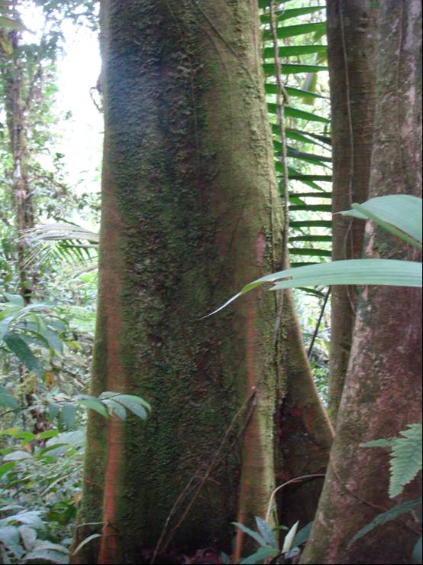
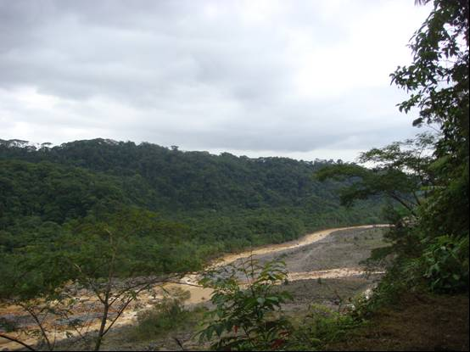
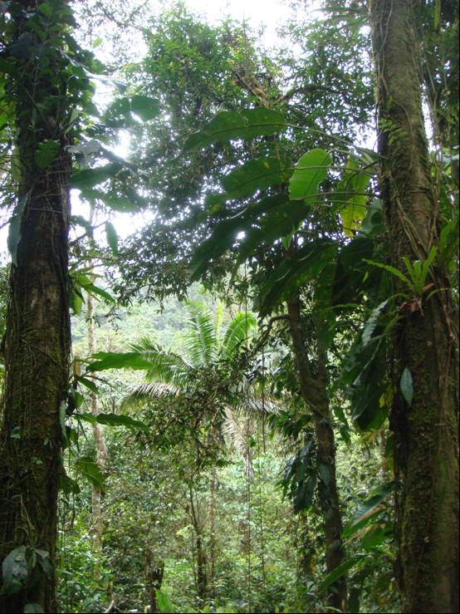
Braulio Carrillo National Park, Costa Rica © Sue Stolton

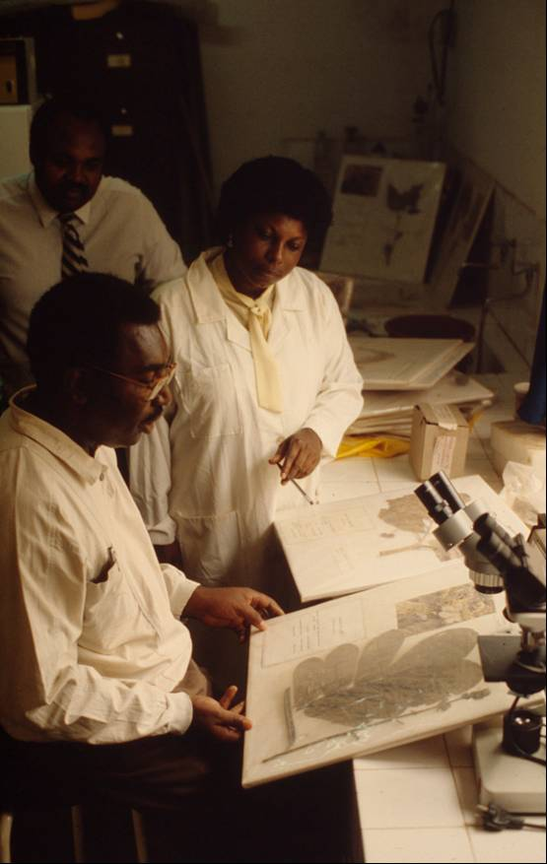
Doctors working on medicines derived from wild plants in Yaoundé University, Cameroon. An ethnobotanical survey was conducted in March 2000 at five markets in Yaoundé city. A total of 35 medicinal plants were obtained from 18 sellers at the Yaoundé markets in March 2000. The plant species comprised 35 genera and 19 families. Malaria, lumbago, and male sexual impotence appear to be the prevailing diseases in terms of the number of references made by these sellers (reference: Jean L. BETTI (2002); Medicinal plants sold in Yaoundé markets, Cameroon, African Study Monographs, 23(2): 47-64).

© Mauri Rautkari / WWF-Canon

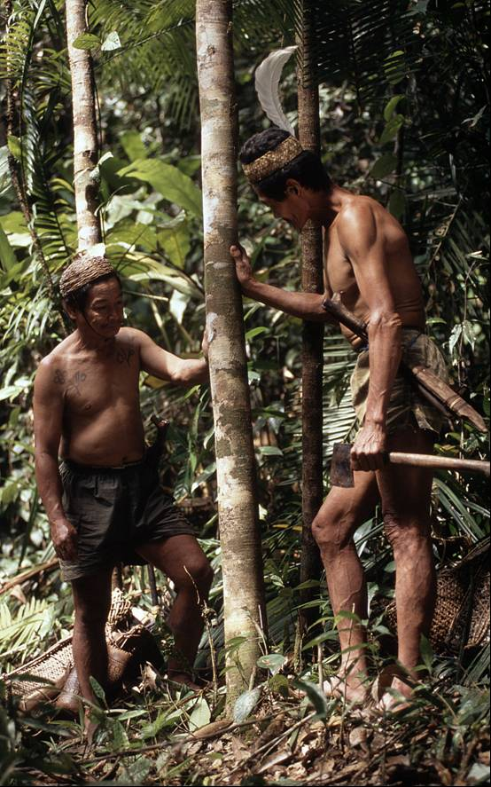
Extracting Gaharu (or Aloewood), Aquilaria sp. in Kayan Mentarang National Park, Eastern Kalimantan (Borneo), Indonesia. Despite the lightness of wood, it is called the "sinking wood". What makes it heavy is due to the permeated highly prized resin or agarwood in the heartwood. There is rarity of this resource in the wild and it is now labelled a "vulnerable" species by the IUCN. It is principally traded as raw materials used in the production of incense, perfume, and medicine.

© Alain Compost / WWF-Canon

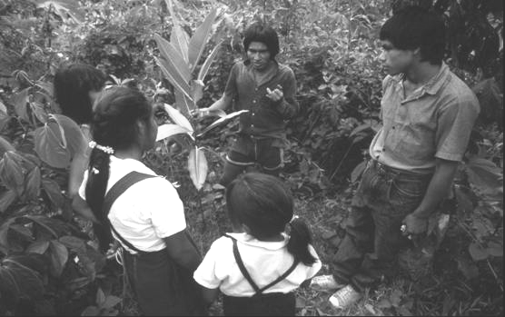
Alberto Mancariapa, of the Huachipaeri Indian Community, living on the southeastern border of Manu National Park, Peru explains effects and use of medicinal plants such as Dr. Ojé fig tree (Ficus insipida, Moraceae family) to school children and their teacher. The latex of big tree is taken internally as highly effective cure for intestinal parasites.

© André Bärtschi / WWF-Canon

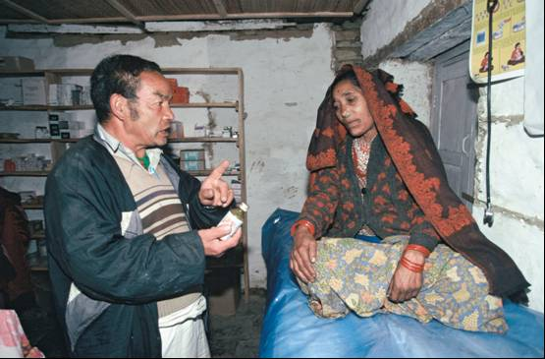
Local doctor prescribing traditional medicine to a patient in the Annapurna Conservation Area, Nepal

© Michel Gunther / WWF-Canon

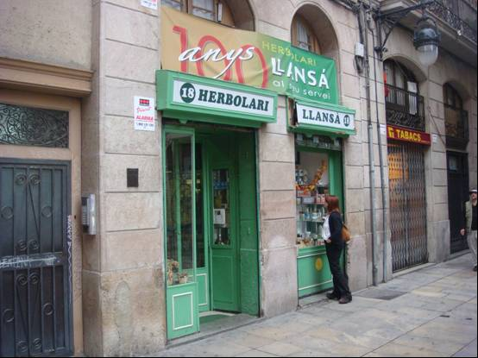
A herbal medicine shop in Barcelona, Spain. In 2003, European countries spent almost ^{US}$5 billion (at manufacturers' prices to wholesalers) on over-the-counter herbal medicines (if this needs a ref – see: http://content.nejm.org/cgi/content/extract/352/12/1176).

© Sue Stolton

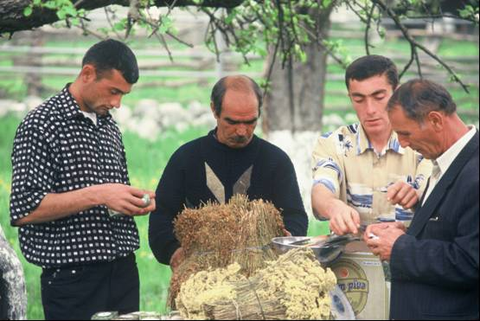
Production of herbs and medicinal plants for the local market by the village community of Topchu, in the buffer zone of the Ismailly Nature Reserve, Azerbaijan. The project was supported by a WWF Project on conservation and sustainable use of medicinal plants.

© Hartmut Jungius / WWF-Canon

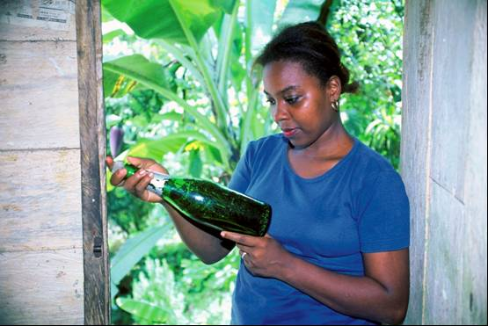
Through traditional medicine, the knowledge of medicine preparation is preserved as a capacity building process for the communities of the Chocó Biogeographic Rainforest in Colombia.

© Diego M. Garces / WWF-Canon

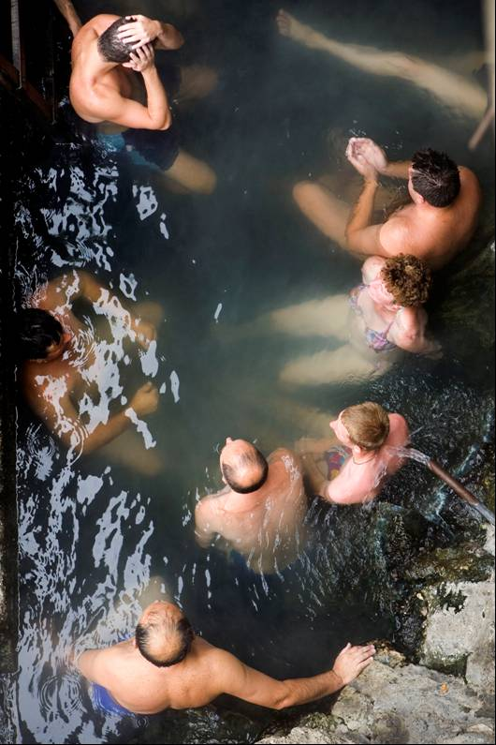
People undergoing a water cure in the thermal baths of Domogled National Park, Romania.

© Michel Gunther / WWF-Canon

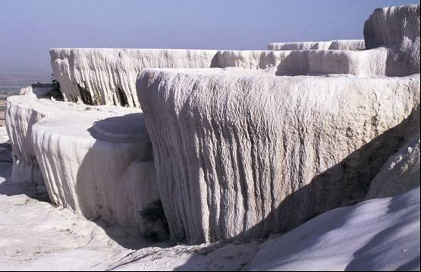
The petrified springs at Pamukkale Protected Area, Denizli Province, Turkey

© Michel Gunther / WWF-Canon

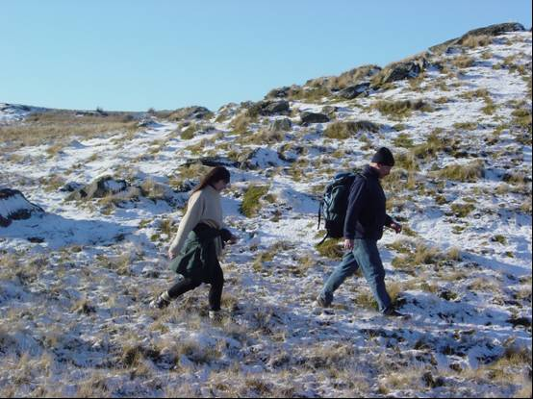
Walking is a popular pursuit in many national parks in the UK

© Nigel Dudley

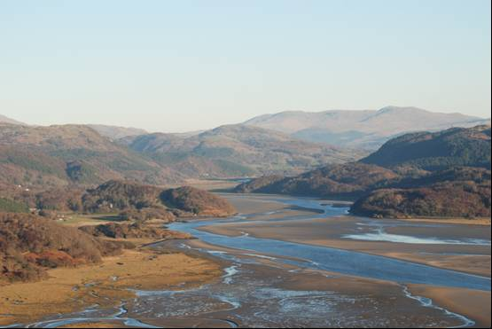
The Mawddach Estuary, Snowdonia National Park, Wales, runs voice trails for blind and visually impaired people. The trails are led by trained volunteers, from the National Park Authority or the Countryside Council for Wales, using radio mikes to provide a live commentary of the walk so participants can ‘listen’ to the view, hear about the local flora and wildlife and learn about local history.

© Sue Stolton

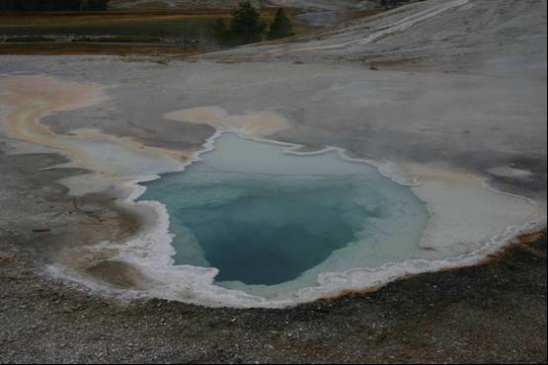
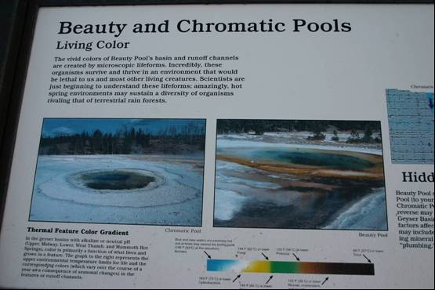
The geothermal features at Yellowstone National Park, USA © Roger Crofts

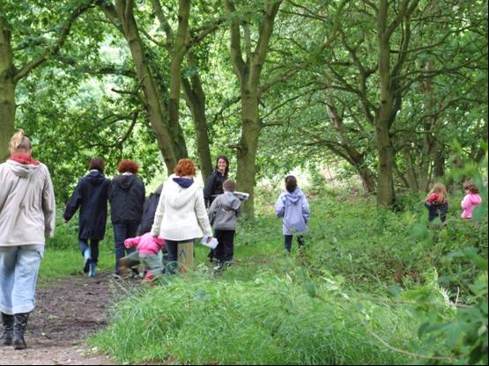
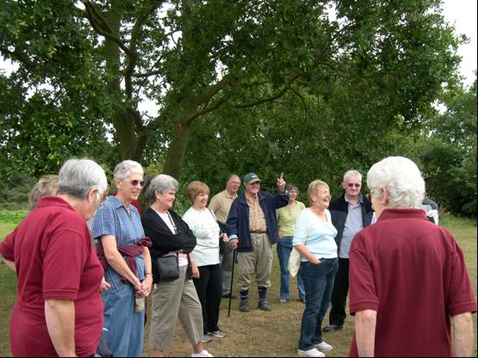
Tiptree Heath, Essex: An Art walk as part of the summer 'Going Ratty' day about small mammals for younger generation (left © Cheryl Pinch) and health walks for the more mature (right © Jenni Jordan)

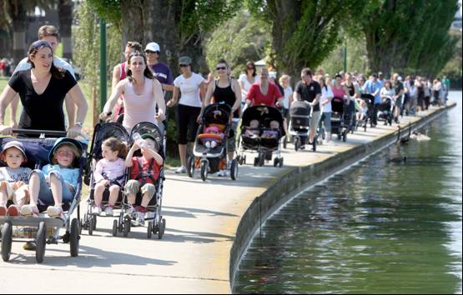
The great pram stroll, Melbourne, Victoria

© Parks Victoria


Ranger Roo (whose adventures can be viewed at: www.rangerroo.com.au/) is a creation of Parks Victoria aimed at inspiring primary school children to learn about and visit Park Victoria’s network of parks and protected areas.

© Parks Victoria

© Parks Victoria

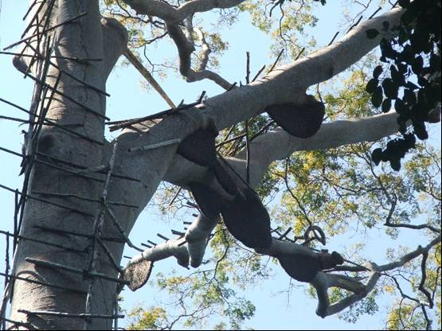
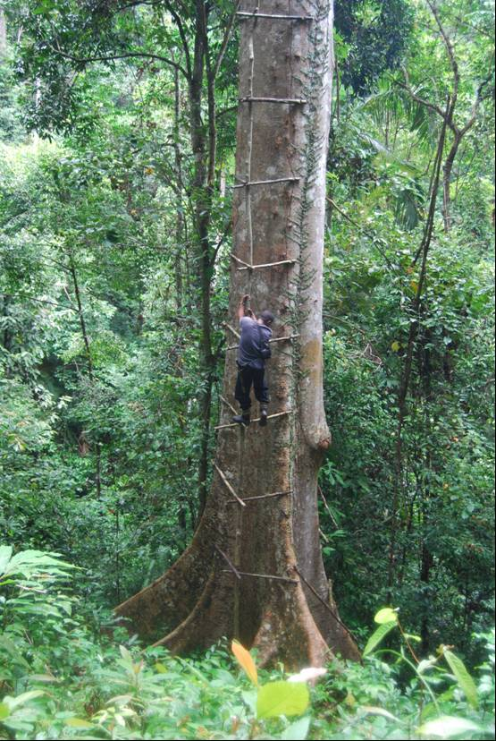
Bee nest in Tualang tree at Ulu Muda (left) © Rohani Rahmani. Honey gatherer climbing the Tualang tree at Ulu Muda (right) © Surin Suksuwan

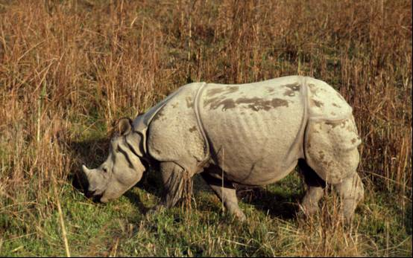
Indian rhinoceros (Rhinoceros unicornis) in Royal Chitwan National Park, Nepal

© Michel Terrettaz / WWF-Canon

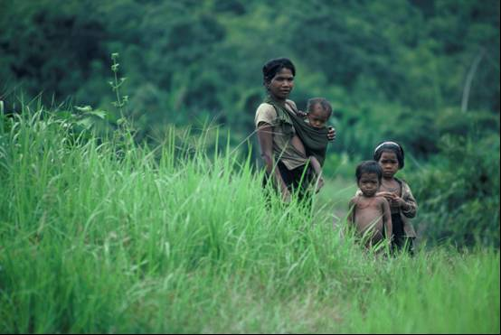
Stieng mother and her children in Cat Tien National Park, Vietnam

© Elizabeth Kemf / WWF-Canon
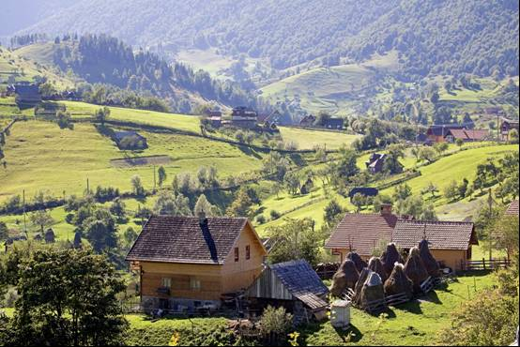
Village of Magura, Piatra Craiului National Park, Transylvania, Romania.

© Michel Gunther / WWF-Canon

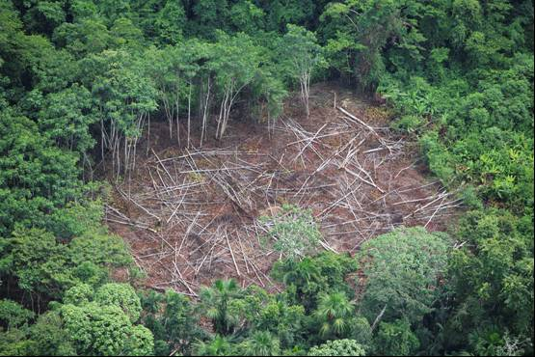
Aerial shot of deforestation in the Amazon, Loreto region, Peru

© Brent Stirton / Getty Images / WWF-UK

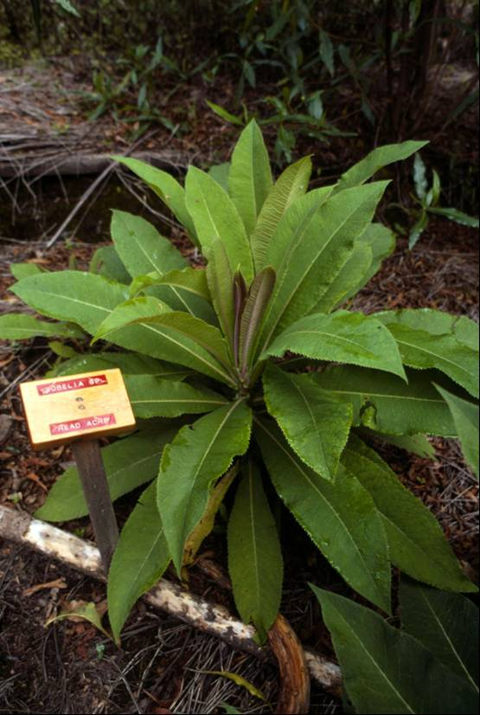
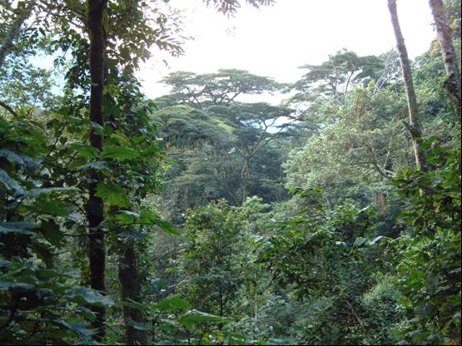
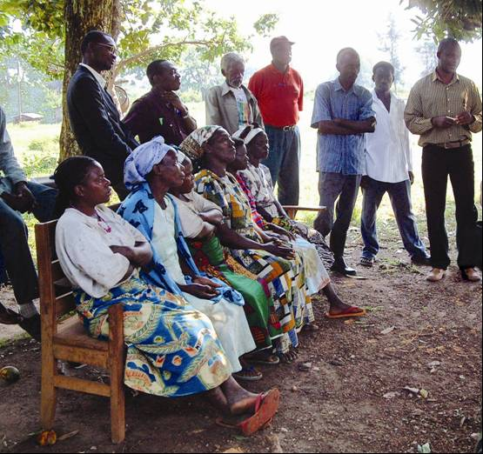
Ethnobotanical garden Ruhija, Bwindi Impenetrable National Park, Uganda (left) © Frederick J. Weyerhaeuser / WWF-Canon. Bwindi forest (middle) and local community (right) © Marc Hockings

Chapter 5
Guidance/Conclusions – rough notes so far

Linking environment and health at the policy level
In 1986, an international conference sponsored by the WHO highlighted the need to bring the health and environment agenda’s together in a more comprehensive approach to health that went far beyond the normal responsibilities of countries traditional health sectors. The ‘Ottawa Charter for Health Promotion’ stated that health had to be on the agenda of all sectors and at all levels. The charter noted the “The inextricable links between people and their environment constitutes the basis for a socioecological approach to health” and that “The conservation of natural resources throughout the world should be emphasized as a global responsibility”.

But such changes of policy take time; and unfortunately health and health care is unevenly distributed across the globe. A sad truth represented by the fact that four of the millennium development goals are directly related to health:
- Goal 1: Eradicate extreme poverty and hunger
- Goal 4: Reduce child mortality
- Goal 5: Improve maternal health
- Goal 6: Combat HIV/AIDS, malaria, and other diseases.
As well as the goals linked to environment. Initiatives such as the Health and Environment Linkages Initiative – HELI, a global effort supported by WHO and UNEP to promote and facilitate action in developing countries to reduce environmental threats to human health by support of sustainable development objectives, can contribute to making these linkages, but there is away to go.

So perhaps it is not surprising that twenty years after the WHO conference a WHO and UNEP Inter-ministerial Conference for Health and Environment in Africa was noting that “For too long, the health and environment sectors have sought to cope with the downstream consequences of poorly conceived economic development policies, while having little influence on the more upstream development decisions that profoundly shape the continent’s natural environment.”. And calling for governments amongst other things to:
- Establish and strengthen national institutes or centres for health and environment, to inter alia assess the risks entailed by economic and development processes and provide advice on the management of such risks.
- Encourage the integration of health and environment objectives with poverty reduction strategies and development plans, including investments related to sectoral economic activities.

As was pointed out by the conference: “Whereas health is generally among the top 4 priority areas in national development strategies, environment remains much lower. As a result of this disparity, any progress made in improving the health of the population is eroded by the impact of environmental-related diseases.”. One suggested mechanism for achieving this is to institute health impact assessments as a basic prerequisite in planning in the same way that environmental impact assessments have now become standard in many sectors. Similarly, in the marine environment, the US Commission on Ocean Policy (2004) stated in its preliminary report that, “Significant investment must be put into developing a coordinated national research effort to better understand the links between the oceans and human health ….”.

But this ‘socioecological approach to health’ is only slowly being articulated in policy. Thus although many protected areas across the world have been set up with the dual aims of conservation and recreation, few have had specific health mandates. There are some exceptions. The case studies from the UK and Australia given above show that policy agenda’s linking health and conservation can provide real benefits for both sectors. There is also a growing recognition of the need to link health and conservation initiatives by some of the conservation NGOs. Conservation projects often partner with communities living in remote areas with high biodiversity in the developing world (see China and # case study). Although conservation is the primary aim of these projects, it clearly makes sense to links with and sometimes work directly on other development issues such as healthcare. Such initiatives are often referred to as PHE (population-health-environment) projects; and WWF has recently developed a manual to provide guidance on integrated health and family planning projects.“Partnerships between healthcare providers and nature organisations to share and exchange expertise could create new policies that recognise the interdependence between healthy people and healthy ecosystems”. These projects have the opportunity to lead the way into bringing the environment and health agenda’s closer together. (check this text against case study to come from Judy)

Recommendations
Although research demonstrates that access to nature helps us stay psychologically, emotionally and spiritually healthy the role protected areas can play in human health, wellbeing and development “has not been fully recognised”. As in other reports for the Arguments for Protection series, the guidance and recommendations provided here are very specific to protected area. Clearly there are many other responses that health professionals can take to reduce disease burdens and increase health and life expectancy. The WHO in its 2002 report Reducing Risks, Promoting Healthy Life, for example, suggests a whole range of responses and policies.

The recommendations are divided into ## (perhaps: policy makers, health professionals, protected area professionals, conservation professionals?)

Policy makers
- Note the wider definition of health
- Linking national health and environmental policies in particular re PAs
- Benefit-sharing re resources
- Ensure values are conserved which are or might provide health benefits
- Compatible and equitable of policies and legislation re access to resources and health benefits of medicinal resources from PAs
- Consider emerging infectious disease when making habitat management decisions

Social and health professionals
- Develop awareness of PA roles
- Further research links between emerging infectious disease and habitat management
- Continue to carry out ethnobotanical studies in PAs to increase understanding of resource use
- Ensure equitable benefit-sharing options from positive research outcomes from PAs
- Ensure that ingredients in medicinal resources are sourced sustainably and where appropriate benefits from the resource used are equitably shared
- Be aware

Protected areas professionals
- Develop health arguments and communication strategies to promote these
- Develop – with partners where possible - health activities and ensure access to these
- Ensure sustainable use of resources
- Minimise risk of adverse health impacts
- Benefit-sharing
- Consider specific habitat management for health impacts
- Consider the values of medicinal knowledge (e.g. sustainable harvesting, cultural traditions, etc) as objectives of protected area management

Conservation professionals
- Raise awareness of health issues across projects
- Develop PHE (population-health-environment) projects
- Help develop monitoring and harvesting protocols for medicinal plant resources
Appendix 1: International Standard for Sustainable Wild Collection of Medicinal and Aromatic Plants (ISSC-MAP) Principles and Criteria

SECTION 1: WILD COLLECTION AND CONSERVATION REQUIREMENTS
Principle 1. Maintaining Wild Medicinal and Aromatic Plants (MAP) Resources
Wild collection of MAP resources shall be conducted at a scale and rate and in a manner that maintains populations and species over the long term.
Criteria 1.1 Conservation status of target MAP species
The conservation status of target MAP species and populations is assessed and regularly reviewed.
Criteria 1.2 Knowledge-based collection practices
MAP collection and management practices are based on adequate identification, inventory, assessment, and monitoring of the target species and collection impacts.
Criteria 1.3 Collection intensity and species regeneration
The rate (intensity and frequency) of MAP collection does not exceed the target species’ ability to regenerate over the long term.

Principle 2. Preventing Negative Environmental Impacts
Negative impacts caused by MAP collection activities on other wild species, the collection area, and neighbouring areas shall be prevented.
Criteria 2.1 Sensitive taxa and habitats
Rare, threatened, and endangered species and habitats that are likely to be affected by MAP collection and management are identified and protected.
Criteria 2.2 Habitat (landscape level) management
Management activities supporting wild MAP collection do not adversely affect ecosystem diversity, processes, and functions.

SECTION II: LEGAL AND ETHICAL REQUIREMENTS
Principle 3. Complying with Laws, Regulations, and Agreements
MAP collection and management activities shall be carried out under legitimate tenure arrangements, and comply with relevant laws, regulations, and agreements.
Criteria 3.1 Tenure, management authority, and use rights
Collectors and managers have a clear and recognized right and authority to use and manage the target MAP resources.
Criteria 3.2 Laws, regulations, and administrative requirements
Collection and management of MAP resources complies with all international agreements and with national, and local laws, regulations, and administrative requirements, including those related to protected species and areas.

Principle 4. Respecting Customary Rights
Local communities’ and indigenous peoples’ customary rights to use and manage collection areas and wild collected MAP resources shall be recognized and respected.
Criteria 4.1 Traditional use, access rights, and cultural heritage
Local communities and indigenous people with legal or customary tenure or use rights maintain control, to the extent necessary to protect their rights or resources, over MAP collection operations.
Criteria 4.2 Benefit sharing
Agreements with local communities and indigenous people are based on appropriate and adequate knowledge of MAP resource tenure, management requirements, and resource value.

SECTION III: MANAGEMENT AND BUSINESS REQUIREMENTS
Principle 5. Applying Responsible Management Practices
Wild collection of MAP species shall be based on adaptive, practical, participatory, and transparent management practices.
Criteria 5.1 Species / area management plan
A species / area management plan defines adaptive, practical management processes and good collection practices.
Criteria 5.2 Inventory, assessment, and monitoring
Management of MAP wild collection is supported by adequate and practical resource inventory, assessment, and monitoring of collection impacts.
Criteria 5.3 Transparency and participation
MAP collection activities are carried out in a transparent manner with respect to management planning and implementation, recording and sharing information, and involving stakeholders.
Criteria 5.4 Documentation
Procedures for collecting, managing, and sharing information required for effective collection management are established and carried out.

Principle 6. Applying Responsible Business Practices
Wild collection of wild MAP resources shall be undertaken to support quality, financial, and labour requirements of the market without sacrificing sustainability of the resource.
Criteria 6.1 Market / buyer specifications
The sustainable collection and handling of MAP resources is managed and planned according to market requirements in order to prevent or minimise the collection of products unlikely to be sold.
Criteria 6.2 Traceability
Storage and handling of MAP resources is managed to support traceability to collection area.
Criteria 6.3 Financial viability
Mechanisms are encouraged to ensure the financial viability of systems of sustainable wild collection of MAP resources.
Criteria 6.4 Training and capacity building
Resource managers and collectors have adequate skills (training, supervision, experience) to implement the provisions of the management plan, and to comply with the requirements of this standard.
Criteria 6.5 Worker safety and compensation
MAP collection management provides adequate work-related health, safety, and financial compensation to collectors and other workers

References (to be edited)

For more information on the Arguments for Protection project and to download the reports referred to here visit: www.panda.org/protection/arguments
An infectious disease whose incidence has increased in the past 20 years and threatens to increase in the near future
See for example www.abs-africa.info/bioprospecting_cases.html which provides details of cases of bioprospecting in Africa
The CBD also maintains a database of legislation on access and benefits sharing at: www.cbd.int/abs/intro.shtml
An infectious disease whose incidence has increased in the past 20 years and threatens to increase in the near future
This case study has been written by John Senior, Manager Strategic Partnerships, Parks Victoria
See www.healthyparkshealthypeoplecongress.org
This case study has been written by Sue Stolton with the assistance of Natural England staff Dr William Bird, Strategic Health Advisor, Moira Halstead; Lynda Foster, Health and the Natural Environment/WHI; and Joan Pinch of Tiptree Parish Council, Essex.
http://www.cvni.org/greengym/
http://www.forestry.gov.uk/forestry/INFD-6ACE8M
http://www.whi.org.uk/
This case study has been written by Siti Zuraidah Abidin, WWF-Malaysia
This case study was written by Sue Stolton with much appreciated input from Kathy Sheehan, Molecular, Cellular, and Developmental Biology Dept., University of Colorado-Boulder and from Tom Oliff, Chief of Yellowstone's Center for Resources, Lindsay Mclelland, National Park Service Geologist and Jonathan Putnam, Office of International Affairs, National Park Service
“Risk” is defined in this context as “a probability of an adverse outcome, or a factor that raises this probability”
This table is based on Annex Table 11 of the Reducing Risks, Promoting Healthy Life report
There is no internationally agreed definition or measure of physical activity
More information on the ISSC-MAP can be found at: data.iucn.org/themes/ssc/sgs/mpsg/main/issc_map.html
See for example Goldacre, B (2008); Bad Science, Fourth Estate, London
Ulrich, R S and R Parsons (1992); Influences of passive experiences with plants on individual well-being and health, in Relf, D. (ed) The Role of Horticulture in Human Well-being and Social Development, Timber Press, Portland, Oregon
Preamble to the Constitution of the World Health Organization as adopted by the International Health Conference, New York, 19-22 June, 1946; signed on 22 July 1946 by the representatives of 61 States (Official Records of the World Health Organization, no. 2, p. 100) and entered into force on 7 April 1948.
Maller, C, M Townsend and P Brown (2002); Healthy Parks Healthy People. The Health Benefits of Contact with Nature in a Park Context: A Review of Current Literature, Deakin University and Parks Victoria, Melbourne, Australia
Dudley, N, S Mansourian, S Stolton and S Suksuwan (2008); Safety Net: Protected areas and poverty reduction, WWF, Gland
Dudley, N and S Stolton (2003); Running Pure: The importance of forest protected areas to drinking water, WWF, Gland
Dudley, N, L Higgins-Zogib and S Mansourian (2005); Beyond Belief: Linking faiths and protected areas to support biodiversity conservation, WWF, Gland
Stolton, S, N Dudley and J Randall (2008) Natural Security: Protected areas and hazard mitigation, WWF, Gland
Hamilton, A, K Dürbeck and A Lawrence (2006); Towards a Sustainable Herbal Harvest: A Work in Hand, Plant Talk, 43: January 2006
Farnsworth, N R and D D Soejarto (1988); Global Importance of Medicinal Plants, The Conservation of Medicinal Plants, Proceedings of an International Consultation, Chiang Mai, Thailand, Cambridge University Press.
Prüss-Üstün A and C Corvalán (2006); Preventing disease through healthy environments – Towards an estimate of the environmental burden of disease, WHO, Geneva, Switzerland
Epstein P R and E Mills (eds) (2005); Climate Change Futures: Health, Ecological and Economic Dimensions, Harvard Medical School, USA
Wilcox, B A and B Ellis (2006); Forests and emerging infectious diseases of humans, Unasylva, 57:224
Bell, D, S Robertson and P R Hunter (2004); Animal origins of SARS coronavirus: possible links with the international trade in small carnivores, Philosophical Transactions of the Royal Society London, 359:1107-14.
World Health Organisation (2005); Ecosystems and Human Well-being: Health Synthesis, WHO, Geneva, Switzerland
Walsh J F, D H Molyneux and M H Birley (1993); Deforestation: effects on vector-borne disease, Parasitology,106
Morse, S S (1995); Factors in the emergence of infectious diseases, Emerging Infectious Diseases, 1:1
Wilcox, B A and B Ellis (2006); Forests and emerging infectious diseases of humans, Unasylva, 57:224
Anon (2008); Health Impact Assessment, IMCHE/1/CP8, Inter-ministerial Conference for Health and Environment in Africa, Libreville, Gabon, from 26–29 August 2008, WHO and UNEP
Sandifer, P A, A F Holland, T K Rowles and G I Scott (2004);The Oceans and Human Health, Environmental Health Perspectives, 112:8
McMichael, A J (2002); Population, environment, disease, and survival: past patterns, uncertain futures, The Lancet, 359
Patz, J (2002); A human disease indicator for the effects of recent global climate change, Proceedings of the National Academy of Sciences 99: 12506–12508
Alves, R R N and L M L Rosa (2007); Biodiversity, traditional medicine and public health: where do they meet? Journal of Ethnobiology and Ethnomedicine, 3:14
Chivian, E and A Bernstein (2008); Sustaining life: How human health depends on biodiversity, Oxford University Press, New York
Donia, M and M T Hamann (2003); Marine natural products and their potential applications as anti-infective agents, The Lancet Infectious Diseases; 3:338-348 and Sandifer, P, C Sotka, D Garrison and V Fay (2007); Interagency Oceans and Human Health Research Implementation Plan: A Prescription for the Future, Interagency Working Group on Harmful Algal Blooms, Hypoxia, and Human Health of the Joint Subcommittee on Ocean Science and Technology, Washington, DC
Tibbetts, J (2004); The state of the oceans, part 2: delving deeper into the sea's bounty, Environmental Health Perspectives, 112:8
Alves, R R N and L M L Rosa (2007); Biodiversity, traditional medicine and public health: where do they meet? Journal of Ethnobiology and Ethnomedicine, 3:14
Pierce Colfer, C J, D Sheil and M Kishi (2006); Forests and human health: assessing the evidence, CIFOR Occasional Paper; No. 45, Center for International Forestry Research, Bogor, Indonesia
Zakrzewski, P A (2002); Bioprospecting or Biopiracy? The Pharmaceutical Industry’s Use of Indigenous Medicinal Plants as a Source of Potential Drug Candidates, University of Toronto Medical Journal, 79:3
Shanley, P and L Leda (2003); Degradation on Medicinal Plant Use and Implications for Health Care in Eastern Amazonia; BioScience, 53:6
Schllthulzen, M (2006); Biodiscoveries, Borneo's Botanical Secret, WWF-Indonesia, Jakarta
http://www.forestry.sarawak.gov.my/forweb/research/fr/ip/eco/calophys.htm (accessed 2/1//08)
Young, B E, S N Stuart, J S Chanson, N A Cox and T M Boucher (2004); Disappearing Jewels: The Status of New World Amphibians, NatureServe, Arlington, Virginia
Hamilton, A (2003); Medicinal Plants and Conservation: Issues and Approaches, WWF UK and Press Release from TRAFFIC, Bonn, Germany, 19 May 2008, downloaded at: http://www.traffic.org/home/2008/5/19/therapy-for-medicinal-plants.html (accessed 5/11/08)
Cunningham, A B, P Shanley and S Laird (2008); Health, Habitats and Medicinal Plant Use, in Colfer, C.J.P. (ed.), Human health and forests: a global overview of issues, practice and policy, Earthscan, London
Montenegro, R A and C Stephens (2006); Indigenous health in Latin America and the Caribbean, The Lancet, 367:3
Stephens, C, J Porter, C Nettleton and R Willis (2006); Disappearing, displaced, and undervalued: a call to action for Indigenous health worldwide, The Lancet, 367:17
Stephens, C, J Porter, C Nettleton and R Willis (2006); Disappearing, displaced, and undervalued: a call to action for Indigenous health worldwide, The Lancet, 367:17
Montenegro, R A and C Stephens (2006); Indigenous health in Latin America and the Caribbean, The Lancet, 367:3
Voeks, R A and A Leony (2005); Forgetting the Forest: Assessing Medicinal Plant Erosion in Eastern Brazil, Economic Botany, 58:1
Devi Khumbongmayum, A., K. M. L. Ashalata and R. Tripathi. 2004. Sacred groves of Manipur, northeast India:biodiversity value, status and strategies for their conservation, Biodiversity and Conservation 14: 1541-1582; Devi Khumbongmayum A.D., Khan M.L. and Tripathi R.S. 2005. Biodiversity conservation in sacred groves of Manipur, northeast India: population structure and regeneration status of woody species. Biodiversity and Conservation 15: 2439–2456
Huabin, Hu. 2003. Sacred Natural Sites in Xishuangbanna, in South-Western China. In: The Importance of Sacred Natural Sites for Biodiversity Conservation. Proceedings of the International Workshop held in Kumming and Xishuangbanna Biosphere Reserve, People’s Republic of China, 17-20 February 2003. UNESCO, Paris, France
Pei, S.J. and P. Luo. 2000. Traditional culture and biodiversity conservation in Yunnan. In: J.C. Xu (ed.): Links between cultures and biodiversity: proceedings of the Cultures and Biodiversity Congress 2000, 20-30 July, Yunnan, China. Yunnan Sciences and Technology Press, Kunming, China
Huijun, G., C. Padoch, K. Coffey, C. Aiguo, F. Yongneng. 2002. Economic development, land use and biodiversity change in the tropical mountains of Xishuangbanna, Yunnan, Southwest China. Environmental Science & Policy 5: 471–479
Dudley, N (Editor) (2008); Guidelines for Applying Protected Area Management Categories. Gland, Switzerland
http://www.who.int/malaria/mediacentre/wmr2008/WMR08-news-findings.pdf (accessed 9/12/08)
Chivian, E and A Bernstein (2008); Sustaining life: How human health depends on biodiversity, Oxford University Press, New York
Vittor, A Y, R H Gilman, J Tielsch, G Glass, T Shields, W S Lozano, V Pinedo-Cancino and J A Patz. (2006); The effect of deforestation on the human-biting rate of Anopheles darling, the primary vector of falciparum malaria in the Peruvian Amazon. Am. J. Trop. Med. Hyg., 74(1):3-11
Oglethorpe, J, C Honzak and C Margoluis (2008); Healthy people, healthy ecosystems: A manual for integrating health and family planning into conservation projects. World Wildlife Fund,Washington, D.C.
Hoekstra, J M, T M Boucher, T H Ricketts and C Roberts (2005); Confronting a biome crisis: global disparities of habitat loss and protection, Ecology Letters, 8: 23–29
Reference the CBD brochure on benefits launched in Rome and Pattanayak, S K, C G Corey, Y F Lau and R A Kramer (2003); Forest malaria: A microeconomic study of forest protection and child malaria in Flores, Indonesia, Duke University, USA, available at: http://www.env.duke.edu/solutions/documents/forest-malaria.pdf (accessed 17/7/08)
Anon (2006); Forestry and malaria control in Italy, Unasylva, 57:224
http://www.unep-wcmc.org/wdpa/sitedetails.cfm?siteid=5900&level=nat (accessed 17/7/08)
Pierce Colfer, C J, D Sheil and M Kishi (2006); Forests and human health: assessing the evidence, CIFOR Occasional Paper No. 45, Bogor, Indonesia
mpcn.frlht.org.in/index.htm (accessed 24/11/08)
Hariramamurthi, G (2000); The Genesis of the Medicinal Plants Conservation Network (MPCN), Roots, 1:20
Dudley, N and S Stolton (2003); op cit
UN Habitat (2003); Water and Sanitation in the World’s Cities: Local action for global goals, Earthscan, London
Stolton, S, N Dudley and J Randall (2008); op cit
Roberts, C M and J P Hawkins (2000); Fully Protected Marine Reserves: A guide, WWF Endangered Seas Campaign, Washington DC
Stolton S. N Maxted, B Ford-Lloyd et al (2006); op cit
Dudley, N, S Mansourian, S Stolton et al (2008); op cit
Tilburt, J C and T J Kaptchuk (2008); Herbal medicine research and global health: an ethical analysis, Bulletin of the World Health Organization, Volume 86, 8: 577-656
World Health Organisation (2002); WHO Traditional Medicine Strategy 2002-2005, WHO, Geneva, Switzerland
World Health Organisation (2002); WHO Traditional Medicine Strategy 2002-2005, WHO, Geneva, Switzerland
Farnsworth, N R and D D Soejarto (1988); Global Importance of Medicinal Plants, The Conservation of Medicinal Plants, Proceedings of an International Consultation, Chiang Mai, Thailand, Cambridge University Press.
Hawkins, B (2008); Plants for life: Medicinal plant conservation and botanic gardens, Botanic Gardens Conservation International, Richmond, U.K.
Kunwar, R M, B K Nepal, H B Kshhetri, S K Rai and R W Bussmann (2006); Ethnomedicine in Himalaya: a case study from Dolpa, Humla, Jumla and Mustang districts of Nepal, Journal of Ethnobiology and Ethnomedicine, 2
Alves, R R N and L M L Rosa (2007); Biodiversity, traditional medicine and public health: where do they meet? Journal of Ethnobiology and Ethnomedicine, 3:14; J. Muriuki (2006); Forests as pharmacopoeia: identifying new plant-based treatments for malaria, Unasylva, 57:224
http://www.unep-wcmc.org/wdpa/sitedetails.cfm?siteid=2099&level=int (accessed 28/7/08)
Bonet, M A and J Vallès (2007); Ethnobotany of Montseny biosphere reserve (Catalonia, Iberian Peninsula): Plants used in veterinary medicine, Journal of Ethnopharmacology, 110:1
http://www.unep-wcmc.org/wdpa/sitedetails.cfm?siteid=1340&level=nat (accessed 28/7/08)
Novais, M H, L Santos, S Mendes and C Pinto-Gomesa (2004);Studies on pharmaceutical ethnobotany in Arrabida Natural Park (Portugal), Journal of Ethnopharmacology, 93: 2-3
http://www.unep-wcmc.org/wdpa/sitedetails.cfm?siteid=20673&level=nat (accessed 28/7/08)
Camejo-Rodrigues, J, L Ascensão, M Àngels Bonet and J Vallès (2003); An ethnobotanical study of medicinal and aromatic plants in the Natural Park of “Serra de São Mamede” (Portugal), Journal of Ethnopharmacology, 89: 2-3
http://www.unep-wcmc.org/wdpa/sitedetails.cfm?siteid=63637&level=nat (accessed 28/7/08)
Scherrera, A M, R Mottib and C S Weckerlec (2005); Traditional plant use in the areas of Monte Vesole and Ascea, Cilento National Park (Campania, Southern Italy), Journal of Ethnopharmacology, 97:1
http://www.unep-wcmc.org/wdpa/sitedetails.cfm?siteid=63052&level=nat (accessed 28/7/08)
Leporatti, M L and M Impieri (2007); Ethnobotanical notes about some uses of medicinal plants in Alto Tirreno Cosentino area (Calabria, Southern Italy), J Ethnobiol Ethnomed, 3:34
http://www.unep-wcmc.org/wdpa/sitedetails.cfm?siteid=15598&level=nat (accessed 28/7/08)
Jarić, S, Z Popović, M Mačukanović-Jocić, L Djurdjević, M Mijatović, B Karadžić, M Mitrović and P Pavlović (2007); An ethnobotanical study on the usage of wild medicinal herbs from Kopaonik Mountain (Central Serbia), Journal of Ethnopharmacology, 111:1
Pop, O (2004); The importance of ethnobotanical survey and medicinal plant collection monitoring for biodiversity conservation in Piatra Craiului National Park (Romania), Medicinal Plant Conservation, 9/10, BfN, Germany
http://www.unep-wcmc.org/wdpa/sitedetails.cfm?siteid=92541&level=nat and http://www.unep-wcmc.org/wdpa/sitedetails.cfm?siteid=2489&level=nat (accessed 28/7/08)
Vokou, D, K Katradi and S Kokkini (1993); Ethnobotanical survey of Zagori (Epirus, Greece), a renowned centre of folk medicine in the past, Journal of Ethnopharmacology, 39:3
http://www.unep-wcmc.org/wdpa/sitedetails.cfm?siteid=837&level=nat (accessed 28/7/08)
http://www.unep-wcmc.org/wdpa/sitedetails.cfm?siteid=21415&level=nat (accessed 28/7/08)
Gilani, S A, R Aleem Qureshi and S Javaria Gilani (2006); Indigenous Uses of Some Important Ethnomedicinal Herbs of Ayubia National Park, Abbottabad, Pakistan, Ethnobotanical Leaflets, 10
http://www.unep-wcmc.org/wdpa/sitedetails.cfm?siteid=12420&level=nat (accessed 28/7/08)
Srivastava, S K and K C Sekar (2004); Ethnomedicine of the Pin Valley National Park, Himachal Pradesh: plants used in treating dysentery, Ethnobotany, 16:1/2
http://www.unep-wcmc.org/wdpa/sitedetails.cfm?siteid=9229&level=nat (accessed 28/7/08)
Kala, C P (2003); An ethnobotanical survey of the propagation of rare medicinal herbs by small farmers in the buffer zone of the Valley of Flowers National Park, Chamoli, Garhwal Himalaya, India, in Aumeeruddy-Thomas, Y. and Pei Shengji (eds) Applied Ethnobotany: casestudies from the Himalayan region. People and Plants working paper 12. WWF, Godalming, UK
http://www.unep-wcmc.org/wdpa/sitedetails.cfm?siteid=26293&level=nat (accessed 28/7/08)
Koche, D K, R P Shirsat, S Imran, M Nafees, A K Zingare and K A Donode (2008); Ethnomedicinal Survey of Nagzira Wild Life Sanctuary, District Gondia (M.S.) India- Part II, Ethnobotanical Leaflets, 12
http://www.unep-wcmc.org/wdpa/sitedetails.cfm?siteid=308543&level=nat (accessed 28/7/08)
Singh, S (2007); Floristic Diversity of Betla National Park, Palamau District, Jharkhand - An Overview, Journal of Economic and Taxonomic Botany, 31:2
http://www.unep-wcmc.org/wdpa/sitedetails.cfm?siteid=1808&level=nat (accessed 28/7/08)
Mahawar, M M and D P Jaroli (2006); Animals and their products utilized as medicines by the inhabitants surrounding the Ranthambhore National Park, India, Journal of Ethnobiology and Ethnomedicine, 2:46
http://www.unep-wcmc.org/wdpa/sitedetails.cfm?siteid=1251&level=nat (accessed 28/7/08)
Elliott, S and J Brimacombe (1987); The medicinal plants of Gunung Leuser National Park, Indonesia, Journal of Ethnopharmacology, 9:3
http://www.unep-wcmc.org/wdpa/sitedetails.cfm?siteid=7952&level=nat (accessed 28/7/08)
Kunwar, R M, B K Nepal, H B Kshhetri, S K Rai and R W Bussmann (2006); Ethnomedicine in Himalaya: a case study from Dolpa, Humla, Jumla and Mustang districts of Nepal, Journal of Ethnobiology and Ethnomedicine, 2
Shrestha, I and K Shrestha (2008); Medicinal and aromatic plants in Langtang National Park, in Water Towers of Asia: Experiences in wetland conservation in Nepal, edited by B B Bhandari, S O Suh and S H Woo, IUCN Nepal and Gyeongnam Ramsar Environmental Foundation, South Korea: 92-103
Taylor, C E and K M Wong (1987); Some aspects of herbal medicine among the Orang Hulu community of Kampung Peta, Johore, Malaysia, Malayan Nature Journal, 41:317-328
Davis, S E, V H Heywood and A C Hamilton (eds) (1995); Centres of Plant Diversity: A Guide and Strategy for their Conservation. Volume 2: Asia, Australasia and the Pacific, IUCN, Cambridge
Ngoc Van, N D and N Tap (2008); An overview of the use of plants and animals in traditional medicine systems in Vietnam, TRAFFIC Southeast Asia, Greater Mekong Programme, Hanoi, Vietnam
Davis, S E, V H Heywood and A C Hamilton (eds) (1995); Centres of Plant Diversity: A Guide and Strategy for their Conservation. Volume 2: Asia, Australasia and the Pacific, IUCN, Cambridge
http://www.unep-wcmc.org/wdpa/sitedetails.cfm?siteid=2281&level=nat (accessed 28/7/08)
Yineger, H, E Kelbessa, T Bekele and E Lulekal (2008); Plants used in traditional management of human ailments at Bale Mountains National Park, Southeastern Ethiopia, Journal of Medicinal Plants Research, 2:6
http://www.wdpa.org/SiteSheet.aspx?sitecode=30 (accessed 6/11/08)
Vandebroek, I, J-B Calewaert; S De jonckheere; S SancaI; L Semo; P Van Damme; L Van Puyvelde and N De Kimpe (2004); Use of medicinal plants and pharmaceuticals by indigenous communities in the Bolivian Andes and Amazon, Bull World Health Organ, 82:4
http://www.unep-wcmc.org/wdpa/sitedetails.cfm?siteid=5394&level=nat (accessed 28/7/08)
Estrada, E, J A Villarreal, C Cantú, I Cabral, L Scott and C Yen (2007); Ethnobotany in the Cumbres de Monterrey National Park, Nuevo León, México, Journal of Ethnobiology and Ethnomedicine, 3:8
Cunningham, A B (1993); African Medicinal Plants: Setting Priorities at the Interface between Conservation and Primary Healthcare. People and Plants Working Paper 1. UNESCO, Paris.
http://www.who.int/mediacentre/factsheets/fs134/en/ (accessed 21/7/08)
CBD (1992); Convention on Biological Diversity. www.biodiv.org.
Hamilton, A (2005); Resource assessment for sustainable harvesting of medicinal plants, paper presented at a side-event at the International Botanical Congress (Vienna) on Source to Shelf: Sustainable Supply Chain Management of Medicinal and Aromatic Plants, organized (21-22 July 2005)
Wild, R G and J Mutebi (1996); Conservation Through Community Use of Plant Resources: Establishoing collaborative management at Bwindi Impenetrable and Mgahinga Gorilla National Parks, Uganda, People and Plants Working Paper number 5, UNESCO, WWF and Kew Botanic Gardens, Paris
Cunningham, A B (1996); People, Park and Plant Use: Recommendations for multiple-use zones and development alternatives around Bwindi Impenetrable National Park, Uganda, People and Plants Working Paper number 4, UNESCO, WWF and Kew Botanic Gardens, Paris
Hockings, M, S Stolton, N Dudley, R James, V Mathur, J Courrau, J Makombo and J Parrish (2008); Enhancing our Heritage Toolkit Assessing management effectiveness of natural World Heritage sites, UNESCO, Paris
Tilburt, J C and T J Kaptchuk (2008); Herbal medicine research and global health: an ethical analysis, Bulletin of the World Health Organization, Volume 86, 8: 577-656
Grocott, M (2008); Caudwell Xtreme Everest: understanding hypoxia in the critically ill; Bulletin of The Royal College of Anaesthetists, 47 and news.bbc.co.uk/1/hi/health/7003498.stm (accessed 10/11/08)
Liou, C and R Wasser Eds. (2008); The State of Wildlife Trade in China, TRAFFIC East Asia China Programme.
Zollman, C and A Vickers (1999); ABC of complementary medicine. What is complementary medicine? BMJ, 1319:693-696
World Health Organisation (2002); WHO Traditional Medicine Strategy 2002-2005, WHO, Geneva, Switzerland
Cunningham, A B, P Shanley and S Laird (2008); Health, Habitats and Medicinal Plant Use, in Colfer, C.J.P. (ed.), Human health and forests: a global overview of issues, practice and policy, Earthscan, London
Medicinal Plant Specialist Group (2007); International Standard for Sustainable Wild Collection of Medicinal and Aromatic Plants (ISSC-MAP). Version 1.0, Bundesamt für Naturschutz (BfN), MPSG/SSC/IUCN, WWF Germany, and TRAFFIC, Bonn, Gland, Frankfurt, and Cambridge
TRAFFIC (1998); Europe's medicinal and aromatic plants: Their use, trade and conservation: A Species in Danger Report, Cambridge, UK
Medicinal Plant Specialist Group (2007); International Standard for Sustainable Wild Collection of Medicinal and Aromatic Plants (ISSC-MAP). Version 1.0, Bundesamt für Naturschutz (BfN), MPSG/SSC/IUCN, WWF Germany, and TRAFFIC, Bonn, Gland, Frankfurt, and Cambridge
Evans, T, R Jong Sam and W Duckworth (2004); Management priorities amongst the harvested medicinal plants of Myohyang Mountains Protected Area, DPR Korea, Medicinal Plant Conservation, 9/10, BfN, Germany
Kathe, W and S Honnef (2004); Sustainable use of medicinal and aromatic plants for financial support of protected areas in southeast Europe, Medicinal Plant Conservation, 9/10, BfN, Germany
Schopp-Guth, A and W Fremuth (2001); Sustainable use of medicinal plants and nature conservation in the Prespa National Park area, Albania, Medicinal Plant Conservation, 7, BfN, Germany
Kunwar, R M, B K Nepal, H B Kshhetri, S K Rai and R W Bussmann (2006); Ethnomedicine in Himalaya: a case study from Dolpa, Humla, Jumla and Mustang districts of Nepal, Journal of Ethnobiology and Ethnomedicine, 2
Aumeeruddy-Thomas, Y (2001); Working with Tibetan doctors (amchis) for the conservation of medicinal plants and health care development at Shey Phoksundo National Park, Dolpa, Nepal, Medicinal Plant Conservation, 7, BfN, Germany
Corbin, J (2001); Conservation of species by protective marking, Medicinal Plant Conservation, 7, BfN, Germany
Ngoc Van, N D and N Tap (2008); An overview of the use of plants and animals in traditional medicine systems in Vietnam, TRAFFIC Southeast Asia, Greater Mekong Programme, Hanoi, Vietnam
CBD (2002); Global Strategy for Plant Conservation, CBD Secretariat, Montreal
WHO, IUCN and WWF (1993); Guidelines on the Conservation of Medicinal Plants, IUCN, Switzerland
WHO (2003); WHO Guidelines on Good Agricultural and Collection Practices (GACP) for Medicinal Plants. WHO, Geneva
Medicinal Plant Specialist Group (2007); International Standard for Sustainable Wild Collection of Medicinal and Aromatic Plants (ISSC-MAP). Version 1.0, Bundesamt für Naturschutz (BfN), MPSG/SSC/IUCN, WWF Germany, and TRAFFIC, Bonn, Gland, Frankfurt, and Cambridge
Alves, R R N, I I Rosa and G G Santana (2007); The Role of Animal-derived Remedies as Complementary Medicine in Brazil, BioScience, 57:11
Mahawar, M M and D P Jaroli (2006); Animals and their products utilized as medicines by the inhabitants surrounding the Ranthambhore National Park, India, Journal of Ethnobiology and Ethnomedicine, 2:46
Costa-Neto, E M and M V M Oliveira (2000): Cockroach is Good for Asthma: Zootherapeutic Practices in Northeastern Brazil, Human Ecology Review, 7:2
Alves, R R N, I I Rosa and G G Santana (2007); The Role of Animal-derived Remedies as Complementary Medicine in Brazil, BioScience, 57:11
Ngoc Van, N D and N Tap (2008); An overview of the use of plants and animals in traditional medicine systems in Vietnam, TRAFFIC Southeast Asia, Greater Mekong Programme, Hanoi, Vietnam
Makungwa, S D (1997); Assessment of grass, honey and edible caterpillars in some forest reserves in Malawi, in S A Crafter, J Awimbo and A J Broekhoven, [editors], Non-timber Forest Products: Value, use and management issues in Africa, including examples from Latin America, IUCN Eastern European Regional Office, Nairobi
Mogaka, H (1997); Household use of honey and wild meat around Mau complex and Arabuko-Sokoke Forest Reserves, in S A Crafter, J Awimbo and A J Broekhoven, [editors], Non-timber Forest Products: Value, use and management issues in Africa, including examples from Latin America, IUCN Eastern European Regional Office, Nairobi
Roy, M K (2004); Designing a co-management model for protected areas in Bangladesh, paper at International Seminar on Protected Area Management, University of Montana, August 2004
Wickramisinghe, A, M R Pérez and J Blockhus (1996); Nontimber forest product gathering in Ritigala forest (Sri Lanka): Household strategies and community differentiation, Human Ecology 24: 413-519
Ganesan, B (1993); Extraction of non-timber forest products, including fodder and fuelwood, in Mudumalai, India, Economic Botany 47: 268-274
RNCOS (2008); Global Pharmaceutical Market Forecast to 2012, Delhi, India
Chivian, E and A Bernstein (2008); Sustaining life: How human health depends on biodiversity, Oxford University Press, New York
World Health Organisation (2005); Ecosystems and Human Well-being: Health Synthesis, WHO, Geneva, Switzerland
Zakrzewski, P A (2002); Bioprospecting or Biopiracy? The Pharmaceutical Industry’s Use of Indigenous Medicinal Plants as a Source of Potential Drug Candidates, University of Toronto Medical Journal, 79:3
Newman, D J, C M Gordon and K M Snader (2003); Natural Products as Sources of New Drugs over the Period 1981-2002, J. Nat. Prod. 66:1022-1037
Columbia University, School of International and Public Affairs (1999); Access to Genetic Resources: An Evaluation of the Development and Implementation of Recent Regulation and Access Agreements, Environmental Policy Studies Working Paper #4, The Tides Center – Biodiversity Action Network, Washington
Beattie, A J (2003); New Products and Industries from Biodiversity, in R Hassan, R Scholes and N Ash (Eds), Ecosystems and human well-being: current state and trends. Findings of the Condition and Trends Working Group, Island Press
McGowan, J (2006); Out of Africa: Mysteries of Access and Benefit Sharing, The Edmonds Institute, USA and The African Centre for Biosafety, South Africa
www.inbio.ac.cr/en/default.html (accessed 5/11/08)
For example Juma, C (1989); The Gene Hunters: Biotechnology and the scramble for seeds, Zed Press, London
Laird, S, S Johnston, R Wynberg, E Lisinge and D Lohan (2003); Biodiversity Access and Benefit–Sharing Policies for Protected Areas: An Introduction, United Nations University Institute of Advanced Studies (UNU/IAS), Tokyo, Japan
Zakrzewski, P A (2002); Bioprospecting or Biopiracy? The Pharmaceutical Industry’s Use of Indigenous Medicinal Plants as a Source of Potential Drug Candidates, University of Toronto Medical Journal, 79:3
http://www.icbg.org/ (accessed 5/11/08)
Hayden, C (2005); Can pharmaceutical research give back?, ReVista: Harvard Review of Latin America, Winter 2005 and Rosenthal1, J P (2006):Politics, Culture, and Governance in the Development of Prior Informed Consent in Indigenous Communities, Current Anthropology, 47: 1
http://www.icbg.org/pub/groups.php (accessed 5/11/08)
Secretariat of the Convention on Biological Diversity (2002); Bonn Guidelines on Access to Genetic Resources and Fair and Equitable Sharing of the Benefits Arising out of their Utilization, Secretariat of the Convention on Biological Diversity, Montreal
UNDP (1994); Conserving Indigenous Knowledge: Integrating two systems of innovation, An independent study by the Rural Advancement Foundation International, UNDP
D Schroeder (2007);Benefit sharing: it’s time for a definition, J. Med. Ethics, 33;205-209
Laird, S and R Wynberg (2008); Bioprospecting: securing a piece of the pie, World Conservation, January 2008
Hayden, C (2005); Can pharmaceutical research give back?, ReVista: Harvard Review of Latin America, Winter 2005
Grifo, F, D Newman, A S Fairfield, B Bhattacharya and J T Grupenhoff (1997); The Origins of Prescription Drugs, in Grifo, F and J Rosenthal (eds.) Biodiversity and Human Health, Island Press, Washington, D.C.
Sneader, W (2005); Drug Discovery: A History, John Wiley and Sons, USA
US Patent 5801172 - Antifungal agent from sporomiella minimoides (http://www.patentstorm.us/patents/5801172/description.html - accessed 2/12/08)
Ehrman, T M, D J Barlow and P J Hylands (2007); Phytochemical Databases of Chinese Herbal Constituents and Bioactive Plant Compounds with Known Target Specificities; J. Chem. Inf. Model, 47:2
http://www.who.int/mediacentre/factsheets/fs134/en/ (accessed 21/7/08)
Colfer, C J P, D Sheil, D Kaimowitz and M Kishi (2006); Forests and human health in the tropics: some important connections, Unasylva, 57:224
www.unep-wcmc.org/wdpa/sitedetails.cfm?siteid=20058&level=nat (accessed 5/8/08)
Laird, S, S Johnston, R Wynberg, E Lisinge and D Lohan (2003); Biodiversity Access and Benefit–Sharing Policies for Protected Areas: An Introduction, United Nations University Institute of Advanced Studies, Japan
www.unep-wcmc.org/wdpa/sitedetails.cfm?siteid=2256&level=nat (accessed 5/8/08)
Gustafson, K R, M H G Munro, B W Blunt, J H Cardellina II, J B McMahon, R J Gulakowski, G M Cragg, P A Cox, L S Brinen, J Clardy and M R Boyd (1991); HIV inhibitory natural products. 3. Diterpenes from Homalanthus acuminatus and Chrysobalanus icaco. Tetrahedron 47:4547-4554.
www.unep-wcmc.org/wdpa/sitedetails.cfm?siteid=98182&level=nat (accessed 5/8/08)
Acebey, L, A Apaza, R de Michel, S Beck, V Jullian, G Ruiz, A Gimenez, S Chevalley and M Sauvain (2007); The living library of The Cotapata National Park in Bolivia: an example of application of Bolivian law on the access to genetic resources, Biodiversity and Conservation, 17:8
Carraz M, A Jossang, J F Franetich, A Siau A, C Liliane, L Hannoun, R Sauerwein, F Frappier, P Rasoanaivo, G Snounou and D Mazier (2006); A plant-derived morphinan as a novel lead compound active against malaria liver stages. PLoS Med 3:12: e513. doi:10.1371 (accessed 2/11/08)
www.unep-wcmc.org/wdpa/sitedetails.cfm?siteid=970&level=nat (accessed 5/8/08)
www.unep-wcmc.org/wdpa/sitedetails.cfm?siteid=4658&level=nat (accessed 5/8/08)
Laird, S, S Johnston, R Wynberg, E Lisinge and D Lohan (2003); Biodiversity Access and Benefit–Sharing Policies for Protected Areas: An Introduction, United Nations University Institute of Advanced Studies, Japan
Chivian, E and A Bernstein (2008); Sustaining life: How human health depends on biodiversity, Oxford University Press, New York
NPS (2000); Natural Resource Year in Review--2000, The National Park Service, U.S. Department of the Interior, USA
Butler, T (2005); Coral, Coiba and the Next Big Thing: Bioprospecting in Panama, news.mongabay.com/2005/0420-tina_butler.html (accessed 5/8/08) POOR REFERENCE
www.unep-wcmc.org/wdpa/sitedetails.cfm?siteid=902479&level=int (accessed 5/8/08)
Kursar, T A, C C Caballero-George, T L Capson, L Cubilla-Rios, W H Gerwick, M V Heller, A Ibañez, R G Linington, K L McPhail, E Ortega- Barría, L I Romero and P D Coley (2007); Linking bioprospecting with sustainable development and conservation: the Panama case, Biodiversity and Conservation,16:10
Constantine, R (2001); Increased avoidance of swimmers by wild bottlenose dolphins (Tursiops truncatus) due to long-term exposure to swim-with-dolphin tourism, Marine Mammal Science,17:4
Tibbetts, J (2004); The state of the oceans, part 2: delving deeper into the sea's bounty, Environmental Health Perspectives, 112:8
Bird, W (2004); Natural Fit: Can Green Space and Biodiversity Increase Levels of Physical Activity?, RSPB and The Faculty of Public Health, UK
Giles-Corti, B, M H Broomhall, M Knuiman, C Collins, K Douglas, K Ng, A Lange and R J Donovan (2005); Increasing walking - How important is distance to, attractiveness, and size of public open space? Am J Prev Med,28:2
Bird, W (2004); Natural Fit: Can Green Space and Biodiversity Increase Levels of Physical Activity?, RSPB and The Faculty of Public Health, UK
Hardman, A E and A Hudson (1989); Walking for health - a closer look at exercise, Health Trends, 21
Bird, W (undated);Natural Health, RSPB, UK
www.unep-wcmc.org/wdpa/sitedetails.cfm?siteid=356&level=nat (accessed 28/7/08)
www.unep-wcmc.org/protected_areas/data/wh/blue_mountain.html (accessed 21/7/08)
Park B-J, Y Tsunetsugu, H Ishii, S Furuhashi, H Hirano, T Kagawa, Y Miyazaki (2008); Physiological effects of Shinrin-yoku (taking in the atmosphere of the forest) in a mixed forest in Shinano Town, Japan, Scandinavian Journal of Forest Research, 23:3, 278 - 283
www2.btcv.org.uk/display/greengym (accessed 5/1/09)
www.wallingfordgreengym.org.uk/display/home (accessed 5/1/09)
Wilson, E O (1984); Biophilia, Harvard University Press
Ulrich, R S (1979); Visual Landscapes and Psychological Well-Being, Landscape Research, 4:1
Kaplan, R and S Kaplan (1989); The Experience of Nature: A Psychological Perspective, Cambridge University Press
Gesler, W (1992); Therapeutic landscapes: medical geographic research in light of the new cultural geography, Social Science & Medicine, 34:7
Ogunseitan, O A (2005); Topophilia and the Quality of Life, Environmental Health Perspectives, 113:2
Maller, C, M Townsend, A Pryor, P Brown and L St Leger (2006); Healthy nature - healthy people: ‘Contact with nature’ as an upstream health promotion intervention for populations, Health Promot. Int. 21
Moore, M, M Townsend and J Oldroyd (2006): Linking Human and Ecosystem Health: The Benefits of Community Involvement in Conservation Groups, EcoHealth, 3:4
de Vries S, R A Verheij, P P Groenewegen and P Spreeuwenberg (2003); Natural environments – healthy environments? An exploratory analysis of the relationship between greenspace and health, Environment and Planning, 35:10
Frumkin, H (2001); Beyond Toxicity: Human Health and the Natural Environment, Am J Prev Med, 20:3
Frumkin, H (2001); Beyond Toxicity: Human Health and the Natural Environment, Am J Prev Med, 20:3
Friese, G T, J T Pittman and J C Hendee (1995);Studies of the Use of Wilderness for Personal Growth, Therapy, Education, and Leadership Development: an Annotation and Evaluation, University of Idaho Wilderness Research Center
Bird, W (undated); Natural Health, RSPB, UK
www.phoenix-futures.org.uk/Filestore/Phoenix_Futures_CTP_PDF_Sept_2008.pdf (accessed 5/1/09)
www.naturalengland.org.uk/ourwork/enjoying/health/nnrs/default.aspx (accessed 5/1/09)
www.phoenix-futures.org.uk/Filestore/Phoenix_Futures_CTP_PDF_Sept_2008.pdf (accessed 5/1/09)
McCarthy, O R (2001); The key to the sanatoria, J R Soc Med, 94:413-415
www.unep-wcmc.org/wdpa/sitedetails.cfm?siteid=2502&level=nat (accessed 21/7/08)
Yeatts, D S (2006), Characteristics of Thermal Springs and the Shallow Ground-Water System at Hot Springs National Park, Arkansas, United States Geological Survey, Virginia
www.kemeri.gov.lv/_ParKNP/ENGkulturvesture.htm (accessed 2/11/08)
www.unep-wcmc.org/wdpa/sitedetails.cfm?siteid=763&level=nat (accessed 21/7/08)
www.visitkenya.com/guide/index.php?mID=3&contID=26 (accessed 21/7/08)
Antonioli C and M A Reveley (2005); Randomised controlled trial of animal facilitated therapy with dolphins in the treatment of depression, BMJ, 331: 1231-4
Constantine, R (2001); Increased avoidance of swimmers by wild bottlenose dolphins (Tursiops truncatus) due to long-term exposure to swim-with-dolphin tourism, Marine Mammal Science,17:4
www.greenlinesafaris.fi/english/index.html (accessed 2/2/09)
Colfer, C J P, D Sheil, D Kaimowitz and M Kishi (2006); Forests and human health in the tropics: some important connections, Unasylva, 57:224
Wilcox, B A and B Ellis (2006); Forests and emerging infectious diseases of humans, Unasylva, 57:224
Lebarbenchon, C, R Poulin, M Gauthier-Clerc and T Frédéric (2006); Parasitological Consequences of Overcrowding in Protected Areas, EcoHealth, 3: 4
Kalema-Zikusoka, G (2003); Protected Areas, Human Livelihoods and Healthy Animals: Ideas for Improvements in Conservation and Development Interventions, Southern and East African Experts Panel on Designing Successful Conservation and Development Interventions at the Wildlife/Livestock Interface: Implications for Wildlife, Livestock, and Human Health, AHEAD Forum, September 14–15, 2003, Durban, South Africa
Kalema-Zikusoka, G (2003); Protected Areas, Human Livelihoods and Healthy Animals: Ideas for Improvements in Conservation and Development Interventions, Southern and East African Experts Panel on Designing Successful Conservation and Development Interventions at the Wildlife/Livestock Interface: Implications for Wildlife, Livestock, and Human Health, AHEAD Forum, September 14–15, 2003, Durban, South Africa
Personal communication from protected area staff to Nigel Dudley in 2006
WWF (2008); Common Ground: Solutions for reducing the human, economic and conservation costs of human wildlife conflict, WWF International
Maller, C, M Townsend and P Brown (2002); Healthy Parks Healthy People. The Health Benefits of Contact with Nature in a Park Context: A Review of Current Literature, Deakin University and Parks Victoria, Melbourne, Australia
Maller, C, M Townsend, L St Leger, C Henderson-Wilson, A Pryor, L Prosser and M Moore (2008); Healthy Parks Healthy People. The Health Benefits of Contact with Nature in a Park Context: A Review of Current Literature – 2nd edition, Deakin University and Parks Victoria, Melbourne, Australia
Commons Hansard 17 Jan 2008 : Column 1454W (http://www.parliament.the-stationery-office.com/pa/cm200708/cmhansrd/cm080117/text/80117w0016.htm) accessed 2/12/08
Natural England (2008); op cit
Natural England (2008); Natural England’s Draft Policy on Health and Wellbeing, Paper No: NEB PU0907, Natural England, Sheffield, UK
Natural England (2008); A Manifesto for the Natural Environment, Natural England, Sheffield, UK
Natural England (2008); Policy Position: Health and Wellbeing Statement, September 2008, Natural England, Sheffield, UK
Natural England (2008); op cit
pers com Joan Pinch, c/o Tiptree Parish Council, November 2008
Tunku Shahariah (2007); Honeyman feels the sting. The Star newspaper (Malaysia) 22 March.
Wong, T M (2002); A dictionary of Malaysian Timber. FRIM, Kuala Lumpur.
Whitmore, T.C. (ed). 1972. Tree Flora of Malaya – A Manual for Foresters Volume One. Longman, Kuala Lumpur.
Tsing, A L (2003); Cultivating the Wild: Honey-Hunting and Forest Management in Southeast Kalimantan. In: C. Zerner (ed), Culture and the Question of Rights: Forests, Coasts, and Seas in Southeast Asia, pp 24-55. Duke University Press, Durham, North Carolina.
Crane, E (1999); The World History of Beekeeping and Honey Hunting. Routledge, New York.
Soepadmo, E and K M Wong (1995); Tree Flora of Sabah and Sarawak (Vol. I). FRIM, Kuala Lumpur.
Soepadmo, E. and K M Wong (2000); Tree Flora of Sabah and Sarawak (Vol. III). FRIM, Kuala Lumpur.
Mastaller, M (1997); Mangroves: The Forgotten Forest between Land and Sea. Tropical Press, Kuala Lumpur.
Suksuwan, S (2008); Ulu Muda: The Hidden Realm of the Malaysian Rainforest. WWF-Malaysia, Petaling Jaya
Mohamad, M K, M Z Ahmad, A E Mohamad, J A Ibrahim and N Yunus (2005); Developing Ulu Muda Forest Reserve as a Potential Ecotourism Destination: Some Considerations of Issues and Strategies. In: Mohamad Ismail, S., C H Hassan, M P Dahalan, J Md Som, N Yunus and A. Latiff , Hutan Simpan Ulu Muda, Kedah: Pengurusan, Persekitaran Fizikal dan Biologi (eds.), Jabatan Perhutanan Semenanjung Malaysia, Kuala Lumpur.
Suksuwan, S (2008); op cit
Wong, S L (2007); Collecting from ‘Hitam Manis’. The Star newspaper (Malaysia) 4 March.
Wong, S.L.; op cit
Tsing, A L (2003); op cit
Buchmann, S L and P Mirocha (1997); The Forgotten Pollinators. Island Press, Washington DC.
Buchmann, S L and P Mirocha (1997); op cit
http://www.famaxchange.org/index.php?ch=pusatmedia&pg=beritafama&ac=221 (accessed 12 January 2009)
Quran 16: 68-69
Bible (Proverbs 24:13)
Subrahmanyam, M (2006); Honey in Indian Culture. In: Abstracts 1st International Conference on the Medicinal Uses of Honey (From Hive to Therapy).Universiti Sains Malaysia, Kelantan.
SW, I P (2006); Honey in Chinese Culture. In: Abstracts 1st International Conference on the Medicinal Uses of Honey (From Hive to Therapy).Universiti Sains Malaysia, Kelantan.
Molan, P C (2006); Honey and Medicine: Past, Present and Future. In: Abstracts 1st International Conference on the Medicinal Uses of Honey (From Hive to Therapy).Universiti Sains Malaysia, Kelantan.
Tunku Shahariah (2007); op cit
Buchmann, S L and P Mirocha (1997); op cit
Anon (2008); Kedah makes RM16m profit from logging. The News Straits Times newspaper (Malaysia) 2 November.
Singh, J and A R Ahmad (2003); Logging at Ulu Muda Banned. The News Straits Times newspaper (Malaysia) 19 May.
Povera, A (2008); ‘RM100m or the trees go’. The News Straits Times newspaper (Malaysia) 19 June.
Anon (2008); Green groups oppose Kedah plan. The Star newspaper (Malaysia) 20 June.
www.nature.nps.gov/benefitssharing/whatis.cfm (accessed 28/7/08)
www.nature.nps.gov/benefitssharing/bphistory.cfm (accessed 12/12/08)
www.nps.gov/yell/naturescience/geothermal.htm and www.nps.gov/yell/naturescience/geothermalresources.htm (accessed 12/12/08)
www.nature.nps.gov/benefitssharing/whatis.cfm and serc.carleton.edu/microbelife/topics/bioprospecting/ (accessed 12/12/08)
www.nature.nps.gov/benefitssharing/whatis.cfm (accessed 12/12/08)
University of Wisconsin, whyfiles.org/022critters/hot_bact.html (accessed 12/12/08)
Guatelli, J C, T R Gingeras and D D Richman (1989); Nucleic acid amplification in vitro: detection of sequences with low copy numbers and application to diagnosis of human immunodeficiency virus type 1 infection, Clin. Microbiol. Rev. 2:217–226
en.wikipedia.org/wiki/Taq_polymerase (accessed 12/12/08)
Laird, S, S Johnston, R Wynberg, E Lisinge and D Lohan (2003); Biodiversity Access and Benefit–Sharing Policies for Protected Areas: An Introduction, United Nations University Institute of Advanced Studies, Japan
ten Kate, K, L Touche and A Collis (1998); Submission to the Executive Secretary of the Convention on Biological Diversity by the Royal Botanic Gardens, Kew, 22 April 1998, Royal Botanic Gardens, London
www.nature.nps.gov/benefitssharing/legal.cfm (accessed 12/12/08)
Scott, P (2001); Bioprospecting as a conservation tool: history and background; in Harmon, D (ed), Crossing Boundaries in Park Management: Proceedings of the 11th Conference on Research and Resource Management in Parks and on Public Lands, The George Wright Society, Michigan, USA
ten Kate, K, L Touche and A Collis (1998); Submission to the Executive Secretary of the Convention on Biological Diversity by the Royal Botanic Gardens, Kew, 22 April 1998, Royal Botanic Gardens, London
serc.carleton.edu/microbelife/topics/bioprospecting/ (accessed 12/12/08)
serc.carleton.edu/microbelife/topics/bioprospecting/ (accessed 12/12/08)
ten Kate, K, L Touche and A Collis (1998); Submission to the Executive Secretary of the Convention on Biological Diversity by the Royal Botanic Gardens, Kew, 22 April 1998, Royal Botanic Gardens, London
www.nature.nps.gov/benefitssharing/mission.cfm (accessed 12/12/08)
ten Kate, K, L Touche and A Collis (1998); Submission to the Executive Secretary of the Convention on Biological Diversity by the Royal Botanic Gardens, Kew, 22 April 1998, Royal Botanic Gardens, London
ten Kate, K, L Touche and A Collis (1998); Submission to the Executive Secretary of the Convention on Biological Diversity by the Royal Botanic Gardens, Kew, 22 April 1998, Royal Botanic Gardens, London
ten Kate, K, L Touche and A Collis (1998); Submission to the Executive Secretary of the Convention on Biological Diversity by the Royal Botanic Gardens, Kew, 22 April 1998, Royal Botanic Gardens, London
ten Kate, K, L Touche and A Collis (1998); Submission to the Executive Secretary of the Convention on Biological Diversity by the Royal Botanic Gardens, Kew, 22 April 1998, Royal Botanic Gardens, London
www.nature.nps.gov/benefitssharing/legal.cfm (accessed 12/12/08)
Sheridan, C (2006); Diversa restructures, raising question over bioprospecting, Nature Biotechnology 24, 229
Maller, C, M Townsend and P Brown (2002); Healthy Parks Healthy People. The Health Benefits of Contact with Nature in a Park Context: A Review of Current Literature, Deakin University and Parks Victoria, Melbourne, Australia
World Health Organisation (2002); The World Health Report 2002: Reducing Risks, Promoting Healthy Life, WHO, Geneva, Switzerland
World Health Organisation (2002); The World Health Report 2002: Reducing Risks, Promoting Healthy Life, WHO, Geneva, Switzerland
World Health Organisation (2002); The World Health Report 2002: Reducing Risks, Promoting Healthy Life, WHO, Geneva, Switzerland
World Health Organisation (2002); The World Health Report 2002: Reducing Risks, Promoting Healthy Life, WHO, Geneva, Switzerland
World Health Organisation (2002); The World Health Report 2002: Reducing Risks, Promoting Healthy Life, WHO, Geneva, Switzerland
World Health Organisation (2002); The World Health Report 2002: Reducing Risks, Promoting Healthy Life, WHO, Geneva, Switzerland
World Health Organisation (2002); The World Health Report 2002: Reducing Risks, Promoting Healthy Life, WHO, Geneva, Switzerland
RPA & Cambridge Econometrics (2008); The Economic Impact of Scotland’s Natural Environment, Scottish Natural Heritage Commissioned Report No.304, Scotland
Bird, W (2004); Natural Fit: Can Green Space and Biodiversity Increase Levels of Physical Activity?, RSPB and The Faculty of Public Health, UK
Wexler, J D (2004); Parks as gyms? Recreational paradigms and public health in the national parks, American Journal of Law & Medicine, 30: 2&3
World Health Organisation (2002); The World Health Report 2002: Reducing Risks, Promoting Healthy Life, WHO, Geneva, Switzerland
Nasr, S H (1968); The Encounter of Man and Nature, George Allen and Unwin, London; Glendinning, C (1995); Technology, Trauma and the Wild. In: Ecopsychology: Restoring the Earth, Healing the Mind (Ed. by Roszak, T, Gomes, M E and Kanner, A D), Sierra Club Books, San Francisco; and Canadian Parks/ Recreation Association (1997); The Benefits Catalogue, Canadian Parks/ Recreation Association, Gloucester, ON; all reported in Maller, C, M Townsend, L St Leger, C Henderson-Wilson, A Pryor, L Prosser and M Moore (2008); Healthy Parks Healthy People. The Health Benefits of Contact with Nature in a Park Context: A Review of Current Literature – 2nd edition, Deakin University and Parks Victoria, Melbourne, Australia
www.phoenix-futures.org.uk/Filestore/Phoenix_Futures_CTP_PDF_Sept_2008.pdf (accessed 5/1/09)
www.phoenix-futures.org.uk/Filestore/Phoenix_Futures_CTP_PDF_Sept_2008.pdf (accessed 5/1/09)
www.phoenix-futures.org.uk/Filestore/Phoenix_Futures_CTP_PDF_Sept_2008.pdf (accessed 5/1/09)
World Health Organisation (2002); The World Health Report 2002: Reducing Risks, Promoting Healthy Life, WHO, Geneva, Switzerland
ADD ref
ADD ref
Leisher, C, P van Beuring and L M Scherl (2007); Nature’s Investment Bank: How Marine Protected Areas Contribute to Poverty Reduction, TNC, Washington DC
Aswani, S and T Furusawa (2007); Do Marine Protected Areas Affect Human Nutrition and Health? A Comparison between Villages in Roviana, Solomon Islands, Coastal Management, 35: 5, 545-565
Ogle, B (1996); People’s Dependency on Forests for Food Security, in: Ruiz Pérez, M and J E M Arnold (eds.) Current Issues in Non-Timber Forest Products Research, Center for International Forestry Research, Bogor, Indonesia: 219–241
Dudley, N, A Belokurov, O Borodin, L Higgins-Zogib, M Hockings, L Lacerda and S Stolton (2004); Are Protected Areas Working? WWF International, Gland, Switzerland
Bowen-Jones, E (1998); A Review of the Commercial Bushmeat Trade with Emphasis on Central/West Africa and the Great Apes, Ape Alliance, Cambridge UK
Ghimire K B and S L Barraclough (2001); Agricultural Expansion and Tropical Deforestation: Poverty, International Trade and Land Use, UNRISD and Earthscan, Geneva and London
Gell, F R and C M Roberts (2003); The Fishery Effects of Marine Reserves and Fishery Closures, WWF-US, Washington D.C.
Claridge, G (2003); Freshwater fisheries and protected areas in the Lower Mekong region, Parks 13 (3): 62-70
Scott, P (1998); From Conflict to Collaboration - People and Forests at Mount Elgon, Uganda, IUCN, Gland, Switzerland
Bennett, E L and J G Robinson (2000): Hunting of wildlife in tropical forests: Implications for biodiversity and forest peoples, Environment Department Papers number 76, The World Bank, Washington DC
Stolton, S, N Maxted, B Ford-Lloyd, S Kell and N Dudley (2006); Food Stores: Using protected areas to secure crop diversity, WWF and University of Birmingham, Gland, Switzerland and Birmingham, UK
Colchester, M and A Argumedo (2003); Peru: Visit to a 'Potato Park', document prepared for the IUCN World Parks Congress, http://www.tilcepa.org/themes/themes.asp?ID=3#titles (accessed 21/4/07)
National Research Council (1989); Lost Crops of the Incas: Little-Known Plants of the Andes with Promise for Worldwide Cultivation, Ad Hoc Panel of the Advisory Committee on Technology Innovation, Board on Science and Technology for International Development, Office of International Affairs, Washington DC
Damania, A (1996); Biodiversity conservation: a review of options complementary to standard ex situ methods. Plant Genetic Resources Newsletter 107: 1–18
See for example Phillips, A (2002); Management Guidelines for IUCN Category V Protected Areas: Protected Landscapes / Seasscapes, Best Practice Protected Areas Guidelines Series number 9, Cardiff University and IUCN
Land Use Consultants in association with L Mason and C Trewin (2006); Exploration of the relationship between Locality Foods and Landscape Character. Countryside Agency, Cheltenham
Nagy, L, G Grabherr, C Körner and D B A Thompson (eds.) (2003); Alpine Biodiversity in Europe, Ecological Studies 167, Springer
Borrini-Feyerabend, G, A Kothari and G Oviedo (2004); Indigenous and Local Communities and Protected Areas: Towards Equity and Enhanced Conservation, IUCN, Gland, Switzerland and Cambridge, UK
Murrieta, J R and R P Rueda (1995); Extractive Reserves, IUCN, Gland, Switzerland
Maretti, C C, in collaboration with L H O Wadt, D A P Gomes-Silva, W T P de V. Maldonado, A R Sanches, F Coutinho and S de S Brito (2005); From pre-assumptions to a ‘just world conserving nature:’ the role of category VI in protecting landscapes, in Brown, J, N Mitchell and M Beresford (eds.) The protected landscape approach: linking nature, culture and community, IUCN, Gland, Switzerland and Cambridge, UK
Stolton, S, B Geier and J A McNeely (eds.) (2000); The Relationship between Nature Conservation, Biodiversity and Organic Agriculture, International Federation of Organic Agricultural Movements (IFOAM), IUCN, Associazone Italiana per l`Agricoltura Biologica (AIAB) and WWF
Jones, B T B, S Stolton and N Dudley (2005); Private protected areas in East and southern Africa: contributing to biodiversity conservation and rural development, Parks 15 (2): 67-77
Philpott, S and T Dietsch (2003); Coffee and Conservation: A Global Context and the Value of Farmer Involvement, Conservation Biology 117 (6): 1844-1846.
Parrish, J D and L J Petit (1996); Value of shade coffee plantations for tropical birds: Landscape and vegetation effects; in Proceedings of the International Conference of Environmental Enhancement Through Agriculture, Nov. 1995, Boston, MA
Miller, K R, E Change and N Johnson (2001); Defining Common Ground for the Meso-American Biological Corridor, World Resources Institute, Washington DC
World Health Organisation (2002); The World Health Report 2002: Reducing Risks, Promoting Healthy Life, WHO, Geneva, Switzerland
Prüss-Üstün A and C Corvalán (2006); Preventing disease through healthy environments – Towards an estimate of the environmental burden of disease, WHO, Geneva, Switzerland
World Health Organisation (2002); The World Health Report 2002: Reducing Risks, Promoting Healthy Life, WHO, Geneva, Switzerland
World Health Organisation (2002); The World Health Report 2002: Reducing Risks, Promoting Healthy Life, WHO, Geneva, Switzerland
World Health Organisation (2002); The World Health Report 2002: Reducing Risks, Promoting Healthy Life, WHO, Geneva, Switzerland
Reid, W V (2001); Capturing the value of ecosystem services to protect biodiversity. In G. Chichilenisky, G.C. Daily, P. Ehrlich, G. Heal, J.S. Miller eds. Managing human-dominated ecosystems, Missouri Botanical Garden Press, St. Louis, USA
Dudley, N and S Stolton (2003); Running Pure: The importance of forest protected areas to drinking water, WWF/World Bank Forest Alliance, WWF International, Gland, Switzerland
Calder, I R (2000); Forests and hydrological services: reconciling public and science perceptions, Land Use and Water Resources Research 2: 2.1-2.12
Natural Resources Defence Council (2003); What’s On Tap? Grading Drinking Water in U.S. Cities, Natural Resources Defence Council, USA
Dudley, N and S Stolton (2003); Running Pure: The importance of forest protected areas to drinking water, WWF/World Bank Forest Alliance, WWF International, Gland, Switzerland
USAID (2005); Biodiversity Conservation: A guide for USAID staff and partners, USAID
Costanza, R, R d’Arge, R de Groot, S Farberk, M Grasso, B Hannon, K Limburg, I Shahid Naeem, R O’Neill, J Paruelo, R Raskin, P Sutton and M van den Belt (1997); The Value of the World’s Ecosystem Services and Natural Capital, Nature, Vol. 387
Dudley, N and S Stolton (2003); Running Pure: The importance of forest protected areas to drinking water, WWF/World Bank Forest Alliance, WWF International, Gland, Switzerland
Dudley, N and S Stolton (2003); Running Pure: The importance of forest protected areas to drinking water, WWF/World Bank Forest Alliance, WWF International, Gland, Switzerland
World Health Organisation (2002); The World Health Report 2002: Reducing Risks, Promoting Healthy Life, WHO, Geneva, Switzerland
www.icbg.org/pub/groups.php (accessed 5/11/08)
Laird, S, S Johnston, R Wynberg, E Lisinge and D Lohan (2003); op cit
Gustafson, K R, M H G Munro, B W Blunt, J H Cardellina II, J B McMahon, R J Gulakowski, G M Cragg, P A Cox, L S Brinen, J Clardy and M R Boyd (1991); op cit
Gelman, N B, J Oglethorpe and D Mauambeta (2005); The impact of HIV/AIDS: How can it be anticipated and managed? Parks 15(1): 13-24
Gelman, N B, J Oglethorpe and D Mauambeta (2005); The impact of HIV/AIDS: How can it be anticipated and managed? Parks 15(1): 13-24
Lopez, P, U Bergmann, P Dresrüsse, A Fröde, M Hoppe and S Rotzinger (2005); Linking protected area management and HIV/AIDS prevention – experiences from Ankarafantsika National Park, Madagascar, Parks 15(1): 13-24
Lopez, P, U Bergmann, P Dresrüsse, A Fröde, M Hoppe and S Rotzinger (2005);Linking protected area management and HIV/AIDS prevention – experiences from Ankarafantsika National Park, Madagascar, Parks 15(1): 13-24
Gelman, N B, J Oglethorpe and D Mauambeta (2005); The impact of HIV/AIDS: How can it be anticipated and managed? Parks 15(1): 13-24
World Health Organisation (2002); The World Health Report 2002: Reducing Risks, Promoting Healthy Life, WHO, Geneva, Switzerland
World Health Organisation (2002); The World Health Report 2002: Reducing Risks, Promoting Healthy Life, WHO, Geneva, Switzerland
M’bete, R A (2003); La Gestion participative des aires protégées (faune et flore) en Afrique. Etude de cas: La gestion participative du sanctuaire de gorilles de Lossi au Congo-Brazzaville, Mémoire de fin d’études en vue de l’obtention du diplôme d’Etudes Spécialisées en Gestion des Ressources Animales et Végétales en Milieux Tropicaux, Faculté Universitaire des Sciences Agronomiques de Gembloux et de l’Université de Liège, Belgium
http://www.equatorinitiative.net/files/2004-0048_Nom_SociedadeCivilMamiraua_Brazil.pdf (accessed: 22/2/2007)
WHO (1986); Ottawa Charter for Health Promotion, First International Conference on Health Promotion, Ottawa, 21 November 1986 - WHO/HPR/HEP/95.1, WHO, Rome
Anon (2008); Economic and Development Dimensions of Environmental Risk Factors to Human Health, IMCHE/1/CP2, Inter-ministerial Conference for Health and Environment in Africa, Libreville, Gabon, from 26–29 August 2008, WHO and UNEP
Anon (2008); Policy Frameworks for Addressing Health and Environmental Challenges, IMCHE/1/CP4, Inter-ministerial Conference for Health and Environment in Africa, Libreville, Gabon, from 26–29 August 2008, WHO and UNEP
Anon (2008); Health Impact Assessment, IMCHE/1/CP8, Inter-ministerial Conference for Health and Environment in Africa, Libreville, Gabon, from 26–29 August 2008, WHO and UNEP
Sandifer, P A, A F Holland, T K Rowles and G I Scott (2004);The Oceans and Human Health, Environmental Health Perspectives, 112:8
Oglethorpe, J, C Honzak and C Margoluis (2008); Healthy people, healthy ecosystems: A manual for integrating health and family planning into conservation projects. World Wildlife Fund, Washington, D.C.
Burls, A and W Caan (2005); Human health and nature conservation, BMJ, 331: 1221-1222
Maller, C, M Townsend and P Brown (2002); Healthy Parks Healthy People. The Health Benefits of Contact with Nature in a Park Context: A Review of Current Literature, Deakin University and Parks Victoria, Melbourne, Australia
World Health Organisation (2002); The World Health Report 2002: Reducing Risks, Promoting Healthy Life, WHO, Geneva, Switzerland

